TITLE OF THE PRESENTATION
Lead Author Bold^{1,2}, Second Author¹, Third Author³
¹ Organisation 1, City, Country
² Organisation 2, City, Country
³ Organisation 3, City, Country
Correspondence: contact.person@emailaddress.com
Paragraph 1 text. Include references (where applicable) as numbers in square brackets [1] and then the reference details at the end. Include a reference to a table in the text, for example see Table 1.
Table 1. This is the title of the table.
Paragraph 2 text. The abstract will be formatted to fit a single A4 page so only include up to two figures or graphs and note that they may be reduced in size if needed. Include a reference to a figure in the text, for example see Figure 1.
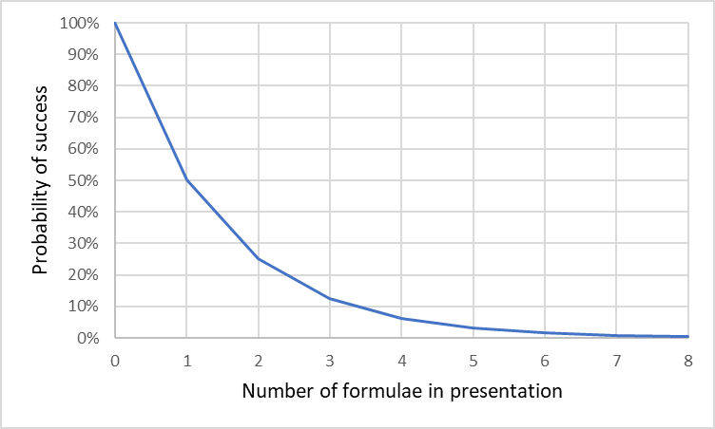
Figure 1: Caption of Figure 1
Paragraph 3 text. Abstracts should be limited to 300 words or fewer – the main intention is to summarise what will be in the presentation and provide a record in an abstract booklet. It is up to the author to determine the format, i.e. Introduction, Background, Results, Conclusion, etc.
References
[1] Author(s), title, journal or publisher, year, DOI
[2] Ibid.

