Calibration methodology of the piston prover for cold and hot water test equipment

Miroslava Benkova¹, Frantisek Schweitzer²,

¹mbenkova@cmi.cz, Czech Institute of Metrology, Okruzni 31, Brno, Czech Republic
²schweitzer@justur.sk, Justur, s.r.o., Dr. A. Schweitzer 194, Stara Tura, Slovakia
E-mail (corresponding author): mbenkova@cmi.cz

Abstract

The papers describes a piston prover with 30 litres volume, integrated into a test line with possibility to measure with cold and/or hot water, which by its innovative system of liquid delivery together with the sophisticated control system allows to reach higher accuracy and stability of measurement conditions.
The contribution is focused on the presentation of method and results of the initial calibration of the piston prover by means of geometrical assessment using 3D measuring equipment. Followed by a successful comparison with the results of next calibration realized automatically via the integrated software by means of volumetric method with a volume standard and an electronic measurement. Comparability of the traceability of the piston prover to the Czech National Standard of Length with traceability to the Czech National Standard of Mass is expressed.
Further the experimental measurements of long-term stability especially in the field of low flow rates (0.13 to 6 l/h) are described and determined. Results have shown that the developed equipment and method may successfully be spread to both higher and also very low flow rates.

1. Introduction

The development of meters with higher accuracy and a wider range of the testing flow rates requires development or improvement of the primary and secondary calibration and adjustment to new trends in this field of measurement.

The papers is focused on the presentation of method and results of the initial calibration of the piston prover by means of geometrical assessment using 3D measuring equipment.

Further the experimental measurements of long-term stability especially in the field of low flow rates (0.13 to 6 l/h) are described and determined.

The uncertainty analysis indicates that at the same requirements for calibration and measurement ability better than 0,1% the testing volumes may be reduced down to 0,2 litres without correlation to the flow rate, whereby at testing volumes over 5 litres the reached measurement uncertainty is better than 0,03%. Even other parameters as temperature and flow rate stability are monitored and have been watched continuously. Advantages of this methodology are described for the developed piston prover working within the range from 0.13 l/h up to 7 500 l/h.

2. Basic information

The piston prover consists of the following main components: calibrated piston, piston's shell, kinetic screw, servo motor, rotary or linear encoder.
The piston is driven by a servo motor with a built-in incremental encoder, by means of which the piston movement is controlled – its acceleration, velocity and its stabilisation, deceleration, setting of position and other functions. However, the definition of the piston’s position for measurement purposes is realized by the means of an independent external rotary incremental encoder. In combination with a quadrature time converter we gain 40 000 pulses per revolution, which corresponds to 10 mm of length displacement. The resolution of 1 pulse is 0.0091 ml. The piston enters the piston’s shell through a sealing. The use of a linear encoder is optionally available.
Tests have been provided with instant use of both encoders with control of the position adjustment. Tests have confirmed the reliability of the rotary encoder, which allows a more practical and effective utilization of the test bench.

2.1 Initial piston calibration
After production and final polishing of the surface the piston is calibrated on a 3D measuring equipment SIP CMM5 with an expanded measurement uncertainty of diameter 200mm u(k=2)=1.0 µm. The piston’s calibration is based on accurate measurement of 4 outer diameters and the consecutive calculation of cross-section of particular sections. The measurement is made in every 10 mm along the piston on an overall length of 900 mm. In between of two neighbouring cross-sections linear interpolation is applied.

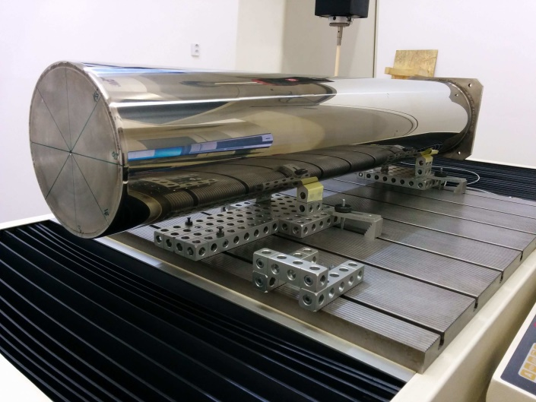

Figure 1: Calibration of piston

2.2 Impact of piston body calibration on the uncertainty
The standard uncertainty of piston’s segment area (cross-section) calibration was defined equally for all i segments

$u\left(S_{i}\right)\text{=u}\left(S\right)=\text{9,86}{\text{mm}}^{2}$ (1)

Calibration was performed with spacing of Li = 10 mm along the piston. The uncertainty includes the diameter measuring uncertainty 1 μm, uncertainty of piston body temperature during the calibration and uncertainty, given by an estimation of possible diameter changes between the measured points at its perimeter.

The relative uncertainty is

$u_{R}\left(S\right)=\frac{u\left(S\right)}{\text{363}{\text{cm}}^{2}}=\text{0,027}⋅$ (2)

The number of segments N, participating in a test, is equal to
$\text{N=}\frac{V_{C}}{L_{\text{PS}}⋅S_{P}}$ (3)

where VC is the testing volume, LPS is the average length of a calibration segment and SP is the median of piston’s segment area

Uncertainty of all the segments, used in a test, is considered as dependent, thus the following relation expresses uncertainty resulting from the impact of calibration on the measured volume

$u\left(V_{\text{PT}}\right)=\frac{V_{C}}{S_{P}}⋅u\left(S\right)$ (4)

and the sensitivity coefficient is

$\frac{{\text{dV}}_{C}\left(V_{\text{PT}},\text{...}\right)}{{\text{dV}}_{\text{PT}}}=1$ (5)

2.3 Correction of volume displaced by the piston
The calibration at CMI Prague has been done in the length laboratory in an air-conditioned room at temperature 20°C ± 0.2°C. The real displaced piston volume is numerically corrected according to temperature of real liquid during the test for:
- thermal volume expansion of the piston
- change of water density in between the piston and the DUT (meter under test)
- change of water volume due to different pressure in the piston and the DUT
- The numerical correction of the piston’s thermal volume expansion has experimentally been confirmed by a set of measurements in the following steps:
- measurements made at JUSTUR premises on various dates at ambient temperature of 20°C and 50°C (the piston has been intensely heated by permanent water flow for reaching a surface temperature of 50°C)
- calibration at CMI at 20°C
- comparison of results CMI vs JUSTUR > approval of the measurement results at JUSTUR (green vs. dashed magenta & light blue)
- comparison of results at 50°C with a mathematically corrected curve and the calibration at CMI (dashed yellow & red vs. blue)

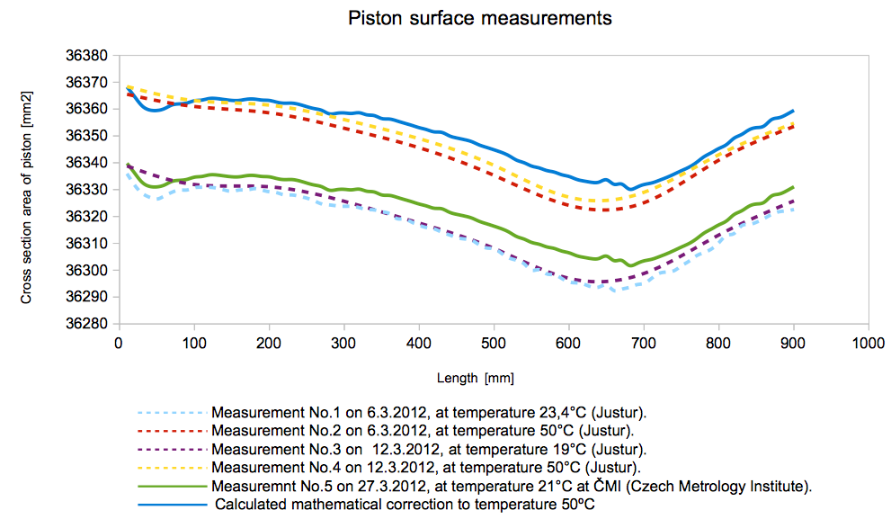

Figure 2: Numeric correction vs. real tests

Following chart shows the testing results of piston prover PP30 compared to a 5 litres measuring vessel (further described method) performed with cold water (24.5°C) and hot water (49.2°C). Each point is the mean value calculated from 5 repetitious tests, the standard deviation for each point is presented.

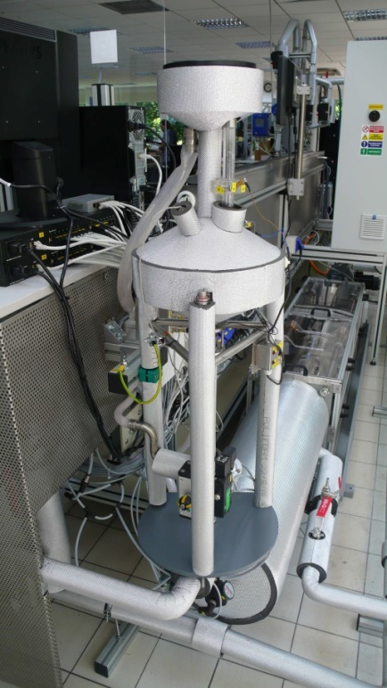
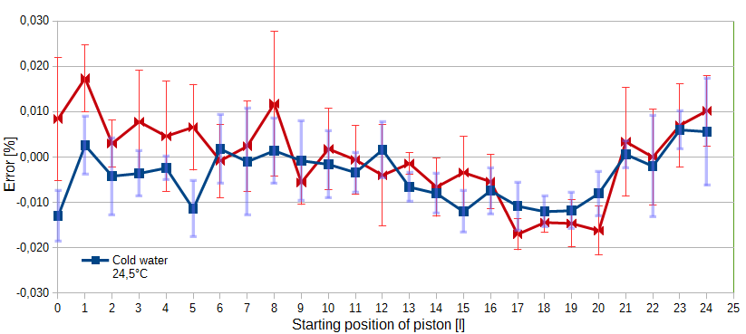

Figure 3: Results of the testing with hot and cold water

3. Confirmation of metrology parameters

Parameters, which had a significant impact on the proper measurement value have been monitored throughout the development stage of the piston. These in particular are accuracy of delivered quantity, which has been evaluated by the gravimetric and also volumetric method accommodated to the objective measurements, flow rate stability and temperature stability.

3.1 Accuracy of delivered volume
The accuracy of volume delivered by the piston has experimentally been inspected by several measurement approaches. In the range of small testing volumes (100, 250, 500 and 1000mL) the gravimetric method has been applied, the 5L testing volume has been realized with a calibration vessel.

3.1.1 Gravimetric method
Weighing scales 200g with d=0,01mg for the lower volume and 1500g with d=0,01g for the bigger volumes have been used. The piston displaced the requested volume into a closed reservoir in order to avoid evaporation. This has been weighed both before and after the measurement and compared to the volume displaced by the piston.

3.1.2 Volumetric method
A calibrated vessel with 5 litres (ON5) volume was used. The equipment allows providing comparative measurements by the means of this calibrated vessel, which is calibrated with an uncertainty of 0,01% (k=2) at CMI. The calibrated vessel is furnished with electrodes for sensing the upper and lower level, which allows an automatic and accurate mode of sensing the volume. Arbitrary test points may be pre-set, e.g. piston’s position from which the measurement of 5 litters is made as well as the amount of repetitions in the given point. The measurements run automatically. Results of the comparative measurements with the ON5 presented in the following graph have been done with a step of 30mm along the entire length of the piston, with 5 repetitions at each point.

Figure 4: Measuring vessel 5l & piston prover PP30

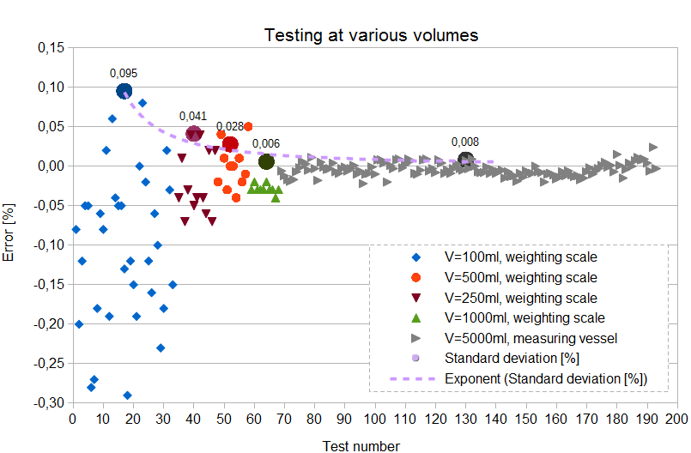

Figure 5: Accuracy of delivered volume

3.2 Flow stability
The piston prover PP30 is characteristic by its wide range of flow rates, which start at 0,13 l/h and reach up to 7.500 l/h. This range is achieved by means of a high-end servo drive and its control unit. The flow setting time is shorter than 1 sec.

The flow stability is a very important feature of flow realization and this increases its importance especially in the low flow rate range, as it directly influences the quality of the DUT testing. The flow stability measurements were realized by direct comparison of the PP30 against Coriolis mass meters Cori-Flow from Bronkhorst company. The piston prover pushed the water (flow) directly through the mass flow meter, during which the stability of flow was logged and compared.
The results are presented in the table 1 for the lower flow rate range (130 to 520) ml/h and the model Coriflow M13 and in the table 2 for the upper range (520 to 5 800) ml/h and the model M14.

Table 1: Results of flow stability by Coriflow M13
Flow [ml/h] | 130 | 260 | 390 | 520
Fluctuation of flow [%] | 0.17 | 0.11 | 0.09 | 0.09
Max-Min of flow [%] | 0.63 | 0.4 | 0.48 | 0.35

Table 2: Results of flow stability by Coriflow M14
Flow [ml/h] | 910 | 1960 | 2870 | 3900 | 6000
Fluctuation of flow [%] | 0.1 | 0.09 | 0.09 | 0.12 | 0.14
Max-Min of flow [%] | 0.31 | 0.39 | 0.58 | 0.38 | 0.53

3.3 Comparison measurements with master meter
The functionality of the entire testing equipment with a piston prover has also been examined with a Coriolis flow meter traceable by gravimetric method in the Czech metrology institute and connected directly in the metering section behind the piston. These measurements have been carried out within (0,002 up to 7 000) m³/h. The defined expanded combined uncertainty of the equipment was better than 0.2 % in this range of flow rates.

4. Uncertainty budget

As the piston prover is a volumetric standard, its dependence on temperature is obvious and may have a significant impact on results. It had been discovered that the biggest uncertainty contribution at small testing volumes is the impact of the so called parasitic volume of water and its storage effect. For hot water tests (50 to 90)°C the piston is furnished with an external heating of the piston shell (from the outside) as well as a heating of the very piston (from the inside), which prevent cooling or volume change of both water and the piston with its shell during the test. Temperature control is electronic and maintains temperature of the inner and outer coat identical with the water temperature. Temperature stability has been documented at various testing flow rates with a fluctuation level of 0.1°C to 0.3°C during the entire test. The storage effect is significant mainly when testing with hot water and with small testing volumes. For its elimination the equipment allows the so called High accuracy mode, when only the really essential amount of water for each particular test is drawn into the piston. The following graph depicts the expanded measurement uncertainty (k=2) of the piston prover for cold and hot water and the comparison of the Normal and High accuracy mode.

5. Monitoring of the stability of metrology parameters, accuracy supervision

In the framework of the quality system it is necessary to continuously provide the stability of the piston’s declared metrology parameters. A geometric calibration after 5 years is recommended. Within this period the metrology parameters may be verified from time to time by means of the ON5 calibration vessel on behalf of the methodology described in the previous chapter.

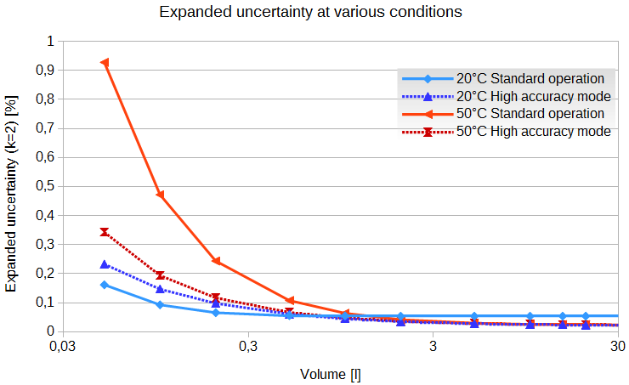

Figure 6: Expanded uncertainty (k=2) for Standard and High accuracy mode at 20°C and 50°C

Following picture shows repeating measurements in 2013 (red) and 2016 (green). Each point is the mean value calculated from 3 to 5 repetitious tests, the standard deviation for each point is also presented.

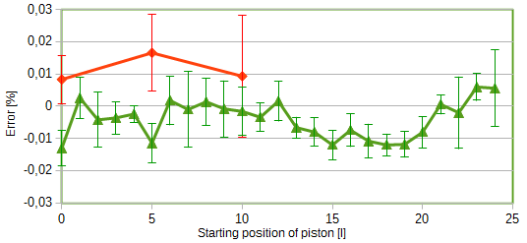

Figure 7: Monitoring of the stability of piston

6. Conclusion

Experimental measurements as well as current practical experience have confirmed the original intent to realize a standard equipment for use of liquid meter calibration in the area of small flow rates, while reaching high accuracy and stability of results, simple calibration and the lowest possible cost for equipment maintenance.
The design ensures long term tightness stability with simple visual leakage control and very high capacity. Direct comparison of volumes as well as the simplicity of the method have a great impact on decreasing partial uncertainties, which ultimately contribute to high precision and stability of measurement. Seamless maintenance of the standard equipment is also an important attribute of measurement reliability.

References

- ILAC Policy for Uncertainty in Calibration, ILAC‐P14:12/2010.

