Laboratory inter-comparison measurements  
- Means of proving traceability in liquid flow metering

**R. Engel\*)**

*Consulting Engineer and independent researcher, drrengel@t-online.de, Braunschweig, Germany*

*\*)The author worked at PTB (German’s NMI) as researcher and head of the working group “Traceability in Liquid Flow Measurement” until December 2015*

# Abstract

Traceability in liquid flow measurement – or, in general, in fluid flow measurement – is practiced as the so-called component-by-component approach, i.e. the flow measurands of fluid flowrate (volumetric or mass flowrate) and totalized flow (total volume or total mass) are determined by tracing the units mass (or volume), density, temperature and time measurement separately back to the corresponding SI units. This represents the state of the art and this approach basically relies on the assumption that the measurement process of flowmeter calibration is a steady-state process and no dynamic changes in fluid flowrate occur. Due to this attitude, it seems to be sufficient, for traceability purpose, to take into account solely those SI units - as steady-state quantities - which represent the composing elements of the flow measurands. But it has already been shown that dynamic flow effects, definitely, have an impact on the accuracy of flowmeter calibration. That is the reason why, for ongoing key and supplementary laboratory comparisons, procedures, techniques and electronic equipment had been developed which provide capabilities to acquire, in addition to simple pulse counting and time measurements, data of the flow measurands and additional process quantities (like line gauge pressure, temperature and fluid density). These measurement data, acquired and logged in real time, open unique possibilities to analyse and investigate the impact of dynamic flow effects on the accuracy and measurement uncertainty of flow calibration.

# 1. Introduction

As a matter of fact, the measurand *flowrate* in the flowmeter calibration process represents a dynamic quantity whose magnitude is subject of more or less random-like variations. These dynamic impacts, in general, are not taken into account in a “plain” static cause-and-effect relationship as it is practiced in the field of flow metrology in general. But earlier research works [1] have revealed that such dynamic impacts cause significant effects to the measurement results of flowmeter calibration and that, thus, cannot be neglected (See: **Figure 1**). This is valid for laboratory comparisons in general, for Key Comparisons (KC) among the flow laboratories of the National Metrology Institutes, this is a fact with a special emphasis.

Owing to the above-mentioned issues and due to the experiences from the first Key Comparison KC1 Water Flow [2] in the years 2003 through 2004, measurement procedures were derived and developed as well as a combination of two transfer flowmeters was selected in order to tackle those problems (inconsistent data sets) which were inherent in comparison measurements in the field of liquid flow measurement.

For the second Key Comparison KC1 Water Flow (which was launched in 2016), a combination of a turbine and a Coriolis meter had been selected to serve as the transfer flowmeter package (See: **Figures 2** and **3**). This combination of flowmeters explicitly involves the requirements to the participating flow calibration laboratories to prove their calibration capabilities both in mass flow and volume flow.

As an outcome of the first KC1 in the years 2003 and 2004, it was decided to prepare transfer flowmeters being run under operating conditions which slightly differ from predefined reference conditions. For this purpose, characterization measurements of the both transfer flowmeters were performed during a longer period of tests and systematic investigations. The characterization of the flowmeter parameters was carried out with the water temperature and the line pressure being varied systematically in order to determine sensitivity coefficients with the changes in these two process parameters [4][9].

In addition to this, the long-term stability of the flowmeter parameters has been analysed in order to determine their operations under defined conditions of repeatability and reproducibility. Capabilities for observing the time responses of the output signals of both flowmeters and the process quantities during calibration were implemented into the electronics of the measurement equipment in order to provide means of stability monitoring for the whole measurement process (See: **Figures 2** and **6**).

****

**Figure 1:** “Comprehensive” traceability chain in fluid flow calibration - including dynamic process effects on the measurement uncertainty of liquid-flow standard facilities:

(1) Liquid evaporation out of weigh tank, condensing humid ambient air on the weigh tank’s out-side wall surface;

(2) Variation of the temperature of the circulating water resulting from flowrate fluctuations and imperfect temperature control operation, respectively;

(3) Variation of the process pressure due to flowrate fluctuations;

(4) Fluctuations of the determined water density due to spatial and temporal changes of the water temperature within the water stream;

(5) Dynamic impacts on weigh scale originating from mechanical vibration excitations;

(6) Impact of flowrate variations on the diverter’s timing error

# 2. Subjects of traceability in fluid flow measurement

*2.1 Flow measurands*

In fluid flow measurement, there are four measurands that are subject of calibration and measurement [3][5]:

1) (Average) **volume flowrate**:

 (1)

2) (Average) **mass flowrate**:

 (2)

3) **Totalized volume flow** measurement:

 (3)

4) **Totalized mass flow** measurement:

 (4)

The meanings of the symbols in the above equations are as follows:

|  |  |  |
| --- | --- | --- |
|  | Average volume flowrate | [m³/h] |
| , | Volume flowrate | [m³/h] |
|  | Totalized volume (during diversion) | [m³] |
|  | Reference volume | [m³] |
|  | Average mass flowrate | [kg/h] |
| , | Mass flowrate | [kg/h] |
|  | Totalized mass (during diversion) | [kg] |
|  | Reference mass | [kg] |
|  | Measurement time | [s] |
|  | Density of water | [kg/m³] |

The national metrology institutes (NMIs) are responsible - in general, by law in their countries – to realize and disseminate these units for their utilization in the national economies. These units, their measurement ranges and the dedicated measurement uncertainties are gathered and made available to the public in the CMC database of BIPM [3]. These CMC entries have to be verified and proven periodically (after defined periods of time) in so-called key comparisons [6] and supplementary comparisons [7], respectively, which practically represent laboratory inter-comparison measurements.

The vast majority of the flow laboratories of the NMIs have CMC entries for the four above-mentioned flow measurands. Thus, all these flow measurands have to be verified in accordance with the CMC entries of an NMI.

*2.2 Quantities which are subject of calibration*

Although the above-mentioned 4 quantities are the measurands in fluid flow measurement, in general, the meter K-factor is the subject of flow calibration, regardless whether volumetric or gravimetric reference standards are used in calibrating flowmeters.

So, the meter K-factor was already the measurand in the CCM.FF-K1 Key Comparison for water flow in 2003/2004 [2] and was the subject of the calibration measurements.

The meter K-factor of a flowmeter is defined as given in **Equation (5)**:

; (5)

with:

|  |  |  |
| --- | --- | --- |
|  | Meter K-factor, general | [pulses/quantity] |
|  | Frequency, output signal | [Hz] |
|  | Reference flowrate | [m³/h] |
|  | Reference volume | [m³] |
|  | Pulse count | / |
|  | Measurement time (for filling the reference volume) | [s] |

The determination of the meter K-factor, generally, relies on the static-weighing principle of a gravimetric reference with a diverter-operated actuation of the filling process with the fluid stream being directed into the weigh tank during the measurement time *TMEAS* [5]. This measurement principle is known as or is called flying-start-and-finish gravimetric calibration.

In **Figure 2a**, the meter K-factor  vs. flowrate (within measurement range of the flowmeter) as a real measurement instrument is shown. In practice, all types and makes of flowmeters practically reveal a non-linear steady-state response behavior, which can be visualized as an error curve (See: **Figure 2b** and caption).



a)



b)

**Figure 2**: Characteristics of flow metering devices

**a)** Steady-state transmission characteristics

: Inverse meter K-factor (also: Meter factor)

**b)** - Primary ordinate: Meter K-factor 

- Secondary ordinate: Linearity error;

(also: Meter error)

Depending on the operating principles of the flowmeters that are used in a comparison – a key comparison or a supplementary comparison - , following meter K-factors are subject of measurement and have to be determined in the comparison measurements [6][7]:

1) *Turbine flowmeter*:

- volume-related frequency output:

***KTur\_V*** [pulses/unit volume]

2) *Coriolis flowmeter*:

**a)** - mass-related frequency output:

***KCor\_m*** [pulses/unit mass]

**b)** - volume-related frequency output:

***KCor\_V*** [pulses/unit volume]

It should be noted that, under certain circumstances, even flow calibration standards whose operation principle relies on the standing-start-and-finish operation may be utilized for metering flowrates and meter K-factors.

*2.3 Reference standards in fluid flow calibration*

Standard facilities for fluid flow calibration can be systematically categorized in following types, depending on what type of a reference standard is in use and what is their time behavior like [5,6,7]:

*1. Flow calibration facilities with gravimetric reference standard*

1.1. Flying-start-and-finish calibration method (diverter-operated static weighing)

1.2. Standing-start-and-finish calibration method (static weighing)

1.3. Dynamic-weighing calibration method

*2. Flow calibration facilities with volumetric reference standard*

2.1. Flying-start-and-finish calibration method (diverter operated, scaled tank)

2.2. Standing-start-and-finish calibration method (scaled tank)

2.3a Dynamic level gauging (scaled tank)

2.3b Volumetric proving device (prover)

Calibration method 1.1 (Flying-start-and-finish operation based upon diverter-operated static weighing), in general, provides the highest accuracy in liquid flow calibration. That is the reason why this technique is in use in the majority of the nation metrology institutes where liquid flow facilities are established.

The above-mentioned systematic overview of categories, on principle, can also be applied on calibration facilities for gaseous media.

# 3. Transfer packages as means for proving correctness of traceability

*3.1 Transfer flowmeters and the acquisition of process quantities*

A transfer package for (key) comparison inter-laboratory measurements which combines a turbine flowmeter and a Coriolis flowmeter - i.e. a combination of a volume-related and a mass-related flowmeter - has proven to be a beneficial solution [10], as it provides, in addition to the “plain” calibration data, useful means of diagnostics and real-time flow data analysis.

As shown in **Figure 3** in a principle functional diagram, the diagnostic capabilities of the transfer package are provided through accessory sensors and transmitters:

- Pressure transmitter (gauge pressure);

- Temperature transmitter (water temperature);

- Differential-pressure transmitter (means for monitoring the operation of the turbine meter);

- Add-on for providing (in addition to the inherent mass flowrate output) a volume flowrate signal output;

- Implementation of the Coriolis meter’s internal function of a fluid densitometer as a current output to the transfer package electronics.

**

**Figure 3:** Principle of signal acquisition during the comparison measurements

How this concept of an extended monitoring approach in liquid flow (water flow) comparison measurements was transferred into practice can seen **Figures 4a** (Key Comparison KC1 water flow) and **4b** (supplementary SIM comparison water flow). For more detailed explanations, see caption of **Figure 4**.

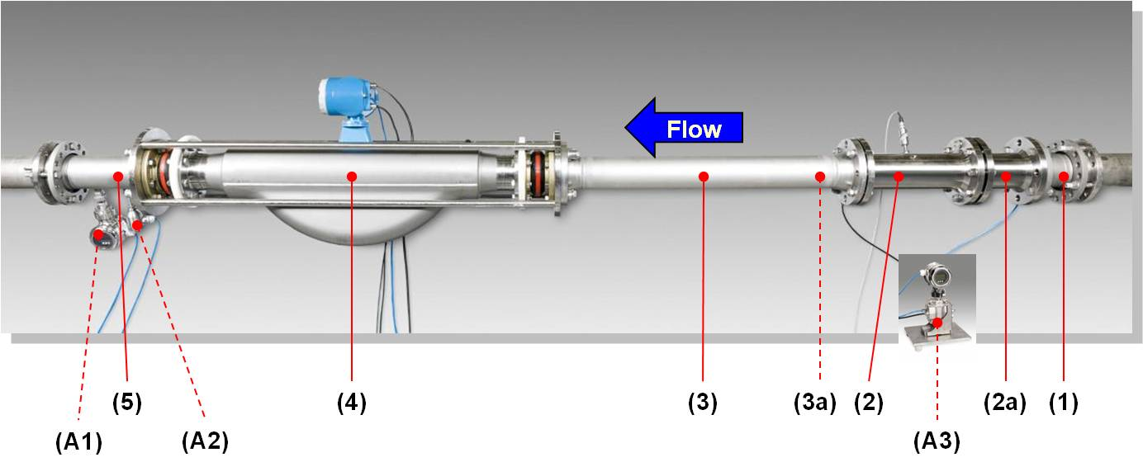

***a)***

*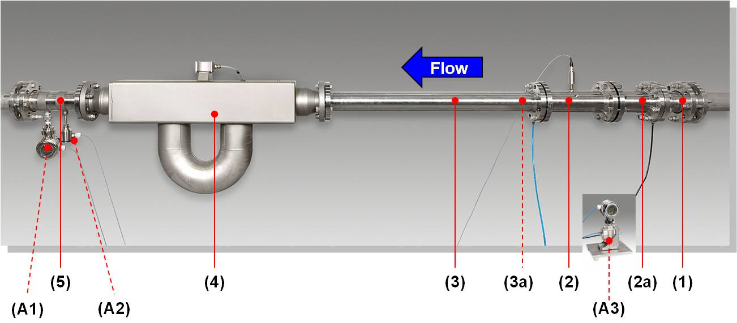*

***b)***

**Figure 4:** **Sets of comparison transfer flowmeters:**

**-** Combination of a Coriolis and a turbine flowmeter

**a) Sample installation DN100**: applied with Key Comparison **CCM.FF-K1.2015**

**b) Sample installation DN80**: applied with SIM Comparison **SIM.M.FF-S9**

(1) Inlet pipe section (adaptable to both ANSI and DIN flange connections)

(2) Turbine meter

(2a) Tube-bundle flow conditioner dedicated to the turbine

1. Connecting pipe section with

(3a) Integrated tube-bundle flow conditioner

(4) Coriolis flowmeter

(5) Outlet pipe section (adaptable to both ANSI and DIN flange connections)

**Auxiliary devices:**

(A1) Pressure transmitter

(A2) Temperature transmitter

(A3) Differential pressure transmitter

*3.2 Auxiliary measurement devices*

A special cause-and-effect relationship, which is utilized to enhance the reliability of flow measurement, is, in addition to a turbine meter’s signal output, to measure the pressure drop across the turbine meter. Thus, the simple metering principle of a turbine meter is extended in a way where variations of the fluid density and viscosity, due to variations of the fluid temperature, as well as wearing effects in the turbine meter can be measured or, at least, detected for diagnostic purposes [6][7].

Furthermore, the fluid temperature, the water gauge pressure, and the internal densitometer signal from the Coriolis flowmeter are acquired through the electronics of the transfer package in order to obtain information about the stability and quality of the calibration measurement.

*3.3 Measurement program for providing traceability through key comparisons*

The primary aim of (key) comparisons in fluid flow metrology is to verify and to prove the correct traceability of the flow measurands to the SI units at an accuracy level that matches the uncertainty level of the corresponding CMC entries in the BIPM CMC database.

In order to fulfil this premise, a special-purpose measurement program [6][7] had been developed which is aimed at the determination of meter errors (correctness of calibration), measurement repeatability and reproducibility effects.

For determining the repeatability (which is seen to be part of the measurement uncertainty budget) and reproducibility (which has to be handled as an additional source of uncertainty), the comparison measurement program is run over 5 days (the pilot laboratory) or 3 days (other participating laboratories) and covers following items [6][7]:

- *Repeatability* (Comprises both meter properties as well characteristics and impacts of the calibration facility on measurements):

- Repeatability in general;

- Day-to-day repeatability (in a flow laboratory);

- ***Reproducibility***: - Laboratory-internal reproducibility;

- Lab-to-lab reproducibility

(during the meters’ round robin in the comparison).

# 4. Data acquisition of flow signals for high-accuracy comparison measurements

*4.1 Real-time acquisition of flowmeter output signals*

For special purposes, it can be very beneficial to utilize capabilities of direct real-time access to the frequency output signals of the flowmeters. Pulse count measurents practically represent an integration of the pulsed frequency signals delivered from the flowmeter over a period of time. That is why, for the measurement signal acquisition and processing in real time, the determination of the instantaneous frequency of the respective signal by measuring the period of time between two signal pulses is applied, as it is given by **Equation (6)**.

***Coriolis flowmeter:***

This elementary approach of frequency measurement is applied on signals from the Coriolis flowmeter:

. (6)

In this case, the frequency output is internally derived from the primary flow sensor (relying on the Coriolis effect) by a combination of hardware and signal processing software within the meter’s electronics.

***Turbine flowmeter*** (turbine wheel with 8 blades [6]):

The rotational speed [min-1] of the turbine wheel , in general, is proportional to the volumetric flowrate; and the output frequency [s-1] which is detected by the signal pick-up from the moving blades is determined as follows:

 (7)

The instantaneous frequency  between two pulses at the instances of time  and , detected by the pick-up, is calculated according to **Equation (8)**:

; (8)

with the cycle period of a single rotation of the turbine wheel given by **Equation (9)**:

. (9)

As a result for the moving average of the instantaneous frequency  within the time interval of pulse counting, a value according to **Equation (10)** will be obtained:

 (10)

For a turbine meter with 8 blades () on the turbine wheel, **Equation (11)** results from **Equation (10)**:



(11)

These calculation algorithms were implemented in the software for real-time data acquisition and graphical data display of the transfer package, as described in [8].

The symbols, applied above, have following meanings:

|  |  |  |
| --- | --- | --- |
|  | Output frequency delivered from the turbine’s signal pick-up; | [Hz], [s-1] |
|  | Rotational speed (RPM) of the turbine wheel, cause by flowrate ; | [min-1] |
|  | Number of blades on turbine wheel; | / |
|  | Instant of time; | [s] |
|  | Period of time between pulses No. ***j-1*** and ***j,*** | [s] |
| *i* | Position number of blade on turbine wheel, ; | / |
| *j* | Index of instances of time  and periods of time ,). | / |

The fast time response, which is realized by means of the above-mentioned measurement approach, can be seen in the diagram in **Figure 5**.

In this diagram, the limits of the fluctuations and the drift of the flowrate during a calibration measurement (which have been measured by utilizing the fast frequency determination of the flow signal) have been identified. These upper and lower limits of the flowrate fluctuations are relevant in order to take into account dynamic impacts on the estimation of the measurement uncertainty.



**Figure 5** Calibration facility: flowrate time characteristics

a) Stable, constant flowrate

b) Step-like time response

c) Drift in flowrate

**Limits of uncertainty:**

d) Stable flow conditions (necessary for proving CMC entries)

e) Instable flow conditions (not acceptable)

Based upon the fast measurement of the flow meters’ frequency signals, a statistical analysis of the flowrate signals and the output signals of the auxiliary devices can be performed as a useful add-on tool for uncertainty analysis purposes [8].

|  |
| --- |
| **vol30_coriolis_volume_flow_histogram**  **a)** @ 30 m³/h |
| **vol240_coriolis_volume_flow_histogram**  **b)** @ 240 m³/h |

**Figure 6:** Statistical analysis of the real-time signal delivered from the Coriolis meter frequency output (volume flowrate) at two flowrates

*4.2 Hardware and software of the transfer package’s electronic equipment*

In order to provide information concerning the long-term characteristics of the transfer meters in use for comparisons and the measurement conditions in all participating laboratories during the whole transfer meter round-robin, the transfer package comprises special sensors and measurement data acquisition electronics. All functions of this special-purpose electronics – in the fundamental core – are based on hardware and software components by National Instruments Corporation (NI). The operation and the operator interactions, the so-called Human Machine Interface (HMI), rely on a LabVIEWTM (NI) application program [6][7] running on a laptop computer, which is a component part of the whole transfer package.

As it can be seen in **Figure 7**, that all sensors of the transfer package will be connected to the electronic box and receive their supply energy from this box. All connecting plugs are coded mechanically and, additionally, by color (See: **Figure 8**). Thus, any erroneous connecting can be avoided.

The flowmeter signals are amplified by booster amplifiers and redirected to BNC outlet sockets to which the electronic counters of the calibration laboratory will be connected for external pulse counting.

Internally, the flow signals are tapped and connected – together with the analog signals from the auxiliary sensing devices – to the dedicated hardware (See: **Figure 7**) for real-time data logging.

The calibration laboratory has to provide an electronic GATE signal, which is derived from the diverter actuation (or from a prover’s piston stroke) and which is to be connected to the corresponding BNC socket (**Figure 7**). By means of this GATE signal, the guidance through the LabVIEW control and visualization program will be triggered and managed automatically [6][7].

Special provisions were made to gain a direct communication between laptop computer and the Coriolis flowmeter in order to initiate an auto-zero of this device and to read device parameters prior to and after auto-zeroing (See: **Figure 7** and [6][7]).

****

**Figure 7** Transfer package electronic box

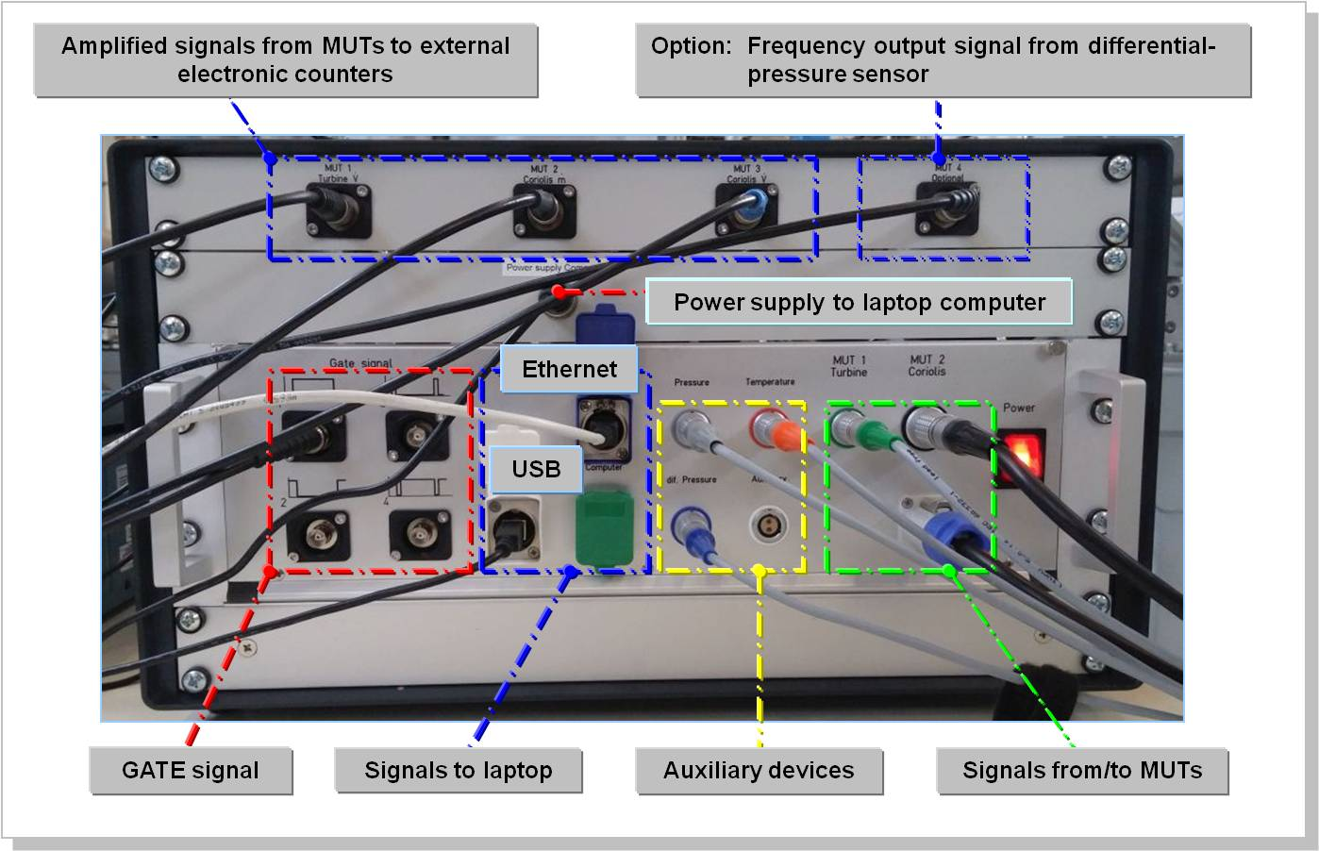

**Figure 8:** “Universal” measurement electronic box providing data acquisition and monitoring capabilities:

- Connectivity to MUTs, external electronic counters and laptop computer

*4.3 Visualization and evaluation of the measurement data and statistical analysis*

Primarily, the “raw” data of the comparison measurements in a lab will be reported to the pilot lab – as it has been a common practice until now - by filling in an EXCEL spreadsheet with those data which have acquired according to the processing procedures defined in the lab’s quality management documents. The results of these data will be the so-called error curves, as shown in **Figure 9**.

|  |
| --- |
| **a)** |
| **b)** |

**Figure 9:** Characterization of the transfer flowmeters:

Temperature sensitivity,

at: 10°C, 15 °C, 20 °C,  25 °C, 30 °C, 35 °C

**a)** Turbine flowmeter

**b)** Coriolis flowmeter

The error curves of the two transfer flowmeters, show in **Figure 9**, represent the summarized calibration results which have been gathered in a permanent process of verification over several years. The meters have been tested at defined temperature points, so that – if it should be necessary – corrections with respect to possible deviations of the fluid temperature from the reference temperature 20 °C could be applied.

The results (compressed in zip files) based upon the real-time measurements will be reported separately to the pilot lab. They serve as further means for visualizing (**Figure 10**) and evaluating the behavior of all relevant quantities during a single measurement.

All the procedures how to handle the real-time measurement data, logged by the participating calibration labs, as well the utilization of these data in the off-line processing have been described in the technical protocols of KC1 [6] and the supplementary SIM comparison [7] of water flow and in [8] , respectively.

As a recommendation, the Key Comparison Reference Value (KCRV) has to be calculated as follows:

(12)

with:

|  |  |
| --- | --- |
|  | KCVR of the meter K-factor at flowrate *i*; |
|  | Reference flowrate |
|  | Measurement uncertainty of lab number *k* at flowrate *i* |
|  | Meter K-factor of lab number *k* at flowrate *i* |

|  |  |  |
| --- | --- | --- |
| **1** | **vol30_coriolis_mass_flow**  **1a)** @ 30 m³/h | **vol240_coriolis_mass_flow**  **1b)** @ 240 m³/h |
| **2** | **vol30_turbine_volume_flow**  **2a)** @ 30 m³/h | **vol240_turbine_volume_flow**  **2b)** @ 240 m³/h |
| **3** | **vol30_pressure**  **3a)** @ 30 m³/h | **vol240_pressure**  **3b)** @ 240 m³/h |

**Figure 10:** Oscilloscope-like data visualization of the real-time calibration measurement data:

1) Coriolis flowmeter: frequency signal output

2) Turbine flowmeter: frequency output

3) Pressure sensor (water gauge pressure): current signal

Based upon the sensor signals, logged and stored in real time by the software of the transfer package during the calibration program running, further information can be extracted so that by applying cross-correlation calculus the uncertainty contributions, dedicated to the meters under test and to the calibration facility, can be separated [11].

# 5. Summary and conclusions

In order to prove traceability of the flow measurands to the SI units, for laboratory inter-comparisons following issues are relevant:

- Measurement uncertainty analysis based on a **common model** of the measurement process in each participating laboratory is an essential prerequisite in order to determine the (key) comparison reference values.

- Each participating calibration laboratory has to carry out comparison measurements for **each measurand** for which the respective laboratory has been accredited or/and for which a national flow laboratory has a dedicated CMC entry in the CMC database of BIPM.

- One essential aspect of laboratory inter-comparisons or key comparisons is that each laboratory has to prove their CMCs through **calibrations both for mass flow and volume flow**, regardless what type of a flow standard (gravimetric reference standard or volumetric reference standard) is in use there.

- Basically, the volumetric flow and mass flow measurement capabilities can be proven by utilizing a **transfer flowmeter package which comprises a volume-flow-related flowmeter as well as a mass-flow-related flowmeter**. By this, each laboratory has to face the problem of determining the fluid density under flow conditions in their flow calibration facility [6].

- As it has been shown in several publications (amongst them [1]), a static component-by-component traceability chain is not sufficient to prove low-level uncertainties in flow calibration measurements.

That is the reason why a special purpose electronic data acquisition unit had been developed for the KC1 water flow key comparison – which, of course, may be utilized beneficially in any laboratory inter-comparison. This data acquisition unit provides capabilities as follows (See **Figure 5**):

* “Classic” measurement data signal acquisition by “plain” pulse counting from the flowmeter output signals;
* Continuous real-time data acquisition both of the flow signals and the process signals, like fluid temperature and water gauge pressure in the pipework of the calibration facility for monitoring and evaluating purposes.

The approaches and the techniques presented in this paper – and practiced for the first times in a WGFF key comparison [5] and in a SIM supplementary comparison [6] for water flow -, on principle, can be utilized beneficially in any flow comparison, regardless whether liquid or gaseous fluids are subject of measurement.

# Acknowledgement

The author would like to thank all his former colleagues of PTB who contributed with their work and activities to this conference paper.

They are: A. Eggestein (hardware of the transfer package’s electronic box and calibration measurements for characterizing the transfer flowmeters), T. Jahn (software of the transfer package electronic box), F. Bürsing (electronic hardware as well as calibration measurements for the KC1 water flow key comparison and for the SIM supplementary comparison water flow, assistance work in coordinating the transfer package’s round robin among the participating laboratories), E. Frahm (responsibilities in organizing the calibration measurements of KC1 and SIM supplementary comparison), D. Godau (electronic hardware and calibration measurements), S. Eichstädt (MATLAB software for processing real-time measurement data delivered by calibration labs [8]) and – last not least – Ms. A. Petrusha (evaluation of the calibration data acquired in the comparison measurements).

# References

1. Engel R., Baade H.-J.: *Quantifying impacts on the measurement uncertainty in flow calibration arising from dynamic flow effects*, Flow Measurement and Instrumentation, 44(2015), pp 51- 60.
2. Paik J.P., Lee K. B., Lau P., Engel R., Loza A., Terao Y., Reader-Harris M.: *CCM.FF-K1 for Water Flow – Final Report*, November, 2006, [www.researchgate.net/profile/Rainer\_Engel2](http://www.researchgate.net/profile/Rainer_Engel2)
3. BIPM Bureau International des Poids et Mesures: *The BIPM key comparison database – Fluid flow*, http://kcdb.bipm.org/
4. Engel R., Baade H.-J.: *Determination of fluid flowmeter characteristics for precision measurement purposes by utilizing special capabilities of PTB’s ´Hydrodynamic Test Field´,* Symposium Proceedings, 6th International Symposium Fluid Flow Measurement, Querétaro, Mexico, June 20-22, 2012,

www.researchgate.net/profile/Rainer\_Engel2

1. Engel R., Ogheard F.: *Uncertainties in fluid flow measurement*, EURAMET Project E1267 “Harmonization of uncertainty methods for liquid flow standards”, 2016 (under preparation)
2. Engel R.: *Technical Protocol for Key Comparison* ***CCM.FF-K1.2015***, April, 2015, *www.researchgate.net/profile/Rainer\_Engel2*
3. Engel R.: *Technical Protocol for flow-laboratory inter-comparison* ***SIM.M.FF-S9***, March, 2016, *www.researchgate.net/profile/Rainer\_Engel2*
4. Eichstädt S.: *VIZFLOW – Pre-processing and plotting of flow data in MATLABTM – Data acquisition and processing of real-time flow data*, unpublished research report, Physikalisch-Technische Bundesanstalt, Berlin, 2015,.
5. Engel R., Baade H.-J.: *Water density determination in high-accuracy flowmeter calibration – Measurement uncertainties and practical aspects*, Flow Measurement and Instrumentation, 25(2012), pp 40 53.
6. Engel R., Paton R., Rowan L., Frahm E.: *EURAMET Project No. E1201 – Evaluation of a comparison between PTB and NEL in water flow rates from 30 m³/h to 180 m³/h*, Final Report – Draft A, October, 2014.
7. Hayward A.T.J.: *Repeatability and Accuracy – An introduction to the subject, and a proposed standard procedure for measuring the repeatability and estimating the accuracy of industrial measuring instruments*, Mechanical Engineering Publications Ltd., London and New York, 1977.