A New Kind of Time Measurement Method for Control System of Flowrate Standard Facility

**Chao Chen1, Can Wang2, Yiping Liu3, Xinhong Yao4**

*1Shanghai Institute of Measurement and Testing Technology, No1500 Zhangheng Rd., Shanghai, China*

*2Shanghai Institute of Measurement and Testing Technology, Shanghai, China*

*3Shanghai Institute of Measurement and Testing Technology, Shanghai, China*

*4Shanghai Institute of Measurement and Testing Technology, Shanghai, China*

*E-mail:chenc@simt.com.cn*

# Abstract

As we know, timer is an important part of the flowrate standard facility which is directly related to the uncertainty of the flowrate standard facility. Currently, an overwhelming majority of flowrate standard facilities using PLC require the external pulse generator as time standard for control system of flowrate standard facility.

In this paper, we use the PLC internal clock as the time standard for the flowrate standard facility by the function of millisecond timer interrupt and immediate data output, which is not affected by the PLC internal program performing a scan cycle. The new method is verified by experiment, the experiment shows that the PLC internal clock can measure the timer’s stability and time interval accurately, the uncertainty of the timer meets the requirements of the flowrate standard facility.

# 1. Introduction

Timer is an important part of the flowrate standard facility which is directly related to the uncertainty of the flowrate standard facility. Nowadays, the most flowrate standard facility in the world using PLC to complete the control, due to the difficulty of detecting the stability of internal clock and accuracy of time interval accurately, the interval clock of PLC is not usually used as the time standard of the flowrate standard facility. Even though using the timer and counter which build-in PLC under the interrupt mode, the time accuracy also can be affected by the internal program scan cycle, about more than the 10 milliseconds errors could be produced, which can not meet the requirement of flowrate standard facility. Regarding above problem, we take account of the PLC’s function of millisecond timer interrupt and immediate data output, and use the internal clock to be the time standard of flowrate standard facility, then the experiments are utilized to verify the effectiveness of this method.

# 2. Traditional time measurement method of the PLC control facility

According to the JJG643-2003 verification regulation of flow standard facilities by master meter method, the flowrate standard facility using the standard instantaneous flow to measure total flow, or using the standard total flow to measure instantaneous flow should be equipped with a timer. The timer utilized in the flowrate standard facility should have oscillator signal output interface, the 8 hours stability of timer oscillator can not less than one-tenth uncertainty of the standard facility, and the minimum resolution of timer is 0.001s.

Most of the PLC have interrupt function, such as, SIEMENS S7-200 series PLC, in which the timer support a minimum time of 1 ms, then, the usage of the internal interrupt can be accurate to 1ms[1]. The timer’s count number is expressed as a binary data in PLC and is saved in a 16-bit register. The most positive integer is 32767 when the sign bit is removed from a 16-bit binary, which is corresponding to the timer’s biggest time interval. Taking the 1ms timer as an example, the biggest measuring time of 32767 count pulse cycle is: 32767*0.001=32.767s, which can not meet the requirement of measuring time for the flowrate standard facility obviously.

Currently, the flowrate standard facility controlled by PLC needs an external pulse generator, which has a oscillator output signal interface [2]. We can measure the stability of the [oscillator](http://dict.youdao.com/w/oscillator/#keyfrom=E2Ctranslation) with corresponding regulation, then take out the standard  signal with 1kHz or 10kHz as the time standard signal for the flowrate standard facility after oscillator frequency pass through a frequency dividing circuit, finally, with the interrupt function of PLC, we can synchronous start and stop the external standard timer to complete the measurement of the flowrate standard facility’s timer.

# 3. The realization of PLC internal timing

*3.1 The working principle of PLC internal timing*

PLC has internal oscillator, which needs only 0.37μs to execute a command, and technical specification of time is superior to the requirement that the flowrate standard facility request to time. After started, PLC’s 1ms timer can count 1ms time interval, the executing the timer command to start timing control, the data bit of timer and the current value of timer can be refreshed once per 1ms, which is asynchronous with scanning cycle of the PLC’s procedure. That is to say, in a scanning cycle which is more than 1ms, the data bit and the current value of timer need be refreshed some times. What’s more, PLC has the interrupt function, which can respond and deal with the PLC external or internal event quickly.

The working principle of PLC’s internal timing is using its own high-frequency pulse output function of PLC, diving the high frequency of PLC to 10kHz, then, according to 10 kHz diving frequency as a reference frequency, the standard frequency counter can be used to measure the PLC’s 8 hours oscillator stability. The sequence diagram of PLC’s internal timing is shown in Figure 1. the stable frequency which has been checked to be the time standard of PLC, and using PLC’s millisecond interrupt function, according to the external trigger signal to record the PLC’s millisecond interrupt times synchronously. Meanwhile, the immediate setting function is used for outputting the high level signal to the output terminals of PLC synchronously. Starting the external standard timer, when the shortest measuring time of facility is up, the external trigger signal stop recording PLC’s MS interrupt times synchronously, then, the immediate setting function be used for outputting the low level signal to the output terminals of PLC synchronously. Stopping working of external standard timer and the MS interrupt times which recorded in PLC’s storage are equal to the once recording time of facility.

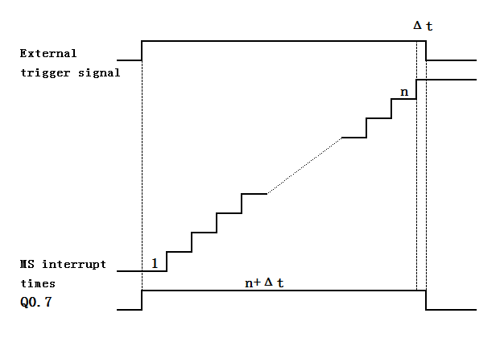

**Figure 1:** The sequence diagram of PLC’s internal timing.

*3.2 The procedure design of PLC’s timing*

The procedure flow diagram is shown in Figure 2.

To begin with, the procedure of timing is initialized the interrupt in main program. The time interval of INT0 is defined as 1ms at the first scan, setting the interrupt program INT3 as the interrupt program of interrupt event number 10 which is used to deal interrupt. Then, enabling the interrupt globally, and the ladder diagram of interrupt initialization is shown in Figure 3.

The first scan

The main program

Set the interval of interrupt 0 is 1ms

Define the interrupt program to deal with the 1ms interrupt

Enable the interrupt globally

N

Whether the control signal is rising edge

Y

Set Q0.7 immediately, reset the milliseconds memory and record the MS interrupt times

Facility’s shortest measurement time is up

N

Whether the control signal is falling edge

Y

Reset Q0.7 immediately, stop recording MS interrupt times, keep the milliseconds memory

Read the milliseconds memory

End a test

**Figure 2:** The procedure flow diagram of PLC’s timing.

When the program is executing, the timer interruption is triggered once per millisecond. Interrupt processing program, executing the increment operation for milliseconds memory VD0. After the operation is over, the internal states will be kept down, the ladder diagram of interrupt processing is shown in Figure 4. If the triggering enable is detected, Q0.7 outputs the high level immediately, meanwhile, the milliseconds memory VD0 is reset and record the MS interrupt times. When the shortest measurement time of facility is up and the detected external interrupt level is low, Q0.7’s level becomes low level immediately. At the same time, stopping recording interrupt times in memory VD0, keeping the milliseconds memory VD0, reading the milliseconds memory VD0 and a verification is be finished.

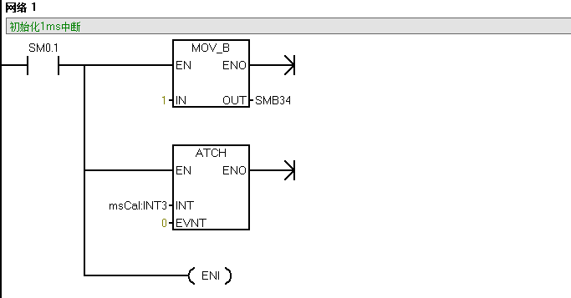

**Figure 3:** The ladder diagram of interrupt initialization.

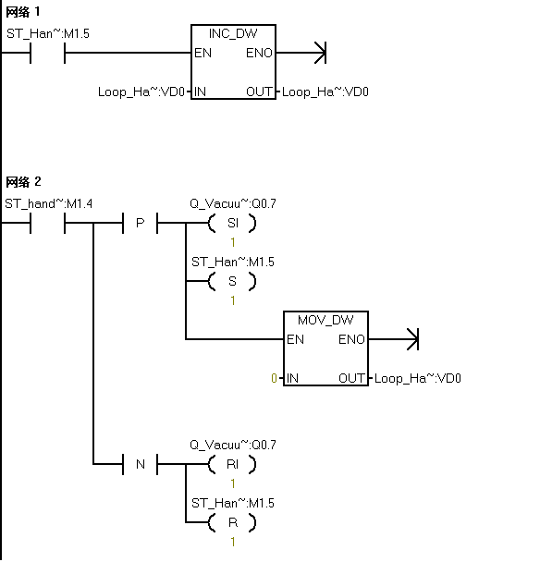

**Figure 4:** The ladder diagram of interrupt processing.

# 4.  Experiment

*4.1 The stability of crystal oscillator*

Taking 10kHz frequency got from the frequency division of PLC as the reference frequency, and outputting it on the output Q0.0 of PLC, then, connecting the output frequency signal to the signal input of the standard frequency. PLC timing connection diagram is shown in figure 5.

Power on, after an hour preheating, reading the frequency value fi(Hz) (i=1,2,…..,8) once an hour[3]. The recording of the stability of crystal oscillator 8 hours is shown in Table 1.

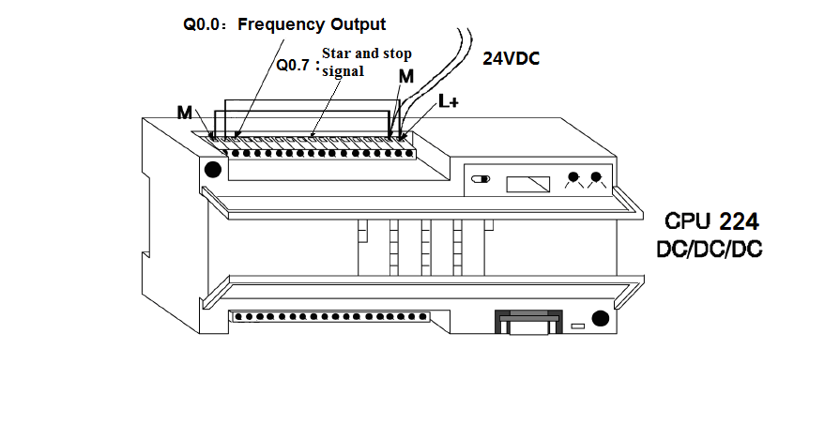

**Figure 5:** PLC timing connection diagram.

**Table 1:**The recording of the stability of crystal oscillator 8 hours

|  |  |  |  |  |
| --- | --- | --- | --- | --- |
| **sequence** | 1 | 2 | 3 | 4 |
| **frequency（kHz）** | 10.0000157 | 10.0000189 | 10.0000181 | 10.0000168 |
| **sequence** | 5 | 6 | 7 | 8 |
| **frequency（kHz）** | 10.0000140 | 10.0000137 | 10.0000159 | 10.0000172 |

The equation of stability of crystal is





= 510-7

Where:is the stability of crystal,%;is the maximum of, Hz;is the minimum of, Hz;is the standard frequency.

*4.2 Time interval of the timer*

Connecting the standard timer to the output Q0.7 of PLC, taking the minimum measurement time of the flowrate standard facility as time interval, starting and stopping the timer synchronously, completing a verification needs to repeat the upper operation for 10 times. The test results are shown in Table 2.

**Table 2:** The time interval of the timer.

|  |  |  |  |
| --- | --- | --- | --- |
| **Test number** | **Tested value**  **（s）** | **Standard value**  **（s）** | **Time difference****（ms）** |
| 1 | 31.202 | 31.2033 | -1.3 |
| 2 | 31.219 | 31.2203 | -1.3 |
| 3 | 31.220 | 31.2212 | -1.2 |
| 4 | 31.222 | 31.2233 | -1.3 |
| 5 | 31.217 | 31.2183 | -1.3 |
| 6 | 31.222 | 31.2233 | -1.3 |
| 7 | 30.279 | 30.2802 | -1.2 |
| 8 | 32.224 | 32.2254 | -1.4 |
| 9 | 31.223 | 31.2244 | -1.4 |
| 10 | 31.221 | 31.2223 | -1.3 |

So the time difference is



The uncertainty  of timer is

0.0002%

The uncertainty  of timer is

=0.0022%

# 5. Conclusion

On the basis of our experimental data, the timer’s oscillator stability, resolution, and uncertainty meet the requirements of the flowrate standard facility. Hence the usage of PLC’s millisecond timer interrupt and immediate data output function can change PLC’s traditional working style. Using the PLC’s internal clock as the time standard of flowrate standard facility conforms to the [operating](http://dict.youdao.com/w/operating/#keyfrom=E2Ctranslation) [requirements](http://dict.youdao.com/w/requirements/#keyfrom=E2Ctranslation), and can be widely used in control systems of the flowrate standard facility to lower the cost of the control system. After many experiments, the test results show that the time differences of timer are all negative deviation and the [repeatability](http://dict.youdao.com/w/repeatability/#keyfrom=E2Ctranslation) of test is excellent. The time measurement accuracy can be improved by the method of time difference correction in the circumstance of higher request for the time accuracy.

# References

1. Yanjun Cao, Yongfeng Jia, “Data Acquisition Based on PLC and Host Computer”, *Development ＆ Innovation of Machinery ＆ Electrical Products*, 22(3), 161~162, 2009.
2. Yanxun Su, Weiliang Guo, Jian Cheng, *LIULIANG JILIANG YU CESHI .*(Beijing, China Metrology Publishing House), 2007.
3. General Administration of Quality Supervision, Inspection and Quarantine of the People’s Republic of China JJF164-2000: *The Standard Facilities for Liquid Flowrate*, 2000.