The influence of stagnation pressure on
discharge coefficient of the sonic nozzle

Peijuan Cao^{1, 2}, Chunhui Li¹, Han Zhang¹

¹National Institute of Metrology (NIM), caopj@nim.ac.cn, Beijing, P. R. China
² Hebei University, Baoding, P. R. China
E-mail (corresponding author): lich@nim.ac.cn

Abstract
Within the stagnation pressure of (0.1~2.5) MPa, the discharge coefficients of the sonic nozzles with throat diameter of (1.921~12.444) mm were investigated. The experimental results showed that:
- The discharge coefficient could be changed 2% for the same nozzle at different stagnation pressure;
- Except for the smallest sonic nozzle, the boundary layer transition from laminar to turbulent all occurred.
Unlike previous studies that the boundary layer transition taking place at the Reynolds number of between (1E+06~2E+06), the boundary layer transition showed obviously advance for some nozzles, which showed significantly relationship with the throat diameter.
Based on the experimental results of 16 nozzles, the curve fitting between the Reynolds number for the transition of the boundary layer and the throat diameter was conducted. When the curve fitting was extrapolated to NMIJ-2013’s results, the consistency was very good, as shown in Fig.1.
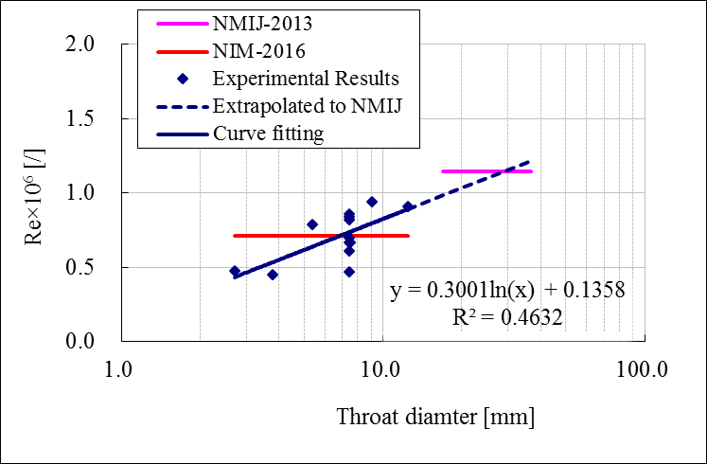
Fig.1 The experimental results.

