Measurement of the Air Flow rate in an Engine Inlet Duct

for Altitude Engine Tests

W. Kang¹, H-M. Choi¹, Y-M. Choi¹, S-H. Lee¹, Y-G. Kim¹, C-T. Kim², K-J. Lee²

¹Korea Research Institute of Standards and Science, 267 Gajeong-ro Yuseong-gu 305-340, Daejeon, Republic of Korea
²Korea Aerospace Research Institute, 169-84 Gwahak-ro Yuseong-gu 305-806, Daejeon, Republic of Korea
E-mail (corresponding author): hmchoi@kriss.re.kr

Abstract

An altitude engine test was carried out to measure the performance of the gas turbine engine of a flight vehicle at a high altitude and in a flight speed environment prior to a flight test. The air flow rate in the engine inlet is one of the most significant parameters to consider when calculating the typical performance values such as the net thrust and the specific fuel consumption of a gas turbine engine. In the altitude engine test facility of the Korea Aerospace Research Institute (KARI), air flow rates are calculated by the static pressure, the total pressure and the temperature measured in an engine inlet duct. In the present study, in order to verify the air flow rate measurement at the engine inlet duct of the KARI altitude engine test facility, the inlet flow measurement devices of a total pressure rake, a total temperature rake and a boundary- layer rake were tested in the high pressure gas flow standard system of the Korea Research Institute of Standards and Science (KRISS). A sonic nozzle calibrated by the gravimetric flow standard in KRISS was used as a reference meter with a flow rate up to 10,000 m³/h, a pressure range up to 50 bar and an expanded uncertainty(k=2) value of 0.18%. The air flow rate obtained by the area-weighted average duct Mach number in the inlet flow measurement devices of the KARI engine inlet duct are compared with reference the flow rates of sonic nozzles at KRISS up to Ma=0.15.

1. Introduction

The Altitude Engine Test Facility (AETF) of the Korea Aerospace Research Institute (KARI) has been operated to verify the performance and reliability of gas turbine engines of flight vehicles at the altitude conditions (altitude 40,000 feet, Mach number < 1, inlet temperature -75~110°C, inlet pressure 30~350kPa) before an actual flight test [1, 2], as shown in Figure 1. The air flow rate in the engine inlet is a significant parameter when calculating the typical performance values such as the net thrust and the specific fuel consumption of a gas turbine engine. The air supply system(< 40 kg/s) at AETF for simulating the flight Mach number of an engine consists of compressors, an air dryer, a reference flowmeter and a sealed test cell in which the test engine is connected to a stilling chamber, a bellmouth and a sliding duct, as shown in Figure 2.
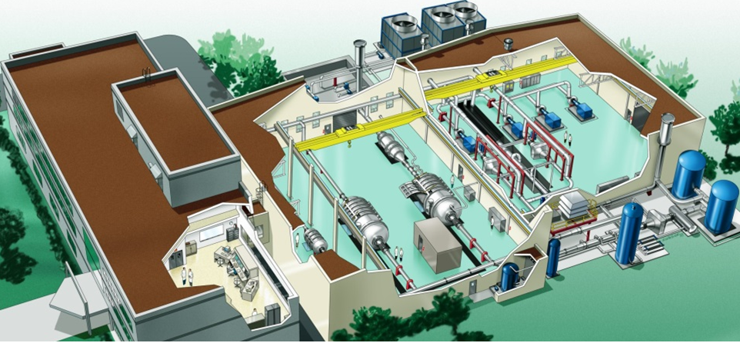
Figure 1: Altitude Engine Test Facility in KARI

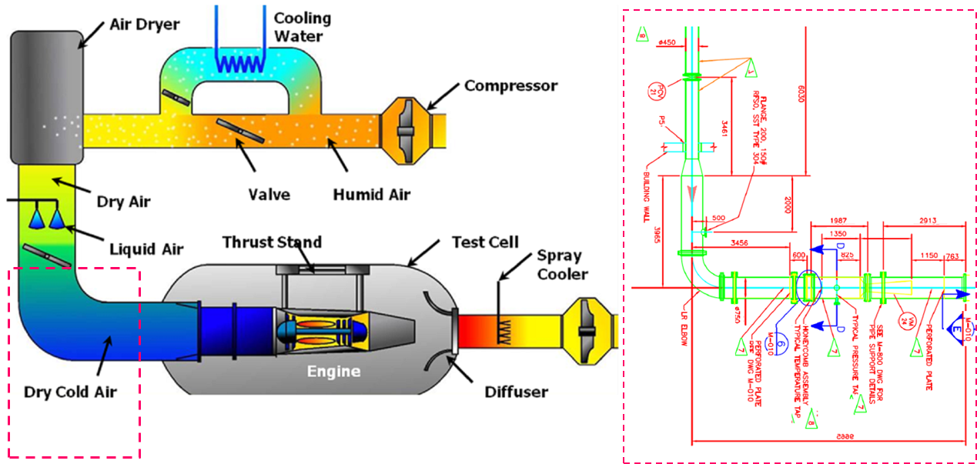
Figure 2: Air supplying system of AETF

The air flow rate into an engine is measured in the front of the test cell by a reference flowmeter, in this case a 30 inch Venturi flowmeter (Model BVF-IF, Badger Meter, Inc.) Air flow measurements using a reference meter cannot take into account the friction, the distortion of the velocity profile and the air leakage due to the stilling chamber, the bellmouth and sliding duct. Thus, in order to measure the actual air flow rate to be supplied to the tested engine more precisely, total pressure rakes, boundary-layer total pressure rakes and total temperature rakes installed in an engine inlet duct are used, as shown in Figure 3. The air flow rate into the tested engine is calculated by the area-weighted average duct Mach number in the engine inlet duct with the total pressure and temperature rakes. However, to maintain the reliability of air flow rate measurement in altitude engine test, this test method with the total pressure and temperature rakes in the engine inlet duct should be calibrated by flow measurements traceable to international standards.

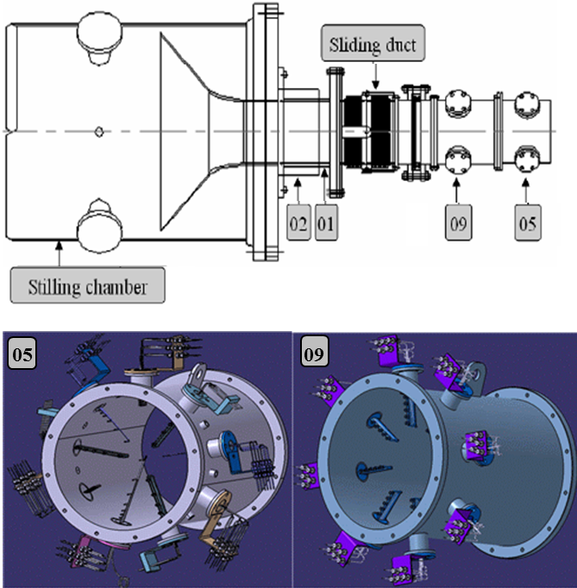
Figure 3: Engine inlet flow measurements devices with the total pressure and temperature rakes in the inlet duct

In the present study, in order to verify the air flow rate measurement at the engine inlet duct of the KARI altitude engine test facility, inlet flow measurement devices, i.e., a total pressure rake, a total temperature rake and a boundary-layer rake were tested in the high pressure gas flow standard system of Korea Research Institute of Standards and Science (KRISS). A sonic nozzle calibrated by the gravimetric flow standard at KRISS was used as a reference meter with a flow rate up to 10,000 m³/h, pressure range up to 50 bar and an expanded uncertainty(k=2) value of 0.18%. Air flow rates obtained by the area-weighted average duct Mach number in inlet flow measurement devices of the KARI engine inlet duct were compared with reference flow rates of sonic nozzles at KRISS up to Ma=0.15.

2. Experimental apparatus

2.1 Engine inlet flow measurement devices
The engine inlet flow measurement devices at the AETF of KARI consisted of three total pressure rakes, three boundary-layer total pressure rakes, three total temperature rakes and nine static pressure ports in the engine inlet duct (05 section) shown in Figure 3. In the present study, to verify the engine inlet flow measurement methodology used to calculate the area-weighted average duct Mach number, a total pressure rake, a boundary-layer total pressure rake, a total temperature rake and the engine inlet duct with three static pressure holes were manufactured as identical to the measurement devices of KARI. Figure 4 shows the manufactured rakes, which are a Kiel-type total temperature rake (5 pts.), a total pressure rake (6 pts.) and a boundary-layer rake (5 pts.). Table 1 shows the location of each measurement point of the rakes in the engine inlet duct, which has a diameter of 264 mm and a length of 324 mm. The total pressure rake, boundary-layer total pressure rake and total temperature rake were installed at the each 120° degree in the circumferential direction of the manufactured inlet duct.
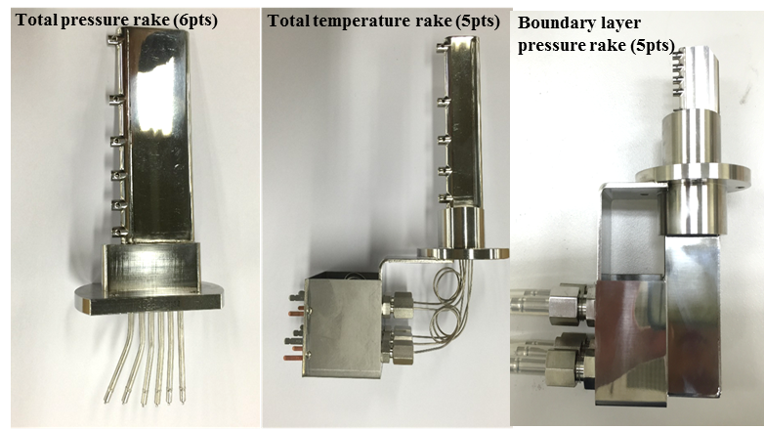
Figure 4: total pressure rake, total temperature rake, boundary-layer pressure rake

Table 1: Measurement points of the rakes in the engine inlet duct
Total pressure rake |  | Total temperature rake |  | Boundary-layer  pressure rake
No. Pts | Distance from center (mm) | No. Pts | Distance from center (mm) | No. Pts | Distance from center (mm)
#1 | 38.1 | #1 | 41.7 | #1 | 108.0
#2 | 66.0 | #2 | 72.3 | #2 | 112.5
#3 | 85.2 | #3 | 93.3 | #3 | 117.0
#4 | 100.8 | #4 | 110.4 | #4 | 121.5
#5 | 114.3 | #5 | 125.2 | #5 | 129.o
#6 | 126.4 | - | - | - | -

2.2 High pressure gas flow standard system of KRISS
The air flow rate measurements in the engine inlet duct were conducted in the high pressure gas flow standard system of KRISS. As shown in Figure 5, the flow facility is a blow-down type, which generates steady air flows within the pressure range of 0.1 to 5 MPa with two compressors, storage tanks, a temperature-control loop and two control valves. The maximum flow rate is 10,000 m³/h at standard conditions (101.325 kPa and 293.15K). The extended uncertainty (k=2) is 0.18 % [3]. The sonic nozzle (ISO 9300) used as a reference meter was calibrated by a gravimetric standard with a fast acting diverter and a weighing tank [4]. The engine inlet flow measurement devices including the inlet duct, the total temperature rake, the total pressure rake and the boundary-layer pressure rake were installed at the Device Under Test (DUT) location downstream of the reference meter in the KRISS facility. The maximum flow velocity in the installed inlet duct is Ma 0.15

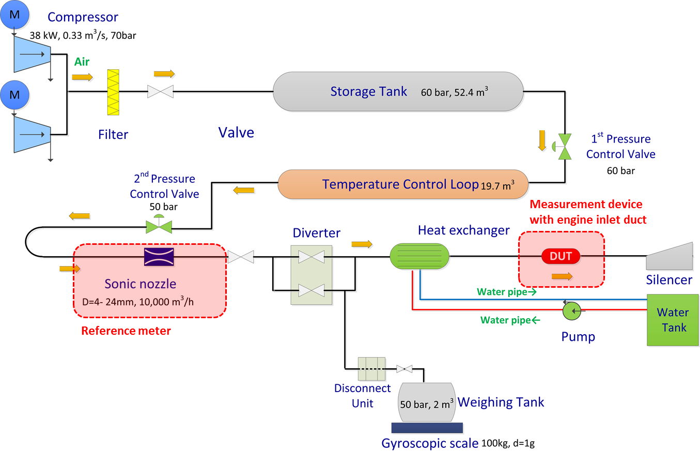
Figure 5: High pressure gas flow standard system of KRISS
Figure 6 shows the data acquisition equipment and the installation of the measurement devices with inlet duct which were in the DUT location of the KRISS facility. A multi-channel pressure scanner (Scanivalve DSA 3217, 16 channel, 10-inch H₂O) was used to measure the pressure from the total pressure and boundary-layer pressure rakes. Thermo-couple DAQ device (NI C-RIO, NI TB9214) measured five temperatures in the total temperature rake. Static pressure levels in the inlet duct were measured through three static pressure ports in the duct by a pressure indicator (RUSKA 7220, 36 psi)

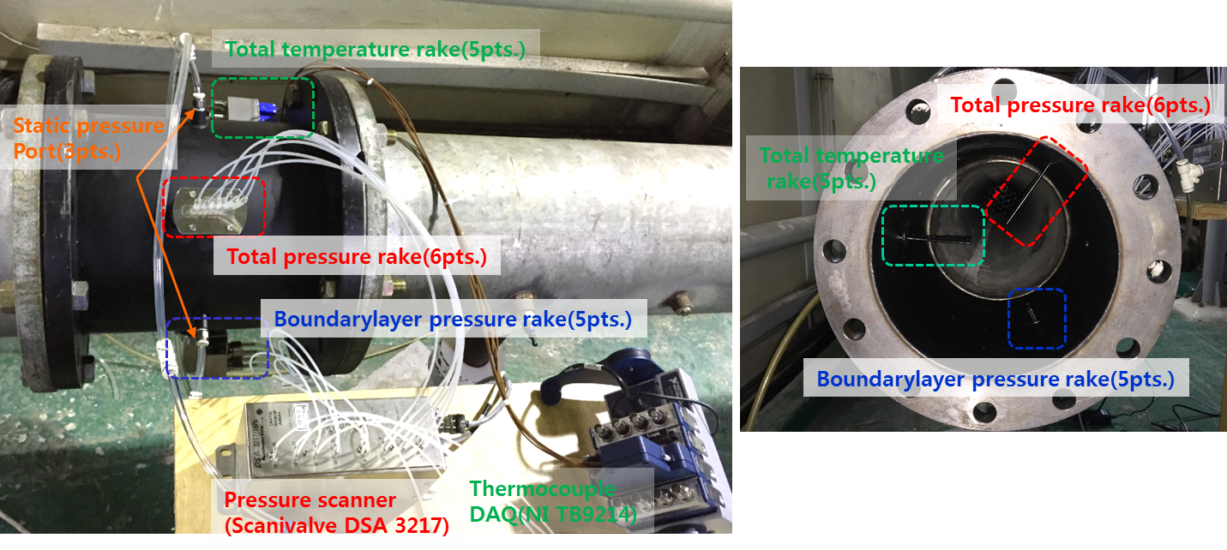
Figure 6: The data acquisition equipment and the installation of the measurement devices with inlet duct

3. Results and discussion

3.1 Air flow rate measurement by the area-weighted average duct Mach number
The air flow rates into the engine inlet duct were calculated by the area-weighted average duct Mach number with the total temperature rake, the total pressure rake, the boundary-layer pressure rake and static pressure ports via the following procedure [4]. The duct Mach number (M_{Duct}) at the inlet duct is defined by Equation (1).

$M_{Duct,i}=\sqrt{\frac{2}{γ-1}\left[{\left(\frac{P_{i}}{PS}\right)}^{\frac{γ-1}{γ}}-1\right]}$ (1)

where P_{i} is the total pressure value of each points measured by the six points the total pressure rake. PS is the average static pressure measured by the three static pressure ports. γ is the ratio of the specific heat of air.

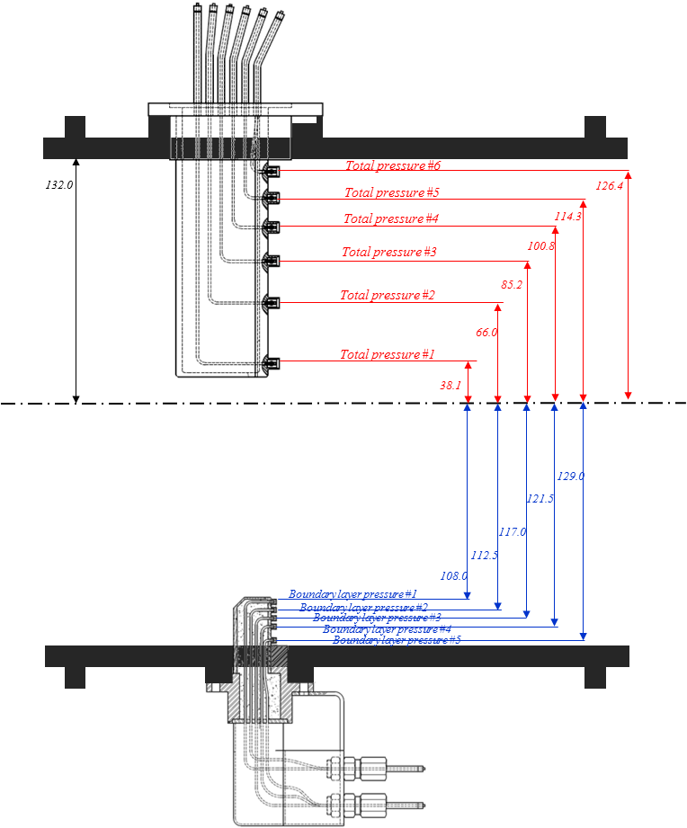
Figure 7: The locations of each of the points in the six points total pressure rake and the five points boundary -layer pressure
Figure 7 shows the locations of each points of the six points total pressure rake and the five points boundary -layer pressure rake. The duct Mach number between adjacent two rake points were calculated by averaging the two duct Mach numbers as shown in table 2.

Table 2: Area-weighted duct Mach number
Rake # | Duct Mach Number | Loca  -tion | Duct Mach number between two rake pts | Area-weighted  ratio (A_{w})
wall | M_{Duct,12} | 132.0 | 0.5Ⅹ(M_{Duct,11+}M_{Duct,12}) | 0.0449
Boundary P #5 | M_{Duct,11} | 129.0 | 0.5Ⅹ(M_{Duct,10+}M_{Duct,11}) | 0.0381
Total P #6 | M_{Duct,10} | 126.4 | 0.5Ⅹ (M_{Duct,9+}M_{Duct,10}) | 0.0697
Boundary P #4 | M_{Duct,9} | 121.5 | 0.5Ⅹ (M_{Duct,8+}M_{Duct,9}) | 0.0616
Boundary P #3 | M_{Duct,8} | 117.0 | 0.5Ⅹ (M_{Duct,7+}M_{Duct,8}) | 0.0358
Total P #5 | M_{Duct,7} | 114.3 | 0.5Ⅹ (M_{Duct,6+}M_{Duct,7}) | 0.0234
Boundary P #2 | M_{Duct,6} | 112.5 | 0.5Ⅹ (M_{Duct,5+}M_{Duct,6}) | 0.0569
Boundary P #1 | M_{Duct,5} | 108.0 | 0.5Ⅹ (M_{Duct,4+}M_{Duct,5}) | 0.0863
Total P #4 | M_{Duct,4} | 100.8 | 0.5Ⅹ (M_{Duct,3+}M_{Duct,4}) | 0.1665
Total P #3 | M_{Duct,3} | 85.2 | 0.5Ⅹ (M_{Duct,2+}M_{Duct,3}) | 0.1666
Total P #2 | M_{Duct,2} | 66.0 | 0.5Ⅹ (M_{Duct,1+}M_{Duct,2}) | 0.1667
Total P #1 | M_{Duct,1} | 38.1 | M_{Duct,1} | 0.0833

The area-weighted average duct Mach number (M_{Duct,avg}) were determined by Equation (2), as follow:

$M_{Duct,avg}=\sum_{i=0}^{11}{\left[A_{w,i}×(0.5×(M_{Duct,i}+M_{Duct,i+1})\right]}$ (2)

The static temperature (TS) in the inlet duct was calculated using the average duct Mach number (M_{Duct,avg}) and the averaged total temperature, which were measured and averaged using the five points total temperature rake with Equation (3) below.

$TS=\frac{{TS}_{avg}+273.15}{(1+\frac{γ-1}{2}M_{Duct,avg})}$ (3)

The speed of sound (SS) can be calculated using Equation (4).

$SS=\sqrt{γ×R×TS}$ (4)

where R is the gas constant of air, i.e., 287.04. The average velocity (V) in the inlet duct was determined using Equation (5).

$V=M_{Duct,avg}×SS$ (5)

Finally, the air flow rate (WA) in the inlet duct according to the area-weighted average duct Mach number can be calculated by Equation (6) with the total temperature rake, the total pressure rake, the boundary-layer pressure rake and static pressure ports.

$WA=ρ×A×V$ (6)

where ρ is the density of air in the inlet duct and A is the cross-section area of the inlet duct at which the total temperature and pressure rakes were installed.

3.2 Air flow rate measurement in engine inlet duct at the KRISS high pressure gas flow standard system
The air flow rate measurements in the engine inlet by the total temperature rake, the total pressure rake and the boundary-layer pressure rake were conducted at the high pressure gas flow standard system of KRISS. Figure 8 shows the results of the duct Mach numbers for each point of the total and boundary layer pressure rakes with respect to different air flow rates of the reference meter at the KRISS facility. As the air flow rate increases from 0.85 kg/s to 3.38 kg/s, the duct Mach number for the cross-sectional area of the inlet duct increases. Velocity distributions of the duct Mach number with respect to radial locations of the inlet duct shows typical fully developed turbulent flow velocity profile. In numerous empirical velocity profiles for turbulent pipe flow, the simplest and the best known is the power-law velocity profile express as Equation (7)

$\frac{V}{V_{max}}={(1-\frac{r}{R})}^{1/n}$ (7)

where r is the radius of pipe and the exponent n is a constant whose value depends on the Reynolds number. The value n=7 generally approximate many flows in practice, giving rise to the term one-seventh power-law velocity profile [6].

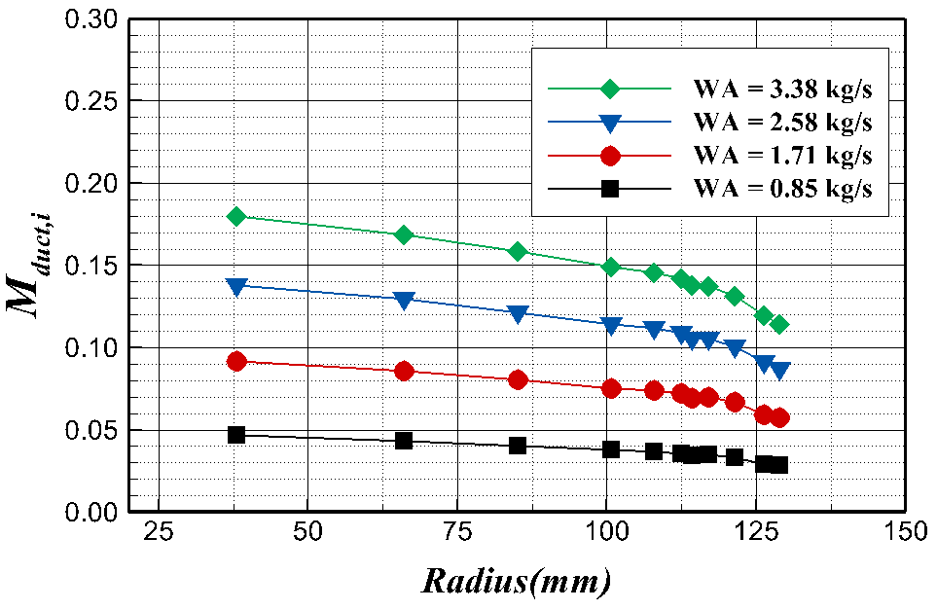
Figure 8: Duct Mach number (M_{Duct,i} ) in the inlet duct for WA=0.85, 1.71, 2.58 and 3.38 kg/s
Figure 9 shows the normalized duct Mach numbers in the cross-sectional area of the inlet duct for three air flow rate conditions calculated through dividing with the average duct Mach number (M_{Duct,i} / M_{Duct,avg}). All duct Mach number distributions overlapped with one-seventh power-law velocity profile. In other words, the air flow rate measurements have good uniformity in the form of the normalized duct Mach number.

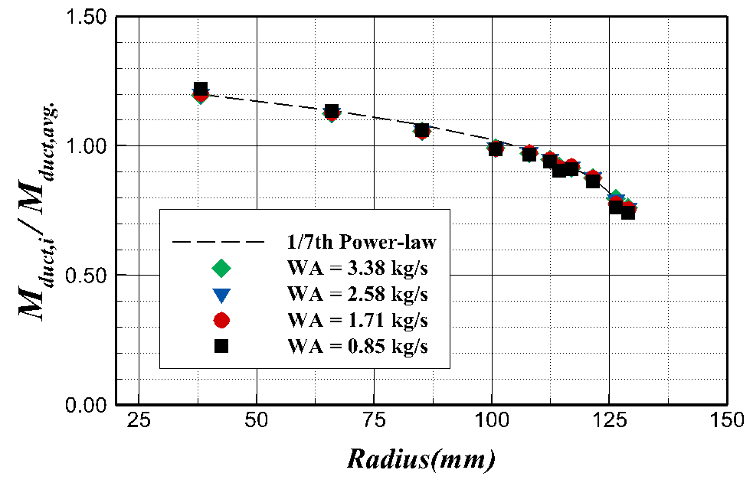
Figure 9: Normalized Duct Mach number (M_{Duct,i} / M_{Duct,duct} ) in the inlet duct for WA=0.85, 1.71, 2.58, 2.52 kg/s and 1/7th Power-law velocity profile.
Figure 10 shows a comparison of results of air flow rate measured by the area-weighted duct Mach number methodology with reference flowmeter, i.e., the sonic nozzle. The air flow rates obtained by area-weighted duct Mach number were found to have as lower flow rate values than that of the reference meter. As the air flow rate increases, the deviation of measured flow rate values between the area-weighted duct Mach number and the reference meter increases from 0.57% to 1.63%. In the altitude engine test, the air flow rate values measured by inlet duct with the total temperature, the total pressure and the boundary-layer pressure rakes would be corrected with the above comparison results with respect to the air flow rate conditions.

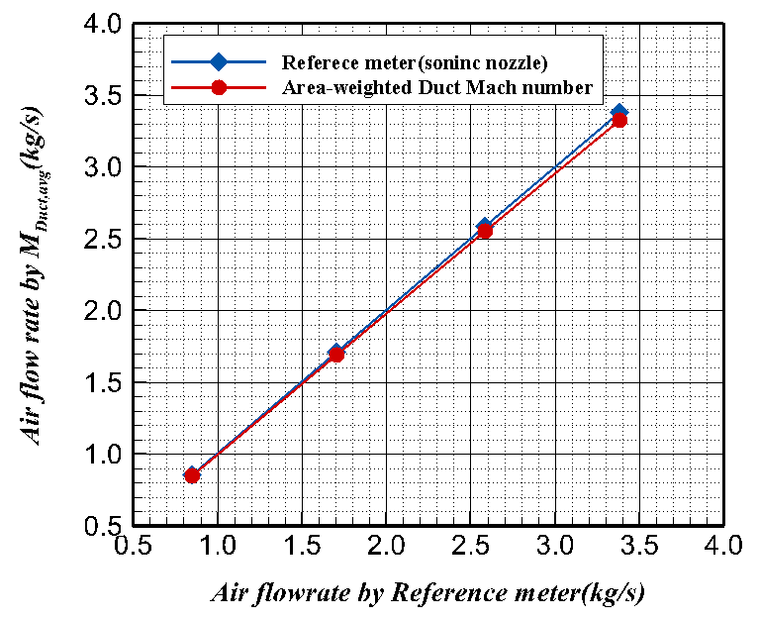
Figure 10: Comparison of air flow rate measurements obtained with the area-weighted duct Mach number with the reference meter (sonic nozzle)

4. Conclusion

The air flow rate in the altitude engine test for flight a vehicle is one of the most significant parameters to consider when calculating the typical performance values of the net thrust and the specific fuel consumption of a gas turbine engine. In the altitude engine test facility of KARI, the air flow rate into the tested engine are calculated using the area-weighted average duct Mach number methodology in the engine inlet duct with the total temperature, the total pressure and boundary-layer pressure rakes. In the present study, in order to verify the air flow rate measurement at the engine inlet duct of altitude engine test facility, inlet flow measurement devices of the total temperature rake, the total pressure and boundary-layer rake were tested in the high pressure gas flow standard system of KRISS with traceability to international standards.
The air flow rate calculated by the installed rakes in the inlet duct with the area-weighted average duct Mach number were compared with the air flow rate measured by reference meter, i.e. the sonic nozzle at the KRISS facility. Velocity distributions by the area-weighted average duct Mach number in the cross-sectional area of the inlet duct were measured and found to have a typical turbulent flow velocity profile with one-seventh the power-law velocity distribution. The air flow rate measurements show good uniformity in the terms of normalized duct Mach numbers. In the comparison of air flow rate measured by the area-weighted duct Mach number with those of the reference flowmeter, the air flow rate obtained by the area-weighted duct Mach number were found to be lower than that of the reference meter. As the air flow rate increases, the deviation in the measured flow rate values between the area-weighted duct Mach number and reference meter increase from 0.57% to 1.63%.

References

[1] Lee J. K., Yang I. Y., Yang S. S. and Kwak J. S., “Uncertainty analysis of ANOVA for the measurement reliability estimation of altitude engine test”, Journal of Mechanical Science and Technology, Vol. 21, 664-671, 2007
[2] Jun Y. M., Yang I. Y., Kim C. T., Yang S. S. and Lee D. S., “Uncertainty analysis and improvement of an altitude test facility for small jet engines”, KSAS International Journal, Vol.5, No.1, 46-56, 2004
[3] Choi, Y. M., Park, K-A., and Park, S. O., “Interference effect between sonic nozzles””, Flow Measurement and Instrumentation, Vol.8, No.2, 113-119, 1988
[4] ISO 9300: Measurement of gas flow by means of critical flow Venturi nozzles, 2005
[5] Lee, B. H., Lee, K. J., and Yang, S. S., “The prediction of air flow and pressure loss at inlet duct”, Journal of the Korean Society of Propulsion Engineers, Vol. 14, No.1, 48-55, 2010
[6] Pope, S. B., Turbulent flow (Cambridge University Press), 2000

