A Study On Wide Range Gas Flow Piston Prover

Chao Chen¹, Jinming Zhang², Yiping Liu³, Jinchuan Wu⁴

¹Shanghai Institute of Measurement and Testing Technology, No1500 Zhangheng Rd., Shanghai, China
²Shanghai Institute of Measurement and Testing Technology, Shanghai, China
³Shanghai Institute of Measurement and Testing Technology, Shanghai, China
⁴Shanghai Institute of Measurement and Testing Technology, Shanghai, China
E-mail:chenc@simt.com.cn

Abstract

In order to expand the flow range of piston prover, and improve the calibration efficiency of small gas flow meters, Shanghai institute of measurement and testing technology developed a new wide range gas flow piston prover, which is made of stepper motor, big and small pistons, piston cylinder, precision ballscrew, encoder, vacuum generator, pressure transmitter, temperature transmitter and control system. The piston prover is designed with vertical structure, the outer diameter of the piston is used as main traceable standard. The working pressure of piston prover can be adjusted from (0 ~ 10) kPa, it can be regulated flowrate accurately with perfect flow stability.The experiments show that the piston prover can calibrate all kinds of gas flow meters with flow range of (1 ~ 7000)ml/min, it can calibrate the flowmeters with suction method or exhaust method, especially suitable for calibration micro or small critical venturi nozzles, standard leak, soap film flowmeters, MFCs, laminar flowmeters and etc.

1. Introduction

With the rapid development of semiconductor manufacturing, biological engineering, medical and chemical industries, the flow measurement is to extend the low-end and the demand of the small gas flow measurement becomes more and more popular.

At present, most of the traditional measuring methods for small gas flow are always need long measurement time, low efficiency, high requirement of environment and difficult to adjust the small flow. In this paper, Shanghai Institute of Measurement and Testing Technology develops a new wide range gas flow piston prover which can calibrate gas flowmeters with fow range of (1 ~ 7000) mL/min in suction method or exhaust method. It also can control flowmeter’s upstream pressure with self-balance adjust mode, especially suitable for calibration micro or small gas flowmeters, such as critical venturi nozzle, standard leak etc^{[1]}.

- Composition and working principle of standard facility

2.1 Composition of standard facility
Standard facility is made of stepper motor, big and small pistons, piston cylinder, precision ballscrew, encoder, vacuum generator, pressure transmitter, temperature transmitter and control system. The pistons are driven by a stepper motor to produce a steady flow.
The structural diagram of the standard facility is shown in Figure 1. The standard facility is designed with vertical structure to avoid the infulence of piston gravity on seal and make piston move more stable. The outer diameter of piston is used as main traceable standard which can improve the precision of the piston. The double sealed method is used to ensure no leakage of the piston. The MUT is installed on top of the piston prover. The temperature transmitter and pressure transmitter are installed to measure the temperature and pressure inside the cylinder. The gas inlet is designed below the cylinder to ensure the gas inside the cylinder is active and fixed. The big and small pistons can produce different flowrate accurately and there is some overlap between two piston flow range.

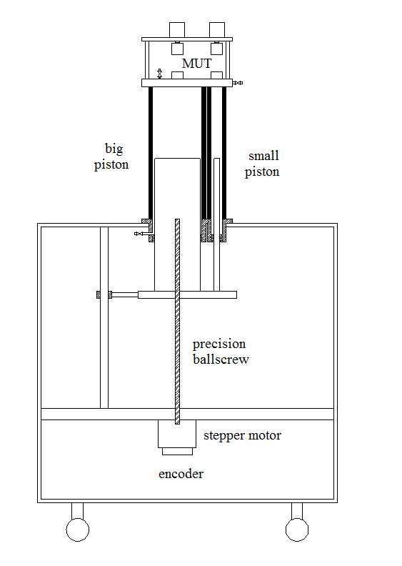
Figure 1：The structure diagram of gas flow piston prover

2.2 Measuring principle
The measuring principle of wide range gas flow piston prover can be divided into self-balance adjusting mode and non-balance adjusting mode.
When the standard facility is operated in the self-balance adjusting mode, open the inlet pipeline valve which is installed at the bottom of the cylinder, the stepper motor pulls the pistons down and sucks the gas into the piston cylinder. After the piston cylinder is filled with gas, switch on the vacuum generator,preset a flowrate, gas enters into cylinder from inlet valve, and passes through MUT. When starting a test, stepper motor reaches the preset speed. After stepper motor moving steadily, then close the inlet valve at the bottom of the cylinder, and the piston will continue moving at the preset speed. In this case, monitor the pressure trend inside the cylinder, if the pressure drops inside the piston, increasing the velocity of the stepper motor, otherwise decreasing the velocity of the stepper motor. Adjusting the speed of stepper motor until the pressure in cylinder is balance, the flowrate of flowmeter equals the flowrate of piston prover. Under this situation, gathering the pulse of encoder, signal of flowmeter, temperature and pressure of the piston and flowmeter synchronously. According to the effective diameter of the piston, piston’s traverse length, temperature and pressure, the reference mass flow of the flowmeter can be calculated.

The working principle of non-balance adjusting mode is similar as the working principle of self-balance adjusting mode, the difference is no necessary to control the pressure inside the cylinder to a certain value.

- Main technical specifications

3.1 Diameters of the piston
The diameters of the piston are measured by universal measuring machine. Firstly, measure the diameters every 50mm interval at the same direction. Secondly, rotate the piston at 90 degree angle and measure diameter 6 points. Finally, calculate the average of all the measurement points for the diameter of the piston^{[2]}. The results of the effective diameters are shown in Table 1.

Table 1: The measurement results of piston diameter.
Test points | The results of the small piston  (mm) |  | The results of the  big piston  (mm)
 | 0°direction | 90° direction | 0°direction | 90° direction
1 | 15.0032 | 15.0033 | 120.021 | 120.022
2 | 15.0035 | 15.0036 | 120.024 | 120.028
3 | 15.0031 | 15.0040 | 120.029 | 120.032
4 | 15.0042 | 15.0037 | 120.027 | 120.034
5 | 15.0041 | 15.0036 | 120.025 | 120.031
6 | 15.0042 | 15.0032 | 120.022 | 120.033
The average diameter  (mm) | 15.0036 | 120.027 | 15.0036 | 120.027
Uncertainty of diameter | 0.003% |  | 0.004%

3.2 Traverse length of the piston
The traverse lengths of the piston are measured by laser interferometer. According to the requirement of the piston’s minimum gas consumption, from the starting position of the piston, the traverse lengths are measured every 20mm of the full piston length. The traverse lengths of piston results are shown in Table 2.

Table 2:The measurement results of traverse length.
Test position  (mm) | Traverse length  (mm) | Laser interferometer  (mm) | Error  (mm)
20 | 20.8253 | 20.8300 | -0.0047
40 | 20.0627 | 20.0632 | -0.0005
60 | 19.7863 | 19.7876 | -0.0013
80 | 20.8873 | 20.8912 | -0.0039
100 | 19.2497 | 19.2465 | 0.0032
120 | 20.0920 | 20.0918 | 0.0002
140 | 20.0412 | 20.0423 | -0.0011
160 | 19.6315 | 19.6355 | -0.0040
180 | 20.5807 | 20.5830 | -0.0023
200 | 19.7570 | 19.7568 | 0.0002
220 | 20.0724 | 20.0715 | 0.0009
240 | 20.0758 | 20.0681 | 0.0077
260 | 19.7882 | 19.7933 | -0.0051
280 | 20.1125 | 20.1075 | 0.0050
300 | 19.6471 | 19.6513 | -0.0042
Total | 300.6098 | 300.6196 | -0.0098

3.3 Technical specification for piston prover
The flow range of the standard facility is (1 ~ 7000) ml/min, of which the big piston’s flow range is (60 ~ 7000) ml/min and the small piston’s flow range is (1 ~ 100) ml/min. The expanded uncertainty U_{rel}=0.06%（k=2）. The stability of standard facility is better than 0.10%. There is an overlapping flow range between two pistons. The internal comparison can be performed by the two pistons respectively. The picture of wide range gas flow piston prover is shown in Figure 2.

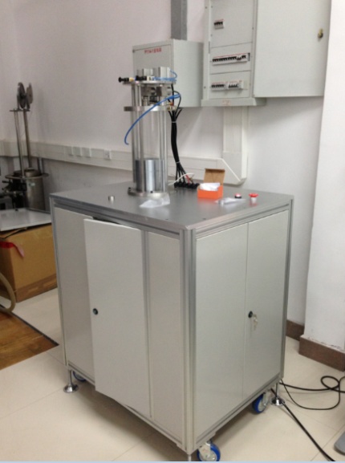

Figure 2:the picture of wide range gas flow piston prover

- Data Processing Method

According to the measurement principle of piston prover^{[3]}, the mass change of gas in the cylinder during a measurement equals:
（1）
Where:is the mass change of gas in the cylinder,is the mass of gas at the beginning of the measurement；is the mass of gas at the end of the measurement； is the volume of cylinder；is the diameter of piston；is piston traverse length；is the density of gas at the beginning of measurement；is the density of gas at the end of measurement.
By the law of the fluid, the reference volume flow at the MUT equals:
（2）
Where：V_{m} is the reference volume at the MUT；
ρ_{m} is the density of gas at the MUT.
The volume flowrate at the MUT equals：
（3）
Where： is time of measurement.

- Experiments

5.1Measuring the critical venturi nozzle
Experiment sample：3 critical venturi nozzles provide by Shkrom co., Ltd.
The big piston is used as standard which the effective volume is 3958mL and the flow range is （60～7000）ml/min. The expanded uncertainty U_{rel} =0.06% （k = 2）.
Test method：Gas flow piston prover is used in self-balance adjusting mode to control the pressure of the cylinder to the atmospheric pressure^{[4] [5]}. Under this situation, the 3 different critical nozzles are measured for 6 times continously and calculate the repeatability. The measurement results are shown in Table 3.

Table 3：The test results of critical venturi nozzles L/h
Sequence | Nozzles serial no.
 | 03-206-16 | 05-300-25 | 98-606-40
1 | 15.8299 | 24.3266 | 40.7589
2 | 15.8295 | 24.3266 | 40.7589
3 | 15.8299 | 24.3264 | 40.7588
4 | 15.8302 | 24.3268 | 40.7583
5 | 15.8303 | 24.3268 | 40.7588
6 | 15.8294 | 24.3261 | 40.7589
Average | 15.8299 | 24.3266 | 40.7588
Reapeatability | 0.002% | 0.001% | 0.001%

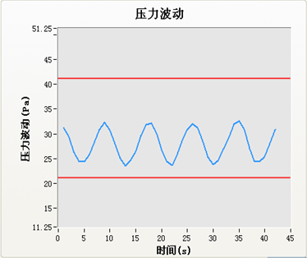
Figure 3:The pressure fluctuation curve inside the piston

The pressure fluctuation curve inside the cylinder during measurement the critical venturi nozzle is shown in Figure 3. From the Figure 3, the pressure fluctuation of cylinder doesn’t exceed 10Pa during the experiment. The measurement efficiency is very high, it only takes 10 minutes to calibrate a critical venture nozzle.

5.2 Standard gas leak
Experiment sample：A standard gas leak provides by Goldcard high-tech co., Ltd. The inlet pressure is 10kPa and the nominal flowrate is 1.024ml/min. The standard gas leak is shown in Figure 4.

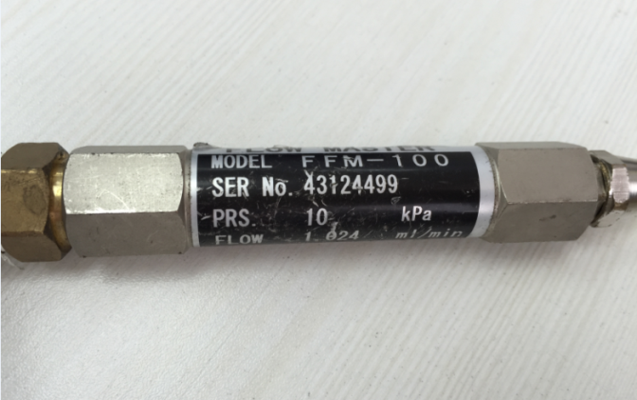

Figure 4：The picture standard gas leak

The small piston is used as standard which the effective volume is 61.85mL and flowrate is （1～100）ml/min. The expanded uncertainty U_{rel} =0.06% (k = 2).

Test method：Gas flow piston prover is used in self-balance adjusting mode to control the pressure of the cylinder to 10kPa, the pressure cylinder fluctuation in cylinder is below 5Pa. Under this situation, the standard gas leak is measured three times continuously. The measurement results are shown in Table 4.

Table 4：The test result of standard gas leak
Sequence | Nominal flowrate  (ml/min) | Piston flowrate  (ml/min) | Average  flowrate  (ml/min) | Repeatability  %
1 | 1.024 | 0.9438 | 0.9433 | 0.07
2 |  | 0.9425
3 |  | 0.9435

6. Result comparison

6.1 Comparison between big and small piston
Compare between the big piston and small piston of gas flow piston prover with a steady laminar flowmeter respectively. The results are shown in Table 5.
Table 5：The results between big and small piston
Sequence | Flowrate  (ml/min) | Small piston  error | Big piston  error | Deviation
1 | 60 | -0.45% | -0.38% | 0.07%
2 | 80 | -0.39% | -0.33% | 0.06%
3 | 100 | -0.32% | -0.27% | 0.05%

Due to the expanded uncertainty of gas flow piston prover U₁=0.06% （k=2）, the comparison method for verification^{[6]},the acceptable deviation shouldn’t exceed U_{d1}=0.08% when using two deferent pistons to measure the same laminar flowmeter.

From table 5, the maximum deviation between the two pistons is 0.07% which is less than 0.08%. So the uncertainty of gas flow piston prover meets the requirements.

6.2 Comparison between different facility
Compare between the LBME lab in German and the gas flow piston prover by 3 critical venturi nozzle respectively. The results are shown in table 6.

Table 6：LBME-SIMT comparision results
Nozzles serial no. | nominal flowrate  (ml/min) | LBME  Flowrate  (ml/min) | SIMT  Flowrate  (ml/min) | Deviat-ion
03-206-16 | 16 | 15.820 | 15.8299 | 0.06%
05-300-25 | 25 | 24.301 | 24.3266 | 0.11%
98-606-40 | 40 | 40.736 | 40.7588 | 0.06%

Due to the expanded uncertainty of gas flow standard facility of LBME U₂= 0.20% (k =2), the comparison method for verification^{[5]} ,the acceptable deviation shouldn’t exceed U_{d2}=0.21% when using two deferent standard facility to measure the same critical venturi nozzle.

From table 6, the maximum deviation between the gas standard facility is 0.11% which is less than 0.21%. So the uncertainty of gas flow piston prover meets the requirements.

Conclusion

SIMT developed a wide range gas flow piston prover successfully.The big and small pistons have been used in the standard facility which can cover a wide flowrate range.It can calibrate gas flowmeters with flow range of (1 ~ 7000) mL/min in suction method or exhaust method.It also can be regulated flowrate easily with perfect flow stability. The experiments show that the piston prover can calibrate all kinds of gas flow meters with high efficiency.

References

- Chunhui Li, Chi Wang, Dongwei Wang, Analysis on uncertainty of Sonic Nozzle gas flow standard device, Measurement Technique, (3):66~68,2007.
- Chi Wang, Analysis on uncertainty of flow measurement, Beijing:China Metrology Publishing House, 2002.
- Yanxun Su, Guowei Liang. Jian Sheng, Flow Metrology and Measurement（second edition） Beijing：China Metrology Publishing House,2007.
- ISO9300-1990: Measurement of gas flow by means of critical flow venturi nozzles, 2004.
- Guowei Liang, Ningning zhou, The principle and application of critical flow venturi nozzle flowmeters, Journal of China Jiliang Unversity, 15 (3): 0186～0190,2006.
- JJF1117-2004: Specification for Comparison of Measuring Instrument, Beijing, China Metrology Publishing House, 2004.

