Experimental study of buoyancy and surface tension effects of an immersed capillary gravimetric micro-flow facility

**F. Ogheard1, S. Margot1, J. Savary1**

*1LNE-CETIAT, 25 avenue des Arts, Villeurbanne, France*

*E-mail (corresponding author): florestan.ogheard@cetiat.fr*

# Abstract

LNE-CETIAT reference micro-flow rate facility uses the start/stop gravimetric method to determine the reference flow rate. The flow range of this facility is between 1 g.h-1 and 10000 g.h-1. The method requires the weighing of a liquid mass over a measured interval of time in order to calculate the reference mass flow rate. To insure the continuity of the flow (i.e. to avoid dripping effect) for flow rates down to 1 g.h-1, a capillary, from which the liquid flows out, is constantly immersed in the water in the container on the scale during the measurement time. The main drawback of this method lies on the consideration of two additional biasing effects on the weighed mass, which has to be included in the uncertainty budget. The first one is the buoyancy effect due to the additional volume of the capillary immersed in the weighed mass of water in the container. The second one is the possible variation of the surface tension effect during the rise of the water along the capillary. This article presents the experimental set up developed and used to quantify those uncertainty sources, as well as the results obtained.

# 1. Introduction

The French primary standard for liquid micro-flow, inaugurated and accredited in 2012 at LNE-CETIAT liquid flow laboratory (French Designated Institute for liquid – water – flow standards), is based on a start/stop gravimetrical method and is described in reference [1].

The flow range capability of this facility scales between 1 g.h-1 and 10000 g.h-1. Due to this large range, several weighing scales are used to be able to weigh an adequate mass of water for each flow rate. Figure 1 below shows a simplified schematic of the facility and Figure 2 shows a picture of the 4 weighing scales used in the facility.

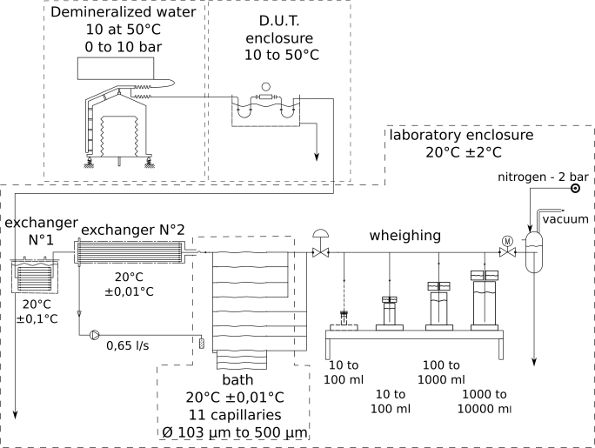

Figure 1: Schematic of the working principle of the facility at LNE-CETIAT.

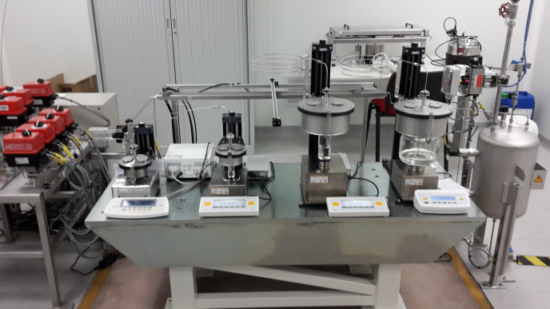

Figure 2: Picture of the weighing section inside a clean room.

Four weighing scales are used, for flow rates respectively from 1 g.h-1 to 10 g.h-1, 10 g.h-1 to 100 g.h-1, 100 g.h-1 to 1000 g.h-1, and 1000 g.h-1 to 10000 g.h-1. This allows having an appropriate weighing resolution on the entire flow rate range. Each of the weighing scale is dedicated to weigh a specific amount of water, respectively 0.5 g, 5 g, 50 g, and 500 g from the smallest to the biggest weighing scale.

As the reference mass flow rate is the ratio between the weighed mass and the time duration to reach this mass in the tank, the main uncertainty sources come from the uncertainty on the weighed mass and from the uncertainty on the measurement duration.

While a very low uncertainty on the time interval between the start and the stop of the measurement point is very low to achieve due to high precision timing electronics, the uncertainty on mass is harder to be evaluated and reduced, especially when dealing with small masses of liquids in a dynamic system such as a micro-flow calibration bench.

In this paper, we will first describe the weighing systems to underline its critical aspects by looking at the uncertainty budget on mass measurement. We will explain the calculation of the critical uncertainty sources on mass measurement as theoretically calculated prior to this paper. Next, the experiment implemented to quantify these parameters and a discussion on the results obtained will be presented.

# 2. The weighing system of the French liquid micro-flow standard

*2.1 Description of the weighing systems*

Each of the four weighing systems is composed of the 4 main parts as shown in Figure 3.

Referring to Figure 3, which shows the weighing systems with the biggest scale, those parts are:

* A: a capillary immersed in the water to be weighed, with different inner and outer diameters depending on the flow rate range of the weighing apparatus,
* B: a saturated tank, not in mechanical contact with the weighing tank. This saturator avoids evaporation during measurement,
* C: a weighing tank, with a neck to link the air above the water in the tank to the air in the saturator, and a cambered bottom to homogenise the mass of water on the weighing scale plate,
* D: an electronic high precision weighing scale with appropriate full scale and resolution.

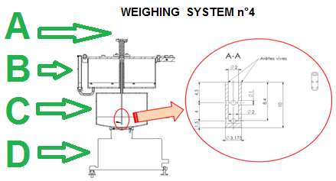

Figure 3: Schematic of weighing apparatus n°4 (biggest weighing scale) of the facility at LNE-CETIAT.

In order to avoid the supplementary uncertainty source that would come from the impact of the water jet on the bottom of the weighing tank, small holes are drilled on the sides of the head of capillary, from which the water flows during the measurement (see close-up at the right hand side of Figure 3).

*2.2 Overview of the uncertainty budget on mass*

Mass measurement is derived from the following equation 1:

 (1)

With:

* mread i the mass measurement done at the time “i”,
* Δmcapillary a correction on the mass evaluation due to the buoyancy effect of the water on the capillary,
* Δmsurface_tension a correction on the mass evaluation due to the variation of surface tension on the capillary.

*2.2.1 Direct mass measurement uncertainty*

The uncertainty on mass measurement (mread i) can be divided in several sources due to the weighting cells (resolution, calibration, repeatability, drift). The influences of weighing cells resolutions are all negligible (less than 6x10-6). Calibrations done within the scope of COFRAC accreditation or equivalent and taking into account several uncertainty sources (resolution, references mass, environment, repeatability) is followed annually for all the weighing cells.

*2.2.2 Theoretical error due to buoyancy effects*

The Archimedes effect is directly proportional to the volume of the capillary under the free surface of water:

 (2)

With:

* “Dtube” the external diameter of the tube,
* “Dtank” the internal diameter of the tank,
* “H” the height of capillary under the free surface,
* “ρw”the water density in the tank.

Given the numerical values on the parameters above, uncertainty of:

 (3)

and

 (4)

are found respectively for the weighing system n°1 (equation 3) and weighing systems n°2, 3, and 4 (equation 4).

*2.2.3 Theoretical error due to surface tension effects*

Due to the presence of a capillary in contact with the fluid to be weighted, capillary effects appear.

The indicated mass has to be corrected to be coherent with its “true” value. In theory, the capillary forces are constant during the filling of the weighing tank. The capillary effect is then suppressed in the final mass measurement (obtained by mass subtraction).

The component Δmsurface tension highlights the irregularities in surface tension due to random effects and irregularities in capillary production. Then:

 (5)

With:

* “Dext” the external diameter of the tube (m),
* “σ” the surface tension coefficient for stainless steel/air/water interface (N/m),
* “g” the gravity constant (g = 9,81 m.s-2)

Due to the lack of experimental measurements prior to the experiment described in the next chapter of this article, we assume that the maximum variation of the surface tension effect corresponds to half of the complete suppression of the capillary forces (pessimistic).

The uncertainty on the Δmsurface tension factor can then be calculated as follow:

 (6)

Knowing the capillary diameter and the surface tension coefficient, the corresponding uncertainty can be calculated for each weighing system (respectively n°1 to 4 for the equation 7 to 10) as follows:

 (7)

 (8)

 (9)

 (10)

# 3. Experimental evaluation of capillary buoyancy and surface tension effects

*3.1 Description of the experiment*

During the measurement process, the water level rises along the capillary, from a given and repeatable initial level to a given and repeatable final level corresponding to the filling of respectively 0.5 ml, 5 ml, 50 ml, and 500 ml for the weighing systems n°1 to n°4.

To be able to quantify the buoyancy and surface effect without involving any other sources of biases on the mass measurement, a simple experiment, as shown on the schematic in Figure 4, has been performed.



Figure 4: Principle of the experiment performed to evaluate buoyancy and surface tension effects on the mass measurement.

In step 1 (see Figure 4), the level of water around the capillary corresponds to that of the initial level of water at the start of a flow measurement. In step 2, we decrease the altitude of the capillary, by known and regular steps, until it reaches an altitude where in step 3, the level of water around the capillary corresponds to that of the final level of water at the end of a flow measurement. The mass measured by the weighing scale is continuously recorded. During this process, the whole capillary is filled with water, but there is no flow going through it due to a closed valve upstream of the weighing system.

In practice, a stepper motor driving a vertical linear stage lifting the saturator + capillary ensemble is programmed to periodically rise the system of given length value, measured by a calibrated height gauge. A dampening spring shape pipe is used upstream of the capillary in order to avoid any vibration or stress on the capillary during the process. Figure 5 shows a photograph of the apparatus.

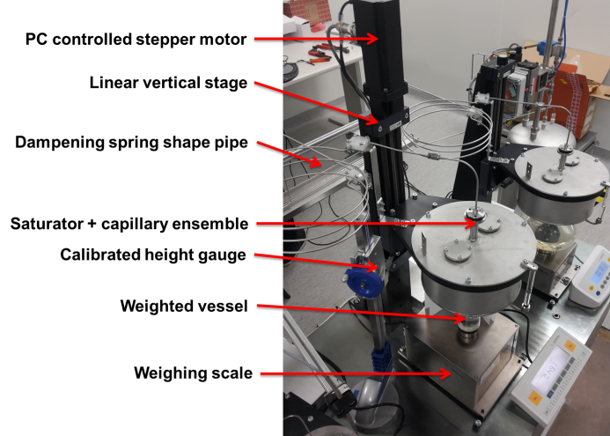

Figure 5: Picture of the experiment performed to evaluate buoyancy and surface tension effects on the mass measurement.

*3.2 Experimental results*

*3.2.1 Weighing system n°1*

The Figure 6 hereafter shows the experimental results obtained for the weighing system n°1.

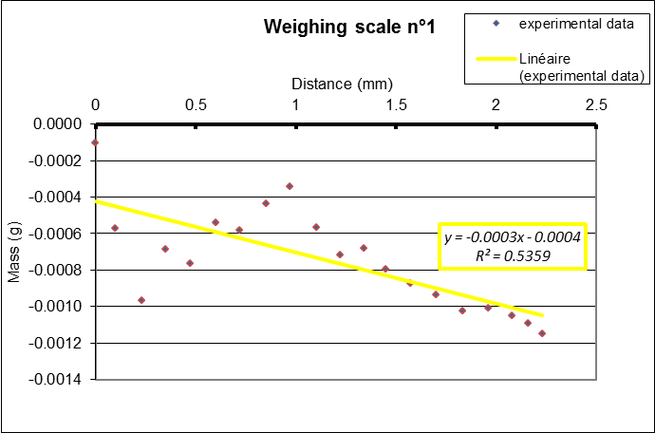

Figure 6: Experimental results of the buoyancy and surface tension evaluation for the weighing system n°1.

As the capillary is cylindrical and vertical on the level variation between start and stop of the measurement, a straight line from zero to the maximum buoyancy would be obtained if there was no surface tension effect.

On the contrary, results show significant variation from a linear model. Thus, the error due to surface tension effect is the maximum discrepancy between the linear model and the experimental data and the buoyancy effect is the absolute value of the difference between masses at initial and final levels.

Then, for the weighing scale n°1, we find a buoyancy effect of about 0.21 % of the measured mass (0.02 % in the theoretical evaluation) and a surface tension effect of 0.1 % (0.5 % in the theoretical evaluation).

If we sum up buoyancy and surface tension effects, experimental analysis gives a total error of 0.3 % on the measured mass (0.52 % in the theoretical evaluation).

*3.2.2 Weighing system n°2*

The Figure 7 hereafter shows the experimental results obtained for the weighing system n°2.

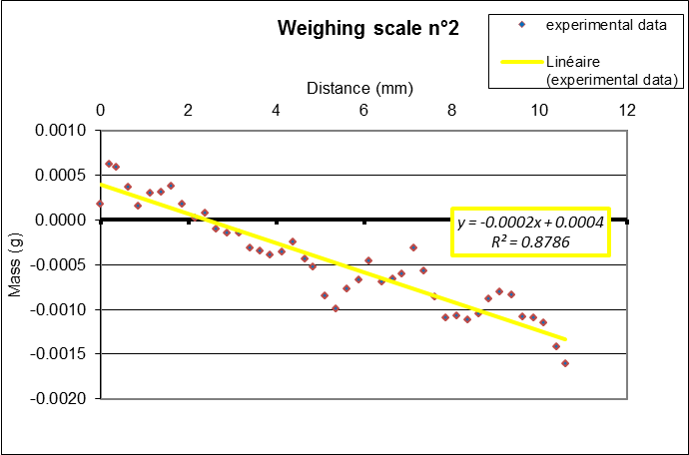

Figure 7: Experimental results of the buoyancy and surface tension evaluation for the weighing system n°2.

For the weighing scale n°2, we find a buoyancy effect of about 0.045 % of the measured mass (0.005 % in the theoretical evaluation) and a surface tension effect of 0.014 % (0.05 % in the theoretical evaluation).

If we sum up buoyancy and surface tension effects, experimental analysis gives a total error of 0.059 % on the measured mass (0.055 % in the theoretical evaluation).

*3.2.3 Weighing system n°3*

The Figure 8 hereafter shows the experimental results obtained for the weighing system n°3.

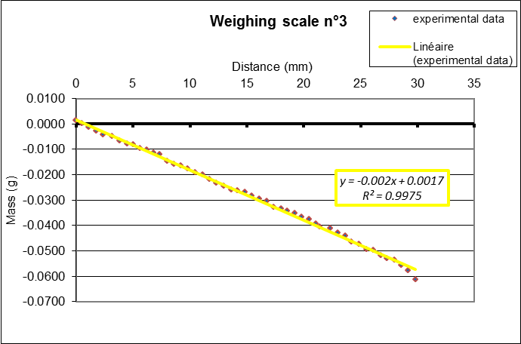

Figure 8: Experimental results of the buoyancy and surface tension evaluation for the weighing system n°3.

For the weighing scale n°3, we find a buoyancy effect of about 0.125 % of the measured mass (0.005 % in the theoretical evaluation) and a surface tension effect of 0.007 % (0.015 % in the theoretical evaluation).

If we sum up buoyancy and surface tension effects, experimental analysis gives a total error of 0.13 % on the measured mass (0.02 % in the theoretical evaluation).

*3.2.4 Weighing system n°4*

The Figure 9 hereafter shows the experimental results obtained for the weighing system n°4.

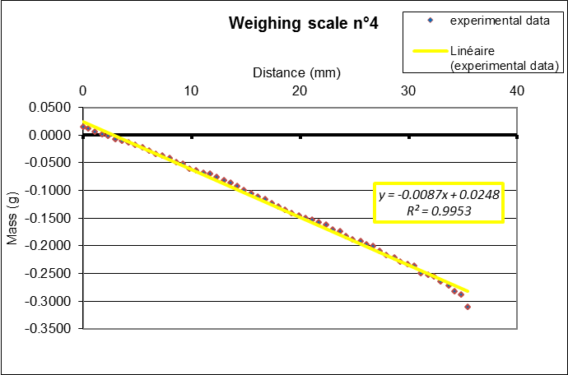

Figure 9: Experimental results of the buoyancy and surface tension evaluation for the weighing system n°4.

For the weighing scale n°4, we find a buoyancy effect of about 0.065 % of the measured mass (0.005 % in the theoretical evaluation) and a surface tension effect of 0.006 % (0.003 % in the theoretical evaluation).

If we sum up buoyancy and surface tension effects, experimental analysis gives a total error of 0.07 % on the measured mass (0.008 % in the theoretical evaluation).

*3.3 Discussion on results*

The experiment performed for this study shows significant discrepancies between theoretical calculations and experimental results.

The discrepancies on the buoyancy evaluation can be explained by errors on the dimensions of the capillary and tank diameter used for the calculations. Indeed, the values used were provided by the manufacturer of the parts, and not verified with metrological grade instruments. Small discrepancies on the diameter of the capillary can result in significant error on its volume. Moreover, the tanks have been changed from stainless steel to chemical glass ones in 2014 and the dimensions could have changed. New measurements of the relevant dimensions will be performed to verify this hypothesis.

The discrepancies on the surface tension evaluation can be due to two different causes: errors on the external diameter of the tube and surface tension coefficient values; and additional phenomenon due to irregularities of the surface encountered by the water rising in the tank. For example, known phenomena in micro-fluidics can act when a fluid/fluid/solid interface is moving on wetted or non-wetted surfaces: hysteresis on the surface tension coefficient due to the dependency of the contact angle upon the speed of the moving interface can occur [2].

In order to validate the findings presented in this paper, repeatability and reproducibility tests will be performed using the same apparatus in the same conditions.

Moreover, new tanks designs are currently tested to reduce buoyancy and surface tension variations during measurements. For example, a tank with smaller height but bigger diameter would decrease the rising height of the water during a filling. Other solutions could also involve changing the immersed capillary principle in use to a system with less influential parameters on mass measurement.

# 3. Conclusion

In order to experimentally quantify the most critical sources of uncertainty of the French primary standard for liquid micro-flow rate, a new experimental method has been developed and used on the weighing systems of the facility.

Buoyancy and surface tension effect, which causes biases on the mass measurement, have been evaluated by accurately decreasing the height of the capillary while monitoring the weighed mass, thus simulating the rise of the water level during the measurement of the reference flow rate.

Significant discrepancies have been found between previously theoretically calculated factors and experimentally calculated ones. The discrepancies can be explained by errors in the parameters values used in the calculation and microfluidic specific phenomena occurring while the liquid interface is rising.

Finally, new measurements are proposed and will be performed to validate these first experimental results, and new designs are currently being developed at LNE-CETIAT to overcome the most critical uncertainty sources of the French micro-flow rate primary standard.

# References

1. Bissig H., Petter H.T., Lucas P., Batista E., Filipe E., Almeida N., Ribeiro L.F., Gala J., Martins R., Savanier B., Ogheard F., Niemann A.K., Lötters J., Sparreboom W., *Primary Standards for Flow Rates from 100 nl/min to 1 ml/min - Gravimetric Principle*, Biomed Tech (Berl), 60, 301-316, 2015.
2. Colin S. et al, *Microfluidique* (Paris, Editions Lavoisier), 224-225, 2004.