An Innovative Technology for Coriolis Metering under Entrained Gas Condition

**H. Zhu1, A. Rieder2, Yaoying Lin2**

*1Endress+Hauser Flowtec AG, Am Lohmuehlbach 12, 85356 Freising, Germany*

*2Endress+Hauser Flowtec AG, Freising, Germany*

*E-mail: hao.zhu@flowtec.endress.com*

# Abstract

Coriolis mass flow meters are usually only used for single-phase fluids, i.e. either liquids or gases, since it has been found that their accuracies can be affected by two-phase flows, e.g. the existence of entrained gas in a liquid flow. It is now known that there are various error sources, among which the significantly increased compressibility due to the gas entrainment brings the most difficulty to the field applications of Coriolis meters. The authors developed a new generation of Coriolis sensor together with an innovative technology, Multi Frequency Technology (MFT), which can compensate the measurement errors introduced by the elevated compressibility of an entrained gas flow. The new Endress+Hauser Coriolis sensor provides a novel hardware platform so that a higher natural mode of the measuring tube can be reliably excited, in addition to the basic working mode. Being driven at different frequencies, the same two phase fluid in the measuring tube can have different influences on the primary mode (i.e. the basic working mode) and the auxiliary mode (i.e. the higher tube mode). By analyzing the corresponding vibrational response of the two phase fluid at the two frequencies, the unique resonance property of this mixture can be obtained and the induced measurement errors can be compensated. In this paper, the theoretical background of Coriolis entrained gas metering is given. Afterwards, the basic principle of the MFT is explained in detail. Measurement data obtained at two independent laboratories are provided to prove the improvement brought by this technology.

# 1. Introduction

Coriolis mass flow meters are widely accepted and used in various industries because of their high reliability and accuracies for density and mass flow rate measurements. For mass flow rate, an accuracy of ±0.1% o.r. or even ±0.05% o.r. can be reached; while for density, ±0.2 kg/m3 has been claimed under reference conditions by some manufacturers. The distinct advantage of the Coriolis measuring principle over other meter types lies in the fact that a Coriolis mass flow meter directly senses the true mass flow rate, whereas most of the others measure volumetric flow rates – in other words, they measure flow velocities.

The above mentioned advantages of Coriolis mass flow meters mainly come from the measurement principle based on the Coriolis effect, which reveals the fact that a Coriolis force is generated when an object on a rotating body moves away or towards the center of rotation. This force is related to the inertia of the object and has a direction perpendicular to both the velocity of the object and the axis of the rotation body. In general, a Coriolis mass flow meter consists of measuring tube(s), which can be of various shapes in commercial designs, a housing that protects the inner part and other components adhering to the measuring tube such as a driver for exciting the tube and sensors for sensing the tube motion, as shown in Figure 1. In a Coriolis meter, the rotation provided by the oscillation of the measuring tube, together with the flow of the medium inside, give rise to the Coriolis effect, which is manifested by anti-symmetrically distorting the tube. Being proportional to the magnitude of this distortion, the mass flow rate can be calculated by physically measuring the distortion with the help of two sensors locating at the inlet and the outlet sections of the tube. In addition to the mass flow rate, Coriolis meters can also provide an accurate density measurement by recording the resonance frequency of the measuring tube. For the purpose of being energy efficient, the tube is continuously excited at its natural frequency, which is defined by the tube properties and the density of the fluid inside. This correlation is thus utilized to calculate the fluid density.

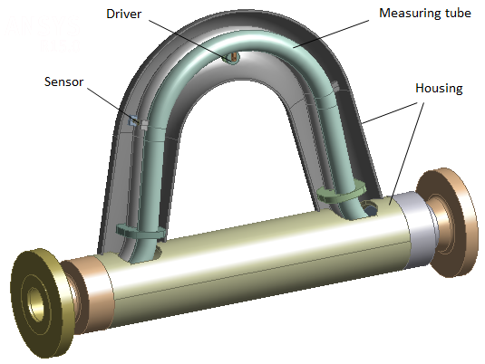

Figure 1: Inside view of a Coriolis mass flow meter.

In practice, Coriolis flow meters are usually only applied for single-phase fluids, i.e. liquids or gases, since it has been known that their accuracies can be affected by the existence of entrained gas in a liquid flow. A number of research activities have been carried out in the past to understand the error mechanisms of Coriolis metering under two-phase conditions. It is now known that there are various error sources, among which the so-called “bubble effect” [1] and “resonator effect” [2, 3, 4] (also referred to as compressibility effect [5]) are the main ones for Coriolis metering.

# 2. Issues with entrained gas

*2.1 Bubble effect*

Bubble effect theory has been developed and later extended to viscous bubble theory by Hemp et al [1]. The essential idea of the root cause of the bubble effect is that a gas bubble in the measuring tube of a Coriolis mass flow meter does not strictly follow the oscillation of the surrounding liquid with the same amplitude, as a result of the density difference between the gas density *ρg* and the liquid density *ρl*, provided the liquid cannot "hold" the bubble well. This generates a relative motion between the bubble and the liquid. Thus a secondary flow (see Figure 2) around the bubble is induced by this relative motion and causes a different inertial effect from the one that Coriolis mass flow meter utilizes to sense mass flow rate. Under such conditions, it can be proven that the oscillation amplitude of the bubble *ug* is greater but in-phase with that of the measuring tube or the liquid *ul*. The corresponding secondary flow around the bubble usually has the opposite direction to the tube vibration. Consequently, a part of the inertia of the liquid that should be felt by the tube wall for a particular flow is lost, which leads to underestimation of the real density and mass flow rate of the liquid phase.

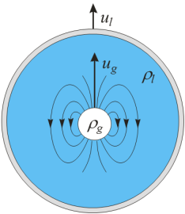

Figure 2: Motion of a bubble in a measuring tube filled with liquid.

Under ideal conditions of “free bubbles”, to which the liquid does not exert any holding effect during the tube oscillation, it can be derived that the bubble effect error to both mass flow and density measurements is calculated by

$$E_{ρ, \dot{m}}^{bub}=\frac{-2α}{1-α} , (1)$$

where *α* is Gas Void Fraction (GVF). It can be seen that the bubble effect can only cause the same negative error for both density and mass flow measurements. If there are only ideal free bubbles, by knowing the liquid density, one can estimate GVF according to the measured density drop of the Coriolis meter from the liquid density, and accordingly compensate the bubble effect error for the mass flow and the density measurements. However, only limited success can be achieved, especially only in laboratories where ideal free bubbles are typically artificially created by injecting air or nitrogen into water flow. But in real applications, bubble problems are more complex than that. One reason is that liquids are not always free of the holding effect to bubble oscillation. For example, viscosities of some oils are much higher than that of water, or the sizes of bubbles generated from an outgassing process are too small to be free in the oscillation. Based on the viscous bubble theory from Hemp, a holding coefficient is defined by the authors to describe the degree of a bubble being “free” in a liquid subject to an oscillation. This coefficient is given by

$$δ=\sqrt{\frac{μ}{d^{2}fρ_{l}}} , (2)$$

where *μ*, *d,* *f* and *l* are the viscosity of the liquid, the bubble diameter, the oscillation frequency and the liquid density. With this definition, the amplitude ratio *J*, which is defined as the ratio of *ug* to *ul*, is plotted in Figure 3 as a function of *δ*.

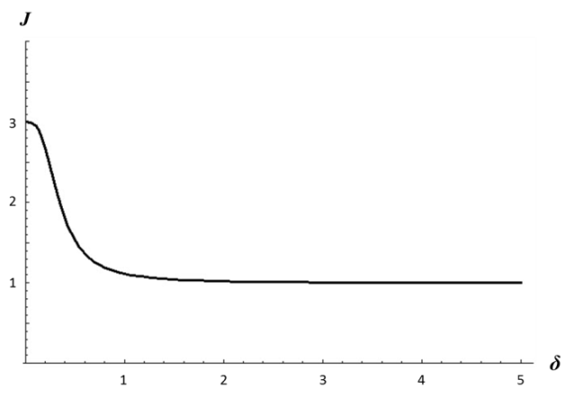

Figure 3: Amplitude ratio as a function of *δ*.

The amplitude ratio 1 means the bubble exactly follows the liquid oscillation and no error of the bubble effect is introduced. This type of bubbles is named as “suspended bubbles” in this paper. The amplitude ratio 3 corresponds to the case of an ideal free bubble that leads to a measurement error calculated by Equation (1). The amplitude ratio between 1 and 3 is known as the transition region between suspended bubbles and free bubbles, where compensation for the bubble effect becomes difficult since the exact value of *δ* can vary over time and process conditions, and is thus not easy to determine in real applications. It can be seen in Equation (2) that the most influence on the value of *δ* comes from the liquid viscosity and the bubble size, which can significantly vary compared with the liquid density and the tube frequency.

Although it is difficult to determine *δ* for non-suspended bubbles, it is much easier to separate them compared with the effort spent to separate suspended bubbles. Being free due to big size or low viscosity of the liquid, free bubbles tend to separate/escape from the liquid carrier phase. Therefore, the best practice to avoid the bubble effect error is to carefully design the process to eliminate or significantly reduce the entrainment of free bubbles in the flow that is to be measured by a Coriolis flow meter. This can be achieved by many practical measures such as maintaining sufficient tank levels to avoid sucking in gas, installing air eliminators or settle tanks to remove big bubbles, or keeping high enough back pressure to the meter or small enough pressure loss upstream of the meter to avoid/suppress severe outgassing in the process. Furthermore, a high pressure or a high flow velocity is helpful to compress/break bubbles into small sizes to obtain suspended bubbles.

*2.2 Resonator Effect*

Compared with free bubbles, suspended bubbles are much more difficult to eliminate in process. Although causing no bubble effect error, they still introduce resonator effect as a result of the significantly increased compressibility, giving rise to density and mass flow measurement errors. It has been found in the past that suspended bubbles bring the most difficulty to field applications of Coriolis flow meters.

The detailed explanation of the resonator effect is given in [2]. For convenience, its basic cause and theoretical treatment are briefly presented again in this paper. As a matter of fact, speed of sound in a liquid decreases dramatically even if only a small amount of gas is mixed. This greatly reduced velocity indicates a low resonance frequency of the mixture in the tube, which approaches the driving frequency of the oscillating tube and causes a resonater effect (driven out of resonance) that cannot be neglected during the measurement.

Considering speed of sound in a two-phase fluid, the following equation gives the relation to GVF and pressure:

$$c={\left(\frac{α}{c_{g}^{2}}+\frac{{\left(1-α\right)}^{2}}{c_{l}^{2}}+\frac{α\left(1-α\right)ρ_{l}}{γp}\right)}^{-\frac{1}{2}}, (3)$$

where and *p* are adiabatic constant and pressure respectively. Sound velocities in the gas, fluid and mixture are denoted as *cg*, *cl* and *c*. Figure 4 shows how fast speed of sound can decrease with the introduction of air into water. For an ideal two-phase medium, assumed that the gas phase is evenly distributed in the liquid phase, the acoustic resonance frequency of interest in the measuring tube can be calculated from the lowest acoustic resonance mode (standing wave, approximately half wavelength in the tube) of the tube cross-section, as given by the following equation:

$$f_{0}=c\frac{λ_{1}}{2πR_{0}}, (4)$$

where *λ*1 = 1.842 and *R*0 is the radius of measuring tube.



Figure 4: Dependence of velocity of sound on GVF and pressure.

Once the acoustic resonance frequency is determined, it is possible to calculate quantitatively the influence of the resonator effect on Coriolis density and mass flow rate measurements. As a simplified version, the density error and the mass flow rate error caused by resonator effect can be calculated as:

$$E_{ρ}^{res}=\left(r_{0}+r_{1}\frac{1}{1-\frac{f^{2}}{f_{0}^{2}}}\right)-1, (5)$$

$$E_{\dot{m}}^{res}=k_{res}E_{ρ}^{res}, (6)$$

where *k*res is the magnitude factor of mass flow rate error to density error, and it has the value about 2, or alternatively can be precisely calculated by the method described in [2]. *r*1 (=0.837) is the portion of the fluid mass in the measuring tube that is active for the resonator model being discussed, while *r*0 (=0.163) is the inactive part. The detailed explanation is given in [2]. It can be concluded from Equations (3)-(6) that since the tube driving frequency is typically far below the acoustic resonance frequency, the resonator effect almost always leads to positive measurement errors, which is opposite to the bubble effect. Although a low tube driving frequency generates a smaller resonator effect error according to Equations (5) and (6), the finite physical dimension of a Coriolis meter determines that the lowest driving frequencies are still of the order of 100 Hz. Moreover, keeping the same driving frequency, a bigger measuring tube diameter results in a lower acoustic resonance frequency of the fluid *f*0 in measuring tube and consequently a more significant resonator effect according to Equations (4) and (5). This means that bigger size meters suffer more from the resonator effect, and it is not of practical value or even impossible to design them with extremely low frequencies (e.g. to the level of a few Hz) to eliminate the errors induced by the resonator effect.

# 3. Multi Frequency Technology (MFT)

To compensate the measurement errors induced by the resonator effect, MFT has been researched and developed based on the vibrational properties of the Coriolis sensor, further advanced to the Two-Mode Compensation proposed in [2]. When a Coriolis meter measures a liquid with suspended bubbles, the measured density error is defined as

$$E_{ρ}^{res}=\frac{ρ_{a}-ρ}{ρ}, (7)$$

where *ρa* and *ρ* are the apparent density reading from the meter and the true density of the two-phase mixture. Combining Equations (5) and (7) gives

$$ρ_{a}=ρ\left(r_{0}+r_{1}\frac{1}{1-\frac{f^{2}}{f_{0}^{2}}}\right). (8)$$

A conventional Coriolis sensor oscillates typically at the first natural mode of the measuring tube, which is a bending mode as shown in Figure 5 (only a half model is shown). Therefore, only one equation, namely Equation (8) can be established, which is not sufficient to determine the two unknowns, *ρ* and *f*0.

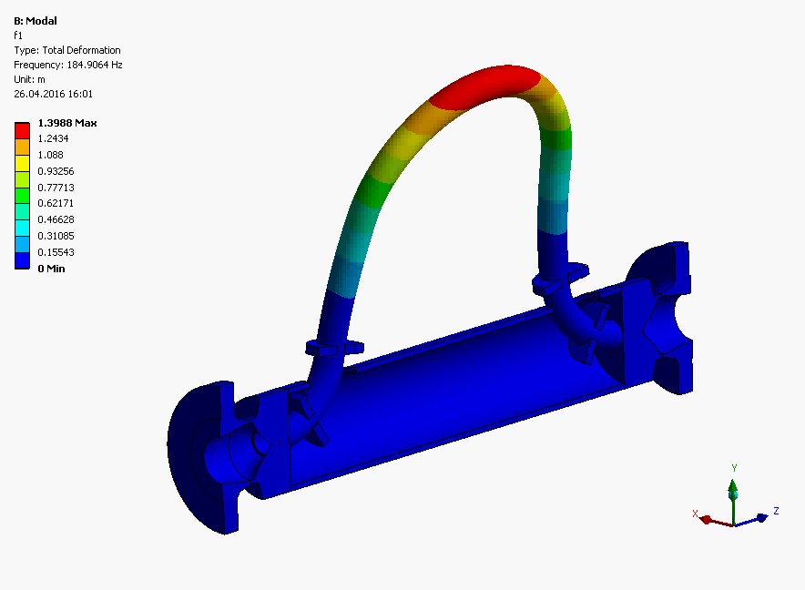

Figure 5: Modal shape of the first natural mode in numerical simulation.

During the new sensor (Promass Q) design, special consideration has been taken by the author that the oscillation of the measuring tube is not only well balanced for the basic working mode, but also for a higher mode, the third mode of the measuring tube, as shown in Figure 6. A good balance for tube oscillation is critical for the design of a Coriolis meter to ensure that the tube vibration is isolated from the external process connection. Then a reliable density measurement can also be realized with the third mode, which provides an independent density reading *ρa*3 from that of the first mode, and therefore can give additional information about the resonance property of the fluid. The reason of relying on the third mode instead of the second mode of the tube lies in the fact that the second tube mode is anti-symmetric with respect to the driver so that this mode cannot be excited by the existing driver shown in Figure 1. In addition to mode shape, the third mode differs from the basic working mode with a much higher resonance frequency, typically by a factor of 5-6. It should be noted that the two tube modes can be driven simultaneously with the same driver. The mechanical motions and the corresponding signals of the two modes are then superimposed. With the modern electronics developed for this purpose, the combined signal can be simultaneously processed and two independent vibrational properties of the two modes can be obtained accordingly.

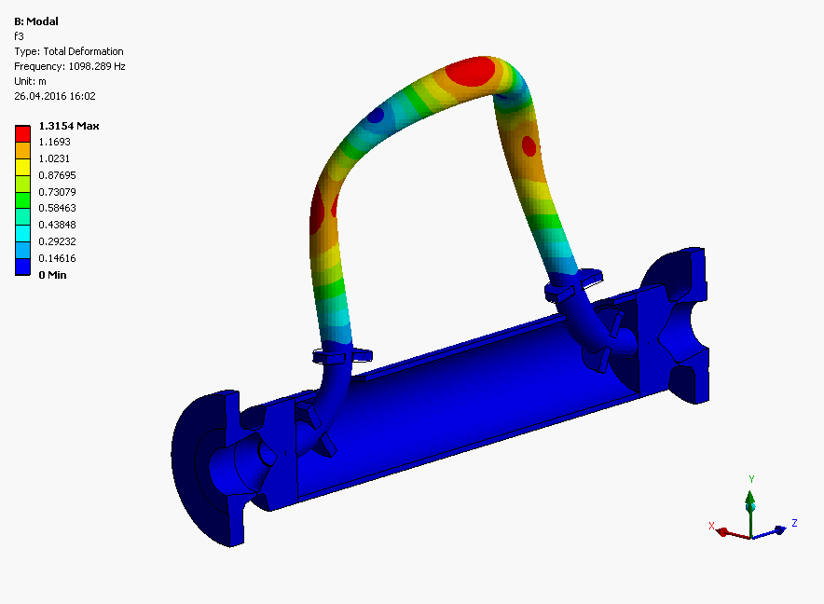

Figure 6: Modal shape of the third natural mode in numerical simulation.

With the same two-phase fluid being driven at two frequencies, two equations, taking the same form as Equation (8), can be established as follow:

$$ρ_{ai}=ρ\left(r_{0}+r_{1}\frac{1}{1-\frac{f_{i}^{2}}{f_{0}^{2}}}\right), (9)$$

where *i* = 1 and 3, corresponding to the first mode and the third mode of the measuring tube, respectively. With the above two equations, the unique resonance property of the entrained gas in the measuring tube can be determined. In other words, the two unknowns, *ρ* and *f*0 can be solved. Therefore, the first measured parameter, the density of the two-phase fluid unaffected by the resonator effect, is already obtained. With the known *f*0, the mass flow error caused by the resonator effect can be calculated with the help of Equations (5) and (6). Once the mass flow error is determined, the actual mass flow measured by the device ${\dot{m}}_{a}$ can then be compensated accordingly with the following equation:

$$\dot{m}=\frac{{\dot{m}}_{a}}{E_{\dot{m}}^{res}+1}, (10)$$

Since *f*0 is obtained from MFT, it is straightforward to calculated speed of sound based on Equation (4) by knowing the radius of the measuring tube. This is not only possible for a liquid with entrained gas, but also for a pure gas. Research work conducted by the authors has shown that speed of sounds of various gases can be measured with MFT, provided the resonator effect of the gas can introduce a sufficient difference between the apparent densities measured by the first mode and the third mode of the measuring tube, respectively. Typically, this can be achieved by a sufficient pressure (e.g. ≥5 barg) of this gas. Limited by the topic addressed, further detail is not given in this paper.

# 4. Application of MFT

There are numerous entrained gas applications that MFT can be applied, such as heavy oils that can hold bubbles because of high viscosity, dairy products that contain micro-bubbles due to product nature, etc. Targeting for one interesting type of applications, Promass Q with MFT was tested with outgassing from produced water at Schlumberger in Porsgunn, Norway. The test setup is shown in Figure 7. A reference Coriolis meter was installed at the high pressure section, where the produced water saturated with Nitrogen was single phase (shown in the left picture of Figure 8), for which the reference Coriolis meter measured with the uncertainty of ±0.1%. The test Coriolis meter with MFT was installed at the low pressure section, where outgassing was created to generate a gas-liquid two phase flow, as shown in the right picture of Figure 8. As can be seen there, a homogeneous micro-bubble flow regime was produced by the outgassing.

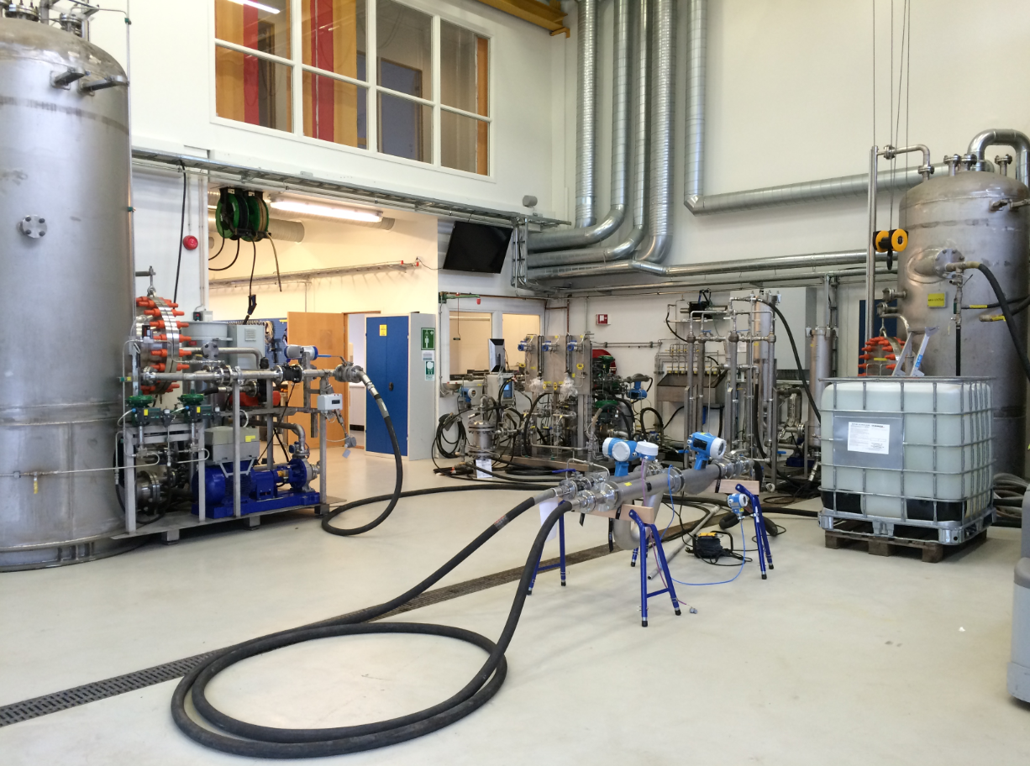

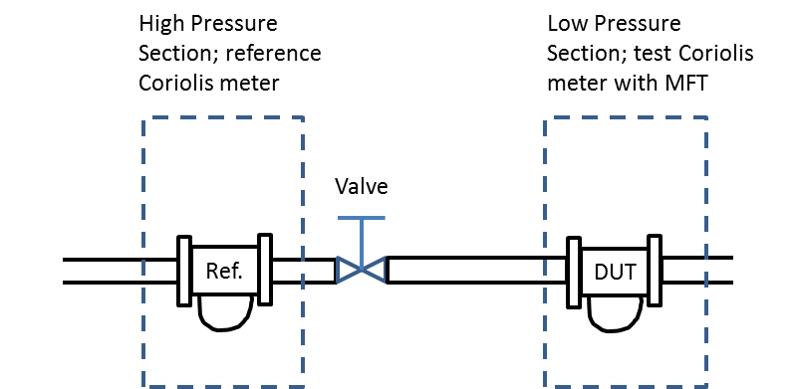

Figure 7: Outgassing setup for Promass Q with MFT at Schlumberger and corresponding schematics

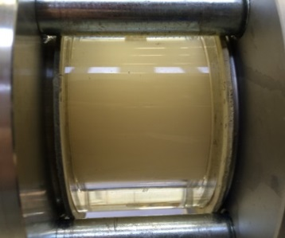

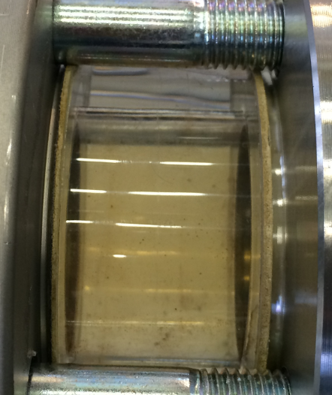

Figure 8: Single phase at the high pressure section (left) and two-phase at the low pressure section due to outgassing (right)

The test conditions are given in Table 1, and the test result is shown in Figure 9.

**Table 1:** test conditions.

|  |  |
| --- | --- |
| **Salinity** | 3.7% |
| **Temperature (°C)** | 50°C |
| **Flow rates (kg/h)** | 7000 – 18000 |

Shown in Figure 9, MFT significantly improved the measurement accuracies from up to 2% errors to an accuracy level about 0.3%. Based on the setup and the fluid, GVF could reach about 3% in this test. In Figure 9, the calculation done for the case “without MFT” was based on the recorded internal parameters of the same test meter and errors were calculated offline after the test. It is interesting to show that the calculated speeds of sound in this test ranged from 78 to 260 m/s, which are lower than the speed of sound either in water or in Nitrogen.

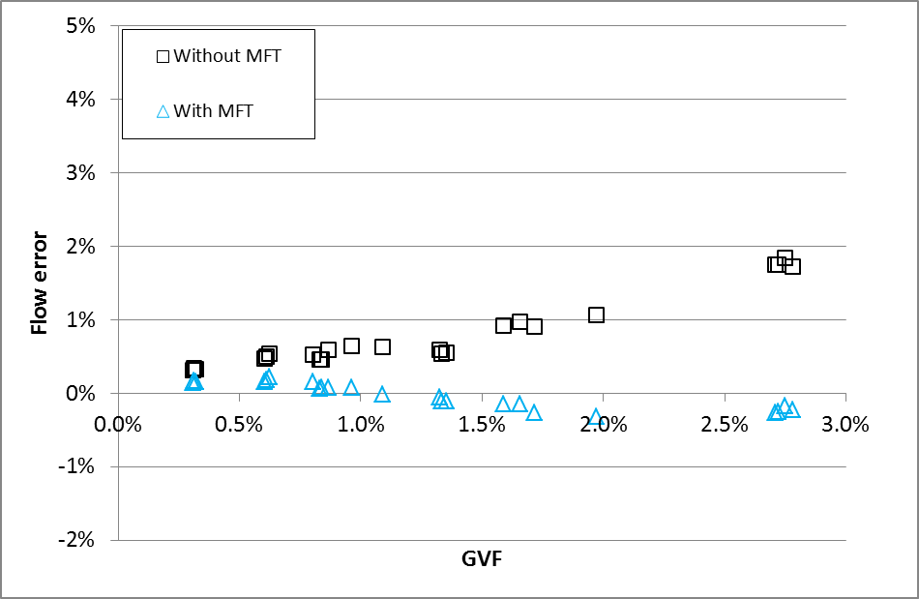

Figure 9: Measurement accuracy as a function of GVF

# 5. Further application of MFT

In addition to the compensation of the density and the mass flow errors induced by the resonator effect, MFT enables the possibilities for measuring more parameters of a compressible fluid, such as the speed of sound in this fluid and GVF in a gas-liquid two-phase fluid.

For a gas-liquid two-phase fluid, once the speed of sound is known, GVF can be calculated from Equation (3) with the knowledge of the process pressure in the device, and the basic thermal dynamic properties of the gas phase and the liquid phase, respectively. It should be noted that analyzing the weighting factors of different terms on the right hand side of Equation (3) suggests that an exact knowledge of *cg* and *cl* is not strictly required since the their contribution to *c* is much smaller than *α* and *P*, at least for most common applications where *α* and *P* are relatively small. Furthermore, the following equation

$$ρ_{l}=\frac{ρ-αρ_{g}}{1-α} (11)$$

generally holds for a gas-liquid two-phase fluid. For most applications of interest here, the term $αρ_{g}$ is much smaller than *ρ*. Therefore, it can be simplified to

$$ρ_{l}=\frac{ρ}{1-α} . (12)$$

Combining Equations (3) and (12) gives the solutions to GVF and liquid density. The latter is of particular interest for some applications, where the liquid phase consists of two components, e.g. water and oil, and Coriolis meter is expected to measure this liquid mixture density to determine the phase volumetric concentrations such as Water Cut (WC, water volume fraction in oil). With MFT, the measurement for three phase volume fractions is enabled, which is otherwise impossible with only a conventional Coriolis meter.

A test of this function was performed at an independent laboratory, DNV GL, where outgassing conditions were generated to introduce the third phase (i.e. gas) in the water-oil two phase flows with various WCs (see Figure 10). The oil used in the test was Exxsol D120 with the viscosity about 4-5 cSt and the density about 0.82 g/ml. The test pressure ranged from 8-14 barg. Figure 11 shows the calculated GVFs with MFT, compared with those derived from the Coriolis density measurement by knowing the liquid phase densities from the lab. It should be pointed out the latter method for the GVF calculation is based on the assumption that the Coriolis density measurement is precise. Therefore, it cannot be strictly taken as the reference and the comparison made in Figure 11 is only qualitative.

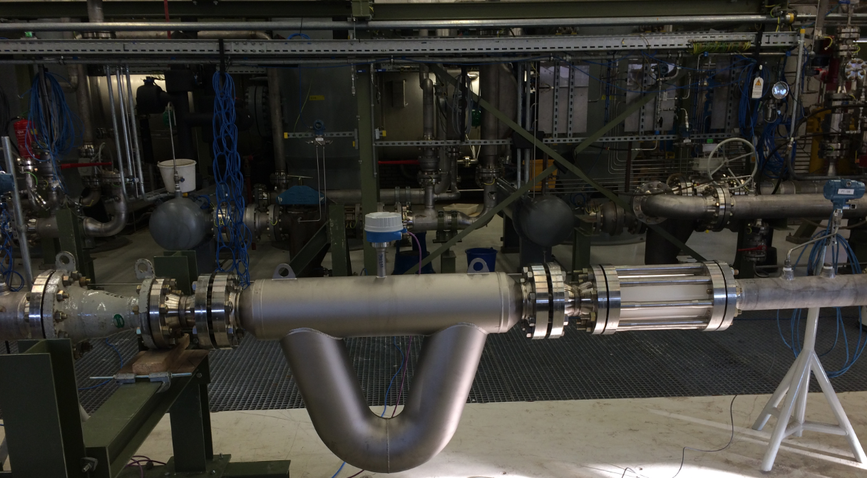

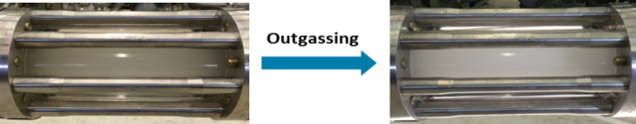

Figure 10: Outgassing test of Promass Q with MFT at DNV GL.

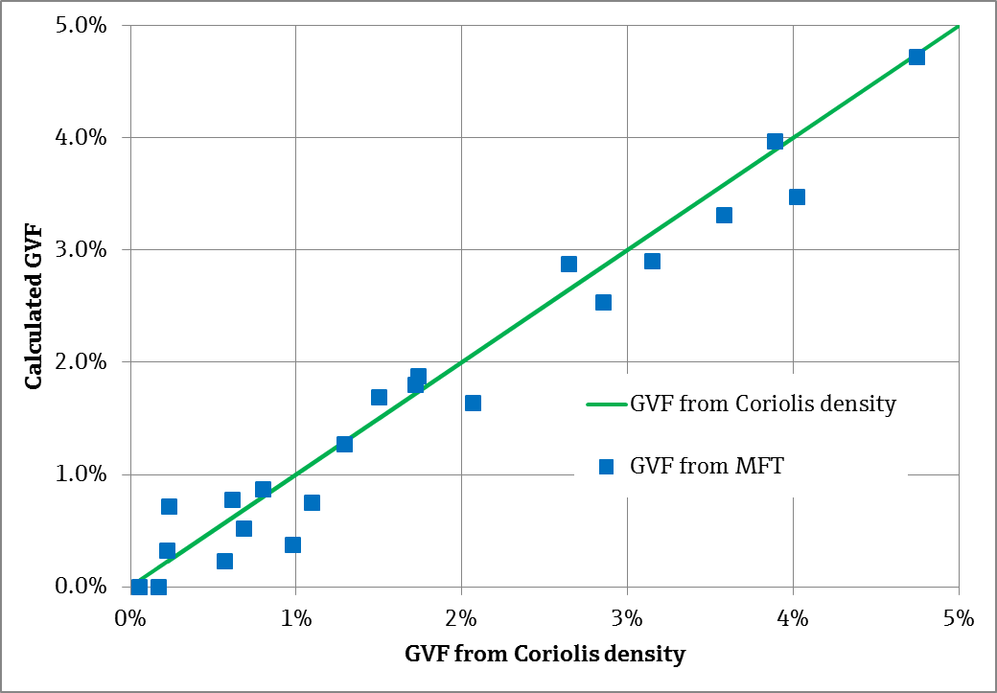

Figure 11: Calculated GVF with MFT compared with the one derived from the Coriolis density measurement

However, the reference for the actual WC provided by DNV is highly reliable since water and oil single phase flows were separately measured before they mixed together. The results of the enhanced WC measurement with MFT are given in Figure 12, compared with the results from the straightforward method, with which the Coriolis density drop caused by the entrained gas was simply wrongly regarded as more concentration of oil, whose density is lower than water. It can be seen in the figure that the WC measurement is significantly improved by correcting the effect of entrained gas with the help of MFT.

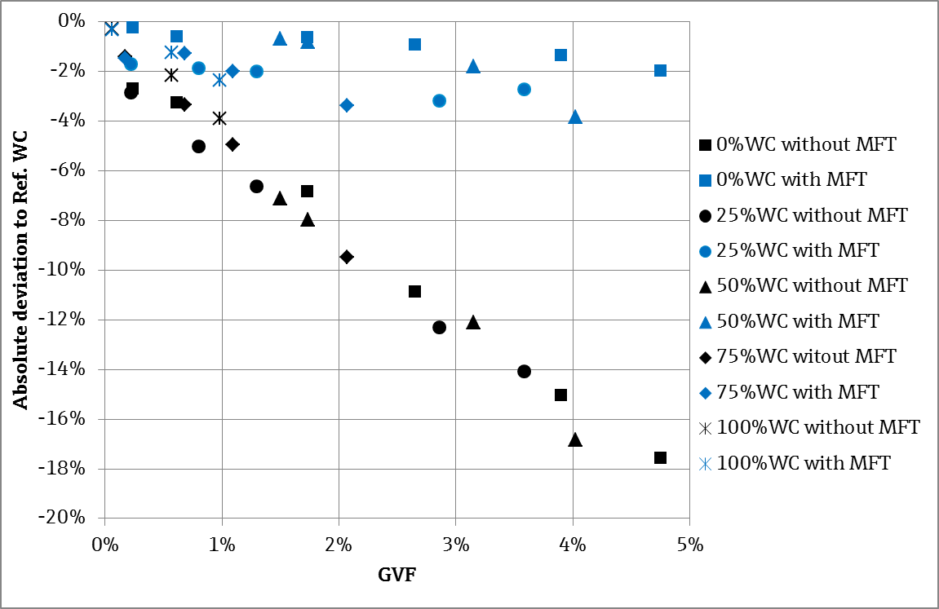

Figure 12: WC measurements corrected with GVF by MFT

# 6. Conclusion

The bubble effect and the resonator effect are the main error sources for Coriolis metering under entrained gas conditions. As the best practice, the bubble effect due to the existence of free bubbles should be suppressed by eliminating the free bubbles with the help of the process optimization, e.g. using gas eliminators or creating high turbulence to break free bubbles into small size suspended bubbles. The resonator effect caused the major problem in the field since suspended bubbles are much more difficult to remove. To cope with this, an innovative technology, MFT, which makes use of multiple oscillation modes of the measuring tube to compensate the resonator effect for both density and mass flow measurements, is introduced in this paper. The measurement of speed of sound in a gas or an entrained gas fluid is enabled with the help of MFT. In combination with a pressure measurement, MFT can further calculate the GVF in an entrained gas fluid, which realizes the measurement of the volume fractions for a three-phase fluid. Two lab tests with outgassing, where homogeneous suspended bubbles were generated, are also shown as validation tests to this technology.

# References

[1] J. Hemp and G. Sultan, “On the theory and performance of Coriolis mass flowmeter,” in *Proceedings of the International Conference on Mass Flow Measurement*, London, 1989.

[2] H. Zhu, *Application of Coriolis Mass Flowmeters in Bubbly or Particulate Two-Phase Flows*, Shaker, 2009.

[3] H. Zhu, A. Rieder, and W. Drahm, “A moving resonator model of Coriolis flowmeters for measuring two-phase flow,” *5th International Symposium on Multiphase Flow, Heat Mass Transfer and Energy Conversion*, Xi’an, China, July 2005.

[4] A. Rieder, H. Zhu, and W. Drahm, Coriolis mass flowmeters: on measurement errors in two-phase conditions, *13th International Flow Measurement Conference*, Peebles Hydro, Scotland, UK, June 2005.

[5] J. Hemp and J. Kutin, “Theory of errors in Coriolis flowmeter readings due to compressibility of the fluid being metered,” *Flow Measurement and Instrumentation*, vol. 17, no. 6, pp. 359–369, 2006.