Metrological support for LNG custody transfer and transport
O. Büker¹, K. Rasmussen², J. B. Kondrup², P. Lucas³, N. Pelevic³, K. Stolt¹, M. van der Beek³, K. Arrhenius¹, J. Li³, A. Lucassen⁴, L. Klare⁵, P. Eilts⁵, P. A. Giuliano Albo⁶, M. Richter⁷,
B. Gieseking⁸, G. Nieuwenkamp³, J. Rauch⁴, T. Mortensen⁹

¹SP Technical Research Institute of Sweden, Brinellgatan 4, 504 62 Borås, Sweden
²FORCE Technology, Park Allé 345, 2605 Brøndby, Denmark
³VSL – Dutch Metrology Institute, Thijsseweg 11, 2629 JA Delft, the Netherlands
⁴PTB, Bundesallee 100, 38116 Braunschweig, Germany
⁵TU Braunschweig, Hermann-Blenk-Straße 42, 38108 Braunschweig, Germany
⁶INRiM, Strada delle Cacce 91, 10135 Torino, Italy
⁷RUB, Ruhr-Universität Bochum, 44780 Bochum, Germany
⁸NPL, Hampton Road, Teddington Middlesex TW11 0LW, United Kingdom
⁹Justervesenet, Fetveien 99, 2007 Kjeller, Norway
E-mail (corresponding author): oliver.buker@sp.se

Abstract

In the framework of the ongoing EMRP Joint Research Project (JRP) ENG 60 “Metrology for LNG” (2014-2017), co-funded by the European Union, a number of metrological challenges associated with custody transfer and transport of LNG will be faced. The project consists of four technical work packages (WP), whereby the main objective is to reduce the measurement uncertainty of LNG custody transfer by a factor two. The focus in WP1 is the design and development of a traceable mid-scale calibration standard for LNG mass and volume flow. The goal is to provide traceable mass and volume flow calibrations up to 400 m3/h (180000 kg/h). In WP2, the emphasis is on the development and validation of a LNG sampling and composition measurement reference standard, consisting of sampler, vaporizer, gas standards, and gas chromatography (GC), which will be used to test and calibrate commercially available LNG sampling and composition measurement systems. The priority in WP3 is given to the development and validation of a method for the determination of the methane number, including correlations based on the LNG composition and corrections for traces of nitrogen and higher hydrocarbons. Since physical properties and quantities play an important role in LNG custody transfer, WP4 comprises reference quality density measurements of LNG to validate and improve models for LNG density predictions, the uncertainty evaluation of enthalpy and calorific value calculations and the development of a novel cryogenic sensor for the simultaneous measurement of speed-of-sound and density. The present paper gives an overview of recently achieved objectives within the project and provides an outlook to future activities.

1. Introduction

With a view to the worldwide rise in energy consumption and the resulting increasing emission of greenhouse gases, as well as the continual tightening of emission regulations, there is a growing demand for natural gas. Compared to other fossil such as oil and coal, natural gas is by far the cleanest and most environmentally-friendly fuel available.
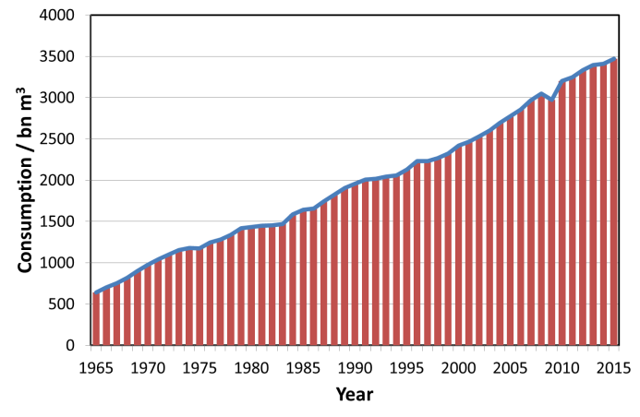
Figure 1 – Worldwide natural gas consumption, between 1965 and 2015 according to BPs statistical review of world energy [1].
Natural gas has already today a share on the world primary energy consumption of 23.85% (2015) [1].
In order to meet the growing demand a constant increase in the worldwide trade of natural gas was recorded over the last decades and forecasts [2] have predicted further growth. As it can be seen in Figure 1, the worldwide consumption of natural gas has more than doubled in the past 30 years (1985: 1642.8 bn m³, 2015: 3468.6 bn m³). For an efficient and effective distribution of natural gas from its origin to the consumer a sophisticated and extensive transportation system is needed. Liquefied Natural Gas (LNG) has an important role in addressing the global natural gas demand, especially for remote and/ or offshore locations. The primary transportation systems for natural gas are pipelines. Pipeline transport accounted for 67.55% (2015: 704.1 bn m3) and LNG for 32.45 % (2015: 338.3 bn m3) of the trade movements. In fact the global natural gas pipeline trade recorded a decline by 6.2% in 2014, while LNG shipment trade increased by 2.4% during the same period [1]. The transportation of LNG by ship is, in comparison to pipeline transportation of natural gas, nearly independent from political conditions and is expected to become as important as pipeline transport of natural gas. In this context the transport of natural gas by ships over long distances is technically and metrologically more challenging than for other fossil fuels.

2. Energy measurement (custody transfer)

The trade of Liquefied Natural Gas (LNG) is based on energy measurement. That means, when LNG is loaded or unloaded from a ship the energy content is the crucial quantity. In this context the energy content is commonly calculated from the volume, density and the gross calorific value, according to the GIIGNL handbook [3]:

$E=V_{LNG}∙D_{LNG}∙{GCV}_{LNG}-E_{gas,displaced}$ (1)

Where:

E Energy transferred (MMBTU)

V_{LNG} Volume of the LNG (m³)

D_{LNG} Density of the LNG (kg/m³)

GCV_{LNG} Gross calorific value (MMBTU/kg)

E_{gas,displaced} Energy of the gas displaced during transfer (MMBTU)

As it can be seen in Table 1, the overall measurement uncertainty determining the LNG energy transferred has, in a best case scenario, an estimated relative uncertainty U(E)/E of ±0.50% (k=2).
Table 1 – Estimated measurement uncertainties according to the GIIGNL handbook [3].
Source of uncertainty | Typical uncertainty values U(E)/E (k=2)
Volume | 0.20 % – 0.54 %
Density | 0.46 %
GCV | 0.04 % – 0.07 %
E_{gas,displaced} | 0.003 %
Energy (total): | 0.50 % – 0.74 %

The (static) volume uncertainty of a tank varies typically in the range of 0.20 – 0.54% (k=2). There is almost a universal agreement that (dynamic) LNG flow metering could provide higher accuracy. In case LNG flow meters could be calibrated under operation conditions, measurement uncertainties in the range of 0.15 – 0.20% (k=2) are possible. Summarized that would mean a reduction of the measurement uncertainty from the current level by a factor two. A more accurate determination of gross calorific value and especially the density offers in general a great potential for a further reduction of the measurement uncertainty. The determination of the gross calorific value and the density is, however, complex and usually derived from the gas composition. LNG consists of a variety of components which together determine the energy content. The composition of LNG, and thus its energy content, can vary significantly depending on its origin and production method. Sampling and vaporization are directly related to composition measurement and have therefore an impact on the measurement uncertainties of the gross calorific value and the density. The measurement uncertainty determination for LNG sampling and vaporization is included in the calculation of the composition uncertainty and thus part of the project. The uncertainty resulting from the calculation of gas displaced in the energy transferred is about ±0.003% [3] and can be considered negligible. The resulting overall uncertainty of the LNG energy transferred, as combined relative uncertainty, can be significantly reduced by a reduction of the measurement uncertainties of the main influence factors (see Table 1). For that reason the focus will mainly be on volume and density measurements since here is the greatest potential. Nonetheless, one main objective of the project is to realize a reduction of all measurement uncertainties involved in the determination of the energy content.

3. LNG calibration facility

Conventionally volumetric gauging is the state of the art measurement principle for the determination of the volume of LNG ship cargo transfer. This (static) ship based method has several disadvantages. The level measurement only takes place before and after the loading or unloading process. For a proper correction regarding operation conditions so-called tank gauge tables are used. Tank gauge tables contain correction tables for list and trim (inclinometer), volume corrections for the tank inclusive tank deformation, process temperatures and other corrections. The alternative use of flow meters appears very attractive to industry and meanwhile flow meters are used even more as secondary standards at some LNG terminals. These flow meters are commercially available but thus far hardly used for custody transfer purposes due to lack of direct traceability to a LNG flow standard at this scale and the lack of an ISO standard. The need for such development is particularly high for small- and midscale distributions and the application of LNG as transport fuel where there is no alternative to flow metering.

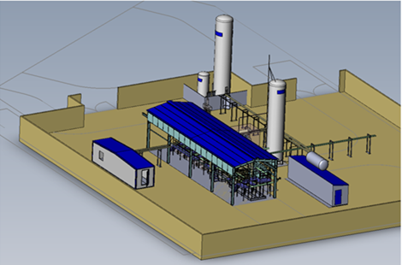
Figure 2 – Overview of the new mid-scale LNG flow facility (the building on the bottom right is the low-scale primary standard, the larger building in the middle contains the meter run package as well as the reference meters and working standards, the building on the left is the control room).
For this reason the development of novel and traceable calibration standards for in-line LNG mass and volume flow is an important part to support the use of flow metering technology throughout the LNG production and distribution chain. An essential component of the new mid-scale primary LNG flow calibration standard (see Figure 2) is the low-scale LNG flow calibration standard for flow rates up to 25 m3/h (11250 kg/h) and measurement uncertainties (k=2) of 0.10 – 0.13%, developed and validated within the previous EMRP joint research project (JRP) ENG03, in the period from
2009 – 2013. The new mid-scale primary standard will build the next step towards full traceability of large scale flow metering. This concerns the design, construction and validation of a mid-scale mass and volume flow calibration standard operating for flow rates up to 400 m³/h (180000 kg/h) and a target measurement uncertainty of 0.15% on mass and 0.20% on volume. A (mass) flow meter operating with a measurement uncertainty (k=2) of e.g. 0.30% (incl. potential installation effects) will be a clear improvement compared to volume determined with tank gauging and conversion to mass through density, with an estimated combined measurement uncertainty of around 0.50 – 0.70% (k=2). With the Coriolis mass flow meter (CFM) and the Ultrasonic flow meter (UFM) two types of flow meter with great potential for the use in custody transfer will be investigated. Both types of flow meters have their advantages and disadvantages. CMFs measure directly mass flow and do not require a density calculation. This is especially useful since the gross calorific value is expressed per unit mass. However, CMFs have size and pressure drop limitations. UFMs in turn require a density calculation but have no size limitations and providing only a very low pressure drop and thus a low risk of LNG flashing. UFMs are therefore well suited for transfer measurements of large volume of LNG. In the further course of the project an ISO standard for flow metering systems will be drafted that will accelerate the application of flow meters in LNG custody transfer and lead to smaller uncertainties and simpler operations. Finally the new mid-scale LNG facility will be used to carry out R&D programs to validate models for extrapolating flow meter calibrations from low to high flow rates and from water to LNG, also since until today LNG flow metering is relying on calibrations with water. The facility will also be used for research results on flow meter installation effects.

4. Composition measurement

The accurate and traceable determination of the LNG composition is crucial for the custody transfer as it allows for the accurate calculation of the physical properties as well as the methane number - both used in transport and trade. For natural gas the most accurate method for measuring the composition is gas chromatography (GC), however in the case of LNG the sampling from the liquid into a homogenous gaseous phase for analysis is challenging. An alternative envisaged for on-line testing in the LNG pipeline stream is Raman spectroscopy, but this approach is comparably new and still in the test phase.

4.1 Mobile and compact sampler
One aim is to address the aforementioned issues by investigating methods to sample and vaporise LNG in a representative, homogeneous and reproducible fashion. In order to achieve this, a mobile and compact sampler has been developed and will be tested and validated on-site at a LBG storage facility in Gothenburg, Sweden.
In addition an accurate laboratory-based LNG sampling and composition measurement reference standard, consisting of sampler, vaporizer, gas standards and GC is being developed. The setup uses certified gas standards of known composition to provide traceability and will be cross-validated by a Raman spectrometer. Afterwards it will be used to validate commercially available LNG sampling and composition measurement systems. In addition the Raman system used for cross-validation will be calibrated by an independent party using a liquefier, before and after the validation measurements with GC.

4.2 Effect of long-term storage of LNG
A second topic that is being investigated is the effect of long-term storage of LNG on its composition and the development of methods to quantify particles in LNG. In general long-term storage of natural gas in the liquid phase is desirable due to the significant increase in the amount of substance that can be stored using the same storage volume. However, since the technique of storing cryogenically cooled liquefied natural gas is new, the effect of storage on the LNG composition is not well documented. Therefore in order to get a better understanding of these aging effects, the aforementioned mobile sampler is used to take a set of samples from a storage facility at regular intervals. Afterwards the samples are being analysed using GC.

4.3 Particle measurement
Since LNG is used as engine fuel, industry, and in particular engine manufactures, have strict requirements regarding its composition and cleanliness. Depending on the technique deployed for supplying LNG and injecting the fuel into the engine, mechanical components like pumps are sensitive to the presence of micrometre-sized particles as they can cause premature wear. Therefore a method for determining the particle number and size distribution in LNG is being developed as part of the work package. In a field study using the mobile sampler combined with an optical particle counter, a series of samples will be taken from a LBG storage site and analysed. The applied test procedure is being developed using representative gas reference standards and particle sources and the results of the field study will be compared with results of an independent gravimetric method for the measurement of particles.

5. Methane number

The methane number (MN) is the natural gas counterpart of the octane number (ON) and describes the knocking resistance of a gas mixture to engine knocking. Knocking is a phenomenon in spark ignited internal combustion engines where ignition occurs at other points in time and space than the spark. This has to be avoided, because it can lead to higher stress on the engine and possibly destruction. To avoid problems the fuels are characterised by a fuel number which expresses the knocking propensity.
Similar to the ON a reference binary mixture is used for the scale were the value 100 corresponds to pure methane with low knocking propensity and the value 0 corresponds to pure hydrogen with a higher knocking propensity. Although widely used to validate the quality of LNG mixtures, there is no homogeneous method for calculating the MN. A main objective is to develop a standardized algorithm for calculating the MN. For the same reason, experimental measurements regarding knocking and ignition delay times will be performed for a further improvement of the calculation algorithm.

5.1 Algorithm for calculating the MN of a LNG mixture based on its composition
The algorithm developed in this work to calculate the methane number from the composition of a LNG mixture is based on the experimental data gathered by the “Anstalt für Verbrennungsmotoren Prof. H. List” (AVL). The AVL method [4] uses the ternary diagrams that summarise the results of the engine tests as an extensive data set for modelling the correlation between the composition of a natural gas mixture and its resulting methane number. The developed algorithm follows for the most part the steps described in the AVL report. One major difference is that the process of deriving the methane numbers for the two sub-mixtures by reading the respective ternary diagram is replaced by an automated procedure. This procedure mimics the way the aforementioned ternary diagrams are likely to be used by a reader. In order to increase the repeatability and reproducibility of the calculation of the MN by means of the new algorithm, a routine is used to minimise the difference in MN for the sub-mixtures ΔMN by varying the methane concentration of both mixtures. For the first time to our knowledge, the new algorithm also determines the uncertainty associated with the calculated MN. The uncertainty contributions mainly stem from the use of the ternary diagrams and in particular the limited resolution of the graphs. Calculated values strongly depend on the composition of LNG yielding expanded measurement uncertainties (k = 2) that vary between 0.2 and 0.7 MN or 0.3 and 0.8% relative. In order to validate the developed algorithm the calculated values for a set of exemplar LNG mixtures were compared with the results from other popular calculation tools developed by “Motorenwerke Mannheim” (MWM) [5] and “Danish Gas Company” (DGC) [6]. The results of the new algorithm show a good agreement with both methods with the difference between the new algorithm and the DGC method being almost negligible. The MWM method yields MN values that agree within ± 1MN.
In order to check the linearity of the developed algorithm, the results for a set of gas mixtures covering a MN range between 60 and 99 were compared with the results derived from the DGC and MWM method. As a result, the newly developed algorithm correlates approximately linearly with the two other methods.

5.2 Spark-Ignition (SI) engine measurements
The MN can only be measured with the equipment originally used by AVL during the development of the method [4]. Unfortunately this equipment is not readily available. If a different engine or different operating conditions are employed the results are different. In order to make the results comparable the so-called service methane number (SMN) has been introduced. The SMN of a gas is defined as the percentage of methane in a mixture of methane and hydrogen which has the same knocking behaviour as the gas to be investigated in an arbitrary engine under arbitrary operating conditions. The SMN shows the same tendencies as the MN, but different absolute values. Depending on the boundary conditions chosen, the correlation between SMN and MN can be nearly linear. To determine the correlation between SMN and MN for the test engines to be used in this project a range of gases the MN of which is known from the work of AVL is measured. To determine the knock propensity the number of knocking events a defined operating point is compared to a calibration curve of methane hydrogen mixtures at the same operating point. On the other hand the operating point at which knocking starts to occur is compared. Subsequently a matrix of typical LNG mixtures will be investigated to determine the dependence of the SMN on the composition.

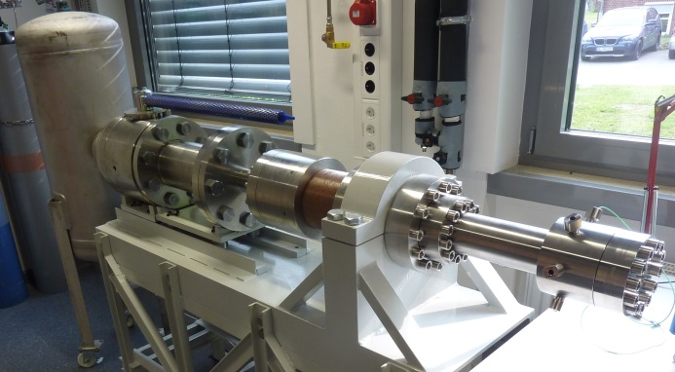
Figure 3 – Rapid Compression Machine (RCM).
5.3 Ignition delay time measurements
One important property of a gas mixture related to knock is the ignition delay time. The ignition delay time is the time between the point where a mixture of combustible gas and oxidizer reaches temperature and pressure conditions under which it is possible to ignite and the actual ignition event. The shorter the ignition delay time the higher the knock propensity of the mixture as hot surfaces for instance can lead to autoignition events before the ignition by the spark. Therefore the same mixtures measured in the engine experiments are measured in a rapid compression machine (see Figure 3) which is basically a single stroke single cylinder engine capable of reaching much defined pressure and temperature conditions very quickly in order to enable the accurate measurement of the ignition delay time. The results can then be used to crosscheck the engine experiments and the calculating algorithm for the MN.

As a next step in this work, the experimental data from the engine and ignition delay time measurements can be used as feedback to modify the algorithm and investigate the effect of higher hydrocarbons on the knocking resistance.

6. Density, Enthalpy and Calorific Value

Besides volume determination, reliable LNG density and energy per mass (calorific value) predictions with small uncertainties are a prerequisite for the custody transfer of energy. Therefore, the aim of this work package, which consists of 4 tasks, is to measure LNG densities at the Ruhr-University Bochum (RUB) and at the national metrology institute of Italy (INRiM) in order to provide an improved model for LNG density prediction. Uncertainties and the traceability of enthalpy and calorific-value calculations will be examined by the national metrology institute of Germany (PTB).

6.1 LNG density measurements using single-sinker densimeter based on the Archimedes (buoyancy) principle
An LNG densimeter was developed at RUB, based on the well-known single-sinker density measurement principle in conjunction with a magnetic suspension coupling. This principle was combined with a special VLE-cell allowing for liquid-density measurements at cryogenic temperatures without changing the composition of the liquid phase. In combination with a new way of operating the apparatus (e.g., supercritical filling), this feature enables measurements, which are much less affected by measurement uncertainties of the liquid-phase composition than measurements with other previous systems. After minimization of a well-known distorting effect – the force-transmission error of the magnetic suspension coupling – density measurements in the homogeneous liquid region of cryogenic liquid mixtures can be carried out with relative combined expanded uncertainties of 0.044% (k=2) [7]. Currently, the densimeter is being deliberately revised to reduce the uncertainty to a value less or equal to 0.030%. The detailed design of the core apparatus of the new densimeter is shown by a sectional drawing in Figure 4.

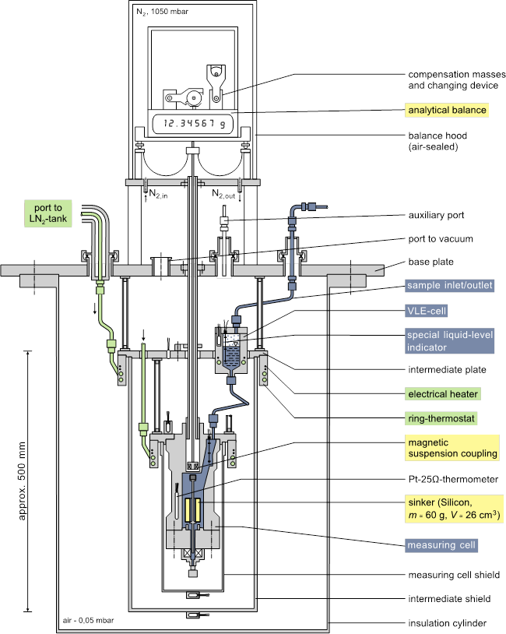
Figure 4 – Schematic diagram of the core apparatus of the densimeter for cryogenic liquid mixtures.
Densities of six different synthetic LNG mixtures were measured over a temperature range from 105 to 135 K at pressures up to 9 MPa. The measurements include saturated liquid densities and homogeneous liquid states as well as supercritical states. The maximum relative deviations of the measured LNG densities from values calculated with the GERG-2008 EOS [8] are between +0.05% and +0.22%, and the experimental saturated liquid densities agree well with the GERG-2008 EOS, in most cases even better with the “Revised Klosek and McKinley Method” (RKM).

6.2 Improvement of a selected equation of state (EOS) for the calculation of LNG densities
The LNG density is crucial for the custody transfer, and in most cases the density is calculated according to the GIIGNL handbook [3]. Therein, the RKM is recom-mended for density calculation, which is a pressure-independent equation to calculate saturated liquid densities within the temperature range relevant for the LNG custody transfer (T < 115 K). Today, it is known that this particular equation is in need of improvement with regard to pressure-dependent density calculations and the corresponding uncertainties. By comparing the new experimental data sets with the relevant equations of state (e.g., RKM and GERG-2008 EOS), RUB developed an enhanced Revised Klosek-McKinley-method (ERKM). The original RKM was supplemented by a new pressure-dependent term. The uncertainties of density calculations with the new ERKM are (independent of pressure) 0.10% for 100 K ≤ T ≤ 115 K and 0.15% for 115 K < T ≤ 135 K. RUB implemented the ERKM in their software tool called ‘TREND’, which also includes other models for the calculation of the thermodynamic properties of LNG.

6.3 LNG ultrasonic speed-of-sound and density sensor
INRiM developed a new type of sensor, which simultaneously determines densities and speed-of-sound (SoS) of LNG samples in the liquid phase at different cryogenic temperatures (91 < (T/K) < 110). The physical measurement principle consists of a dynamic measurement completely different and independent from densimeter developed by RUB, so that the inter-comparison and mutual validation of the experimental results is feasible.

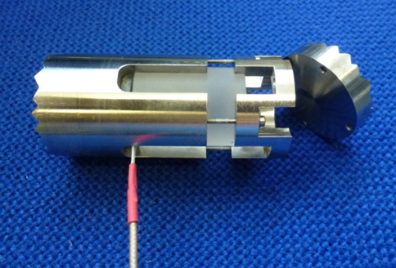
Figure 5 – INRiM's sensor for the simultaneous measurement of the density and speed of sound of a fluid based on the determination of the acoustic impedance of the sample.
The new SoS sensor (see Figure 5) with a relative measurement uncertainty (k=2) of approx. 0.05% works on the principle of the double pulse-echo technique at cryogenic temperature and with a closed-loop cryostat appropriate to thermostat the sensor. This design differs from commercial ultrasonic flow-meters because the cell works completely immersed into the liquid (LNG), in this way density of the LNG sample is obtained (relative measurement uncertainty (k=2) approx. 0.2%) by measuring its acoustic impedance Z and the sound velocity w, ρ=Z/w. Preliminary results [9] obtained in
n-nonane, n-undecane, toluene and water are within 0.2% and thus show a good agreement between the measured density and literature data. Then the sensor will be validated at cryogenic temperature (in the LNG range) inside of the new laboratory cryostat. With the developed SoS sensor, densities and speed-of-sound of methane and, additionally, of LNG-like mixtures will be determined in liquid phase.
6.4 Uncertainty for enthalpy and calorific value calculations
In the preceding EMRP JRP, the PTB calculated the calorific values and enthalpies of formation of typical LNG samples. A notable result of these calculations was the difference in energy content between the LNG in the real liquid state (-160°C, several bar pressure) and at pipeline reference conditions (15 or 25°C, atmospheric pressure). The monetary equivalence of this energy (enthalpy) difference can be up to 500 k€ per shipload. Additionally, the lack of uncertainties, state-of-the-art uncertainty budgets and doubtless traceability for many input quantities for the enthalpy and calorific value calculations, like heat capacities or enthalpies of formation force to critically examine the literature data used in the calculations with respect to the given uncertainties and to check the traceability of these data.

7. Conclusion

Custody transfer of LNG is based on energy measurements of the LNG transferred. The energy is determined by volume, density and the gross calorific value of the LNG. In the framework of an ongoing EMPIR project, the measurement uncertainties of all three main influence parameters are aimed to reduce in order to decrease the overall measurement uncertainty of the energy significantly. The volume of ship tanks is measured (static) using tank level gauging. This measurement method is currently the only established procedure to measure the LNG volume transferred and therefore different to the custody transfer of oil. In the latter case (dynamic) flow measurement is, besides tank level gauging, a well-established procedure in order to determine the volume delivered. This has the advantage that the same, permanently installed infrastructure can be used for each ship which arrives in the port. In addition real-time flow data is available during the load or unload process which improves the handling and operation. Moreover, it can be foreseen that dynamic flow metering of LNG will provide significant lower measurement uncertainties, if the flow meter could be calibrated under real LNG process conditions. In this project a mid-scale calibration test facility will be established, primarily to provide traceable flow measurements (flow rates up to 200 m³/h, expandable to 400 m3/h) under real process conditions, but also as infrastructure to test new approaches related to sampling, density measurement, etc. The accurate and traceable determination of the LNG composition is important, since this is the foundation for the correct determination of the energy content and the calculation of the methane number of the transferred LNG. Furthermore the high-precision determination of density is based on accurate sampling and vaporization. One specific objective of the project was the development of a method for the determination of the methane number, including a correlation of the methane number to the LNG composition, with the aim to harmonize the definition and measurement methods used by gas engine manufacturers worldwide. Another major objective of the project is to provide validated and improved models for determination of LNG density with considerable higher accuracies. In this context improved correlation between density and composition will be established. Within the project a unique high accuracy (off-line) densimeter and a novel (in-line) speed-of-sound (SoS) and density measurement system were developed. That means two independent methods for the determination of the density are available. The SoS and density sensor will be finally used to improve the correlation between SoS and density.

References

- BP, Statistical review of world energy, 65th edition, June 2016.
- OECD/IEA, Medium-Term Gas Market Report 2016: Market Analysis and Forecasts to 2021, 2016.
- GIIGNL, LNG custody transfer handbook, 4th edition (version 4.00), Paris, 2015.
- Forschungsvereinigung Verbrennungskraftmaschi-nen e.V., Erweiterung der Energieerzeugung durch Kraftgase, Teil 1-3, Forschungsberichte Verbrennungskraftmaschinen, Heft 81-82 & 120, Frankfurt/Main – Niederrad, 1968-1971.
- European committee for standardization, prEN 16726:2014, Gas infrastructure – Quality of gas – Group H, Brussels, May 2014.
- Paw Andersen, Algorithm for methane number determination for natural gases, Project Report, Danish Gas Technology Centre a/s, 1999.
- Richter et al., Development of a special single-sinker densimeter for cryogenic liquid mixtures and first results for a liquefied natural gas (LNG), J. Chem. Thermodynamics 93 (2016) 205–221.
- O. Kunz, W. Wagner, The GERG-2008 Wide-Range Equation of State for Natural Gases and Other Mixtures: An Expansion of GERG-2004,
J. Chem. Eng. Data 57 (2012) 3032–3091.
- S. Lago, P.A. Giuliano Albo, A Novel On-Line Ultrasonic Sensor for Simultaneous Density and Speed of Sound Measurements in High Pressure Fluids, 19th Symposium on Thermophysical Properties, Boulder, CO, USA, 21-26 June 2015.

