Discharge coefficient prediction by experimental and numerical simulations through an orifice plate in a round pipe

N. Lancial, M. Arenas, H. Gamel, E. Thibert, N. Dessachy, J. Veau

EDF R&D, 6 quai Watier, BP 49, 78401 Chatou cedex, France
E-mail (corresponding author): nicolas.lancial@edf.fr

Abstract

A square-edged orifice is a pressure differential device commonly used for flow measurements in EDF’s nuclear power plants. The present study presents experimental data obtained on EDF R&D test bench for an orifice plate and computational fluid dynamics calculations (CFD) using the k-ε turbulence model to predict velocity fields, pressure loss and discharge coefficient around this device. Investigations focus on flow rate through the circular square-edged orifice in a round pipe at a Reynolds number close to 8.69E+05. Two pipe configurations have been tested: one with 44D upstream straight length and the second with 9.4D upstream straight length. Velocity profiles are obtained from Laser Doppler Velocimetry measurement (LDV). Simulations presented are only performed for 44D configuration with an open source CFD package developed by EDF (Code_Saturne). Numerical sensitivity studies are carried out using different mesh refinements of the k-ε turbulence model. Discharge coefficient prediction from CFD are compared with ISO 5167 value for 44D upstream straight length. The percentage change in C_{D} is near 2%. Comparison between experimental and numerical velocity fields is promising, with a maximum relative error close to 2.5% upstream and 3.4% downstream of the orifice plate in the center of the pipe.

1. Introduction

The orifice plate is a commonly used industrial device to measure pipe flow rate from a known relationship between a pressure drop and a velocity. It is installed across many industries for single phase flow measurements for this tool is reliable and convenient.

The orifice flowmeter is standardized in ISO 5167-1 [1] and ISO 5167-2 [2]. ISO/TR 12767 [3] gives a general indication of the effects of non-conformity to ISO 5167. Orifice plate differential pressure tappings measurements are generally performed at 1D upstream and 0.5D downstream. The discharge coefficient C_{D} is calculated from Equation (1):

$C_{D}=\frac{4q}{πd^{2}}\sqrt{\frac{(1-β^{4})}{2ρΔP}}$ (1)

where q is the flow rate, d the orifice inner diameter, β is the ratio between the orifice and the pipe inner diameters ρ is the fluid density and ΔP is the pressure drop.

The discharge coefficient $C_{D}$ and its uncertainty can be calculated using the Reader-Harris-Gallagher equation [2]. If orifice plate installation doesn’t meet the ISO 5167-2 requirements, the discharge coefficient value must be evaluated with experimental tests. These tests are usually performed on real pipe configurations. However, some industrial installations cannot be easily tested. CFD simulations could be a relevant tool to evaluate $C_{D}$ in such configurations.

EDF R&D has decided to investigate CFD capability to estimate orifice plate discharge coefficient. To meet this challenge, comparison with reliable experimental data has to be performed.

The literature shows that wall-modelled RANS simulations can well predict the discharge coefficient with, however, a high dependency on the spatial discretization and on the turbulence model.

Benhamadouche et al. [4] have studied a square-edged circular orifice plate without any angle of bevel in a round pipe at Reynolds 25000. They showed that the k-ω SST turbulence models with near wall modelling provide reasonable estimates of the discharge coefficient on. However, the results of the standard k-ε and k-ε with linear production turbulence models are not accurate. These authors also studied a RANS simulation with near wall resolution using the Rij EB-RSM turbulence model [5]. The EB-RSM simulation well predicts the discharge coefficient and shows a significantly reduced dependency on the spatial discretization.

Shah et al. [6] have also studied the same kind of orifice plate geometry. They simulated an orifice flowmeter with a standard k-ε model to show the applicability of this turbulence model to capture turbulence effect. Erdal and Andersson [7] showed in a two-dimensional axisymmetric flow simulation of a circular orifice plate that the pressure drop across the square-edged orifice is highly dependent on the grid refinement around this orifice and the turbulence model used. They found that the axial cell length is more critical that the radial one.

Recently, Shaaban [8] has studied a square-edged circular orifice plate with an angle of bevel without or with downstream ring geometry. He showed that the realizable k-ε turbulence is within 1.4% in discharge coefficient estimation compared to ISO 5167.

Mohan Kumar et al. [9] have also studied this sort of orifice plate. They compared three turbulence models, namely k-ε, k-ω and k-ω SST, showing that the latter gives the closest values to the standard values.

Benhamadouche et al. [10] also demonstrated that a very fine wall-resolved LES with a dynamic Smagorinsky SGS can accurately and precisely model a single phase flow through an orifice plate, showing excellent agreement with the velocity resulting from Shan et al.’s experimental data [11]. These latter used a planar particle image velocimetry (PIV) to measure mean velocity and turbulent fields.

This paper pursues the investigation of the discharge coefficient prediction by experiments and numerical simulations through a square-edged orifice in a round pipe. The main objective is to validate the numerical simulations with experimental data to predict pressure loss, velocity fields and discharge coefficient $C_{D}$.

The present paper is subdivided into three sections. The experimental setup is first presented. Numerical models are then detailed. The experimental data are presented and compared with numerical simulations in the last section.

2. Experimental setup

Experimental tests are performed on EDF R&D flow metering loop (EVEREST). It was built at Chatou (France) in 1997. This test facility is a closed stainless steel pipe loop with a liquid flow rate regulation. Fluid is clean tap water. The test bench provides a steady water stream from 4.10⁴ up to 1.10⁶ Reynolds number. Depending on the test section geometrical configuration, flow range goes from 30 m³.h⁻¹ up to 1100 m³.h⁻¹. Reference volume flow uncertainty goes from 0.36% up to 0.49%, depending of the tested flow rate.

Two experimental configurations have been tested: the first one (Case 1) with a very long straight length of pipe upstream of the orifice plate (44D), downstream a single 90° bend, to conform with ISO 5167 and the second one (Case 2) with a short straight length of pipe upstream of the orifice plate (9.4D), downstream the same 90° bend.

Differential pressure are measured with D and D/2 tappings. 16 pressure tappings have been used in order to evaluate orientation impact. Each tapping has a specific angle as shown in Figure 1.

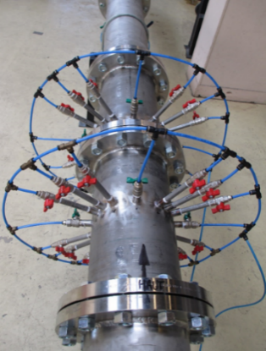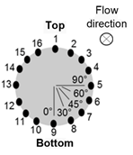

Figure 1: Experimental setup for pressure field.
Three tapping pressure locations (1, 2 and 3) are not presented in this paper due to measurements issues.

The velocity field is measured with a Laser Doppler Velocimetry (LDV) system in rectangular plexiglas pipes (Figure 2) in order to better control beam direction.

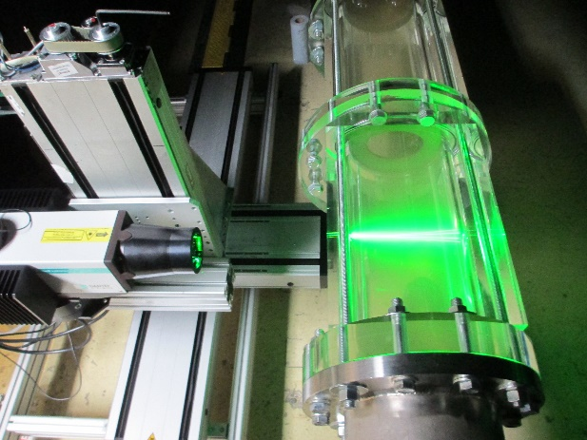

Figure 2: Experimental setup for velocity field (LDV).

The relevant parameters in these experiments are:

D = 204.81 mm; β = 0.59471; α = 44.88°;
e = 4.1 mm; E = 10.057 mm.

with D the pipe inner diameter, α the angle of bevel, e the thickness of the orifice and E the thickness of the plate.

Experimental setup is detailed in Table 1 and in Table 2.

Table 1: Sensors pressure setup
Reference flow rate (m³/h) | Reynolds number Re | Sensor type | Acquisition time per measure (s)
500 | 8.69E5 | 3051 CD3  (Emerson) | 300

Table 2: LDV setup
Reference flow rate (m³/h) | Reynolds number Re | Seeding particles | Number of samples
500 | 8.69E5 | PSP &  HGS | 10000

Case 1 discharge coefficient value and uncertainty are given by ISO 5167-2, sections 5.3.2.1 and 5.3.3.1 [2]. For the tested configuration, $C_{D,ISO}=0.6069 ± 0.5\%$.
Case 2 discharge coefficient value and uncertainty are given by ISO/TR 12767, Table 3 and Table 4 [3]. For the tested configuration, $C_{D,ISO TR}= 0.5995± 1.72\%$.

3. Numerical approach

Code_Saturne is used to launch CFD numerical simulations, which is a customisable open source CFD package developed by EDF. It is based on a co-located finite volume discretization.

Only Case 1 (ISO) is studied by CFD in this paper. The CFD geometry is similar to the experimental test with a few differences in the orifice plate geometry:

D = 203 mm; β = 0.6; α = 45°;
e = 4 mm; E = 10 mm.
The inlet profile is simulated through a recycling method. The flow of the closest cell to the inlet boundary condition is reused as the input to create a fully developed turbulent flow. The velocity and pressure coupling is ensured using the SIMPLEC algorithm.

Two standard velocity scales wall functions are used when needed with near-wall resolved turbulence models while natural conditions (no-slip) are imposed. Standard outlet boundary conditions are also imposed.

The temporal discretization of the transport equations is limited to a first-order Euler implicit scheme. Two different schemes are used to model the convective terms of the transport equations: a first-order upwind scheme for turbulence variables (k and ε) and a second-order central differencing scheme for velocity are used (which is also second-order accurate in space).

All the RANS simulations in the current paper are run with a constant time step (5x10⁻⁵ s) and an unsteady algorithm. A standard k-ε high-Re turbulence model is used, which is a first order turbulence model with two-equation eddy-viscosity models.

ICEM CFD v15.0 is used to generate the mesh. The mesh is structured in the stream-wise direction and is gradually refined near the orifice, as shown in Figure 3.

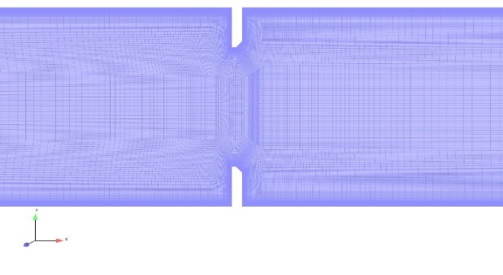

Figure 3: Stream-wise discretization of the finest mesh (y⁺ = 20).
Three levels of refinement are investigated: $y^{+}≈60$ ($≈$ 4.7 million of cells), $y^{+}≈40$ ($≈$6.5 million of cells) and $y^{+}≈20$ ($≈$10 million of cells).

4. Results

4.1 Pressure field

Figure 4 shows experimental and numerical differential pressure results.

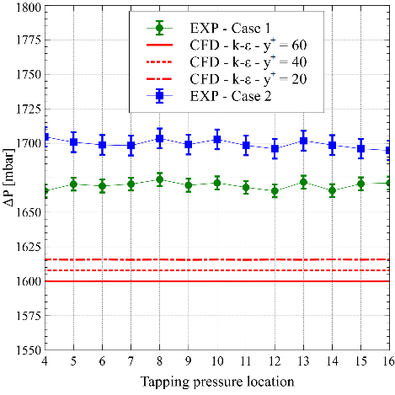

Figure 4: Measurement of differential pressure for both cases.
Figure 4 experimental data show influence of the lack of upstream straight length for all tappings. Average error between Case 1 and 2 is 30.1 mbar, the maximum error is 39.2 mbar (2.3%). Differential pressure comparisons between CFD results and experimental data point out a discrepancy from 3.2% (54 mbar) to 4.2% (69 mbar).

Experimental discharge coefficient and uncertainty are shown in Figure 5. C_{D} numerical results are also detailed.

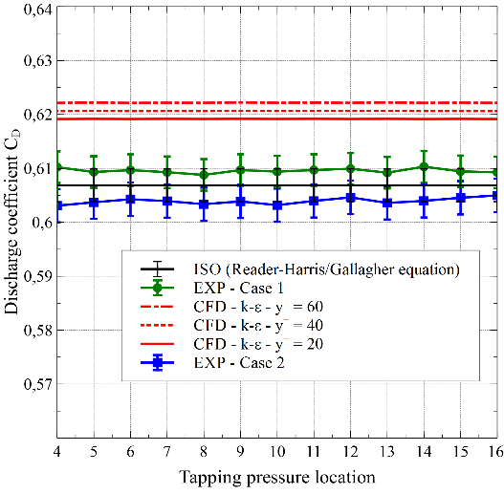
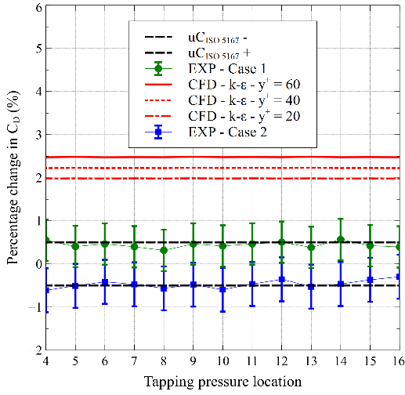

Figure 5: Assessment of the discharge coefficient.
Mean relative error between C_{D} experimental values and C_{D} ISO 5167-2 value for Case 1 is +0.44%. Some experimental values don’t meet the ISO requirements. C_{D} seems to be over evaluated. This issue can be explained by an unspecified sharpness of the inlet edge of the tested orifice plate. Comparisons between ISO 5167-2 C_{D} and the discharge coefficient calculated by CFD shows a 2% bias (Figure 5). This bias is close to the value of 1.8% calculated by Mohan Kumar et al. [8] with the k-ε turbulence model.

Mean relative error between C_{D} experimental values and C_{D} ISO 5167-2 value for Case 2 is -0.47%. Case 2 discharge coefficient is surprisingly close to ISO5167-2 requirements due to the lack of upstream straight length.

The flow rate can be estimated from Equation (2), according to ISO/TR 12767:

$q_{TR}=\frac{π}{4}C_{ISO/TR 12767}\frac{1}{\sqrt{1-β^{4}}}d^{2}\sqrt{2ΔPρ}$ (2)
with $C_{ISO/TR 12767}=C_{ISO 5167}×(1+\frac{c}{100})$, where c is the percentage change in discharge coefficient.
The comparison of the percentage change in CD between ISO/TR 12767 and Case 2 is shown in Figure 6. The additional uncertainty of the discharge coefficient is given by ISO/TR 12767, Table 4, section 8.2.2 [3] from Equation (3):

$u\left(C_{D}\right)=0.5+0.6|c|$ (3)

The percentage change in C_{D} is -1.2% from ISO/TR 12767 for 8D upstream straight length (Table 3, section 8.2.1) and the discharge coefficient uncertainty is ±1.72%. As shown in Figure 6, Case 2 experimental C_{D} meets ISO/TR 12767 requirements.

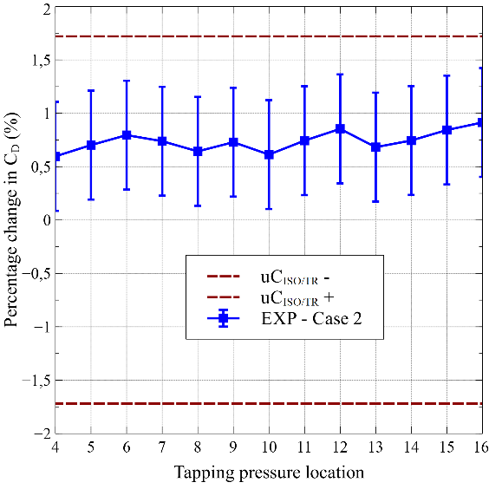

Figure 6: Percentage change in CD between Case 2 and ISO/TR 12767.
Orifice plate flow rate uncertainty can be calculated from the previous parameters with C_{D} values from ISO5167-2 and ISO/TR 12767 (cf. Figure 7).
The flow rate can also be estimated from Equation (4):
$q_{cor}=\frac{π}{4}C_{cor}\frac{1}{\sqrt{1-β^{4}}}d^{2}\sqrt{2ΔPρ}$ (4)
with $C_{cor}=C_{ISO 5167}×K_{rep}$, where $K_{rep}$ is the representativeness coefficient that can be obtained from Equation (5).
$K_{rep}=1-\frac{q_{orifice}-q_{ref}}{q_{ref}}$ (5)
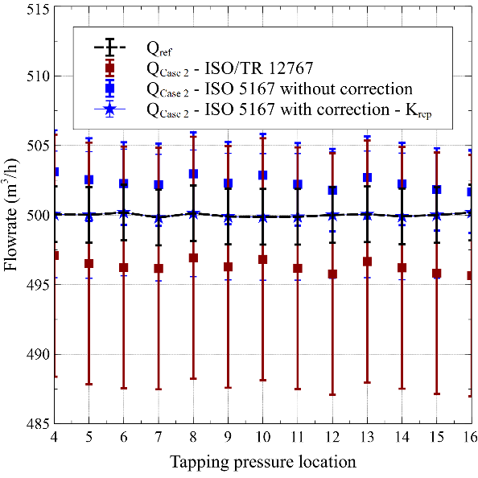

Figure 7: Flow rate measurements in Case 2.
The mean value of $K_{rep}$ is 0.995. The uncertainty of the representativeness coefficient $K_{rep}$ is ± 0.72%. Flow rate uncertainty is then ±0.91% from equation (4). This value is better than flow rate uncertainty calculated with formula (2) from ISO/TR 12767, which is ± 1.75%.
Consequently, the corrected flow rate uncertainty is better than the flow rate uncertainty from ISO/TR 12767, which seems to be conservative. Performing experimental tests prove to be relevant to achieve better flow metering accuracy.

4.2 Velocity field

The velocity field has also been studied upstream (1D) and downstream (0.5D) of the orifice plate. The laser FlowExplorer 0D2C with 2x300 mW (532/561 nm) is used for LDV. The laser uncertainty is given by DANTEC Dynamics at ± 1.9/1000.

The measuring points are given in Figure 8. More measuring points have been studied in the boundary layer compared to the middle of the plane.

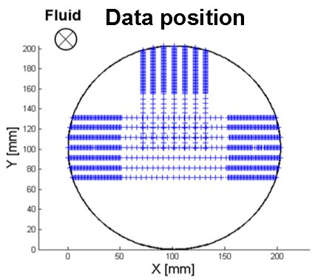

Figure 8: Plot of the measuring points.

Only axial velocity is presented hereafter. The other velocity components are negligible. The Reynolds stresses are not plotted as more samples are required to calculate them. The mean axial velocity profiles are given in Figure 9 and 10 for Case 1. Linear interpolation is hereafter applied to plot 2D velocity fields.

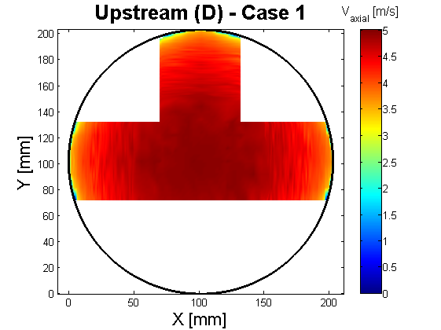

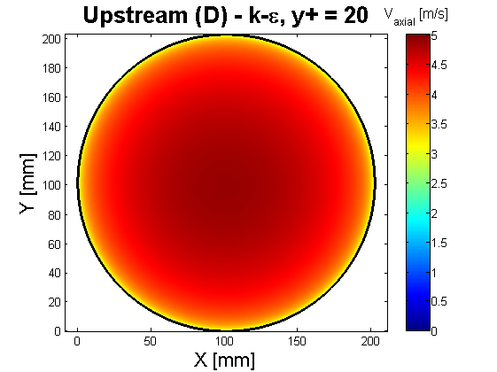

Figure 9: Plot of the upstream velocity field for Case 1.

A similar velocity field can be seen at 1D upstream and 0.5D downstream of the orifice plate between experimental and numerical simulations. The 1D inlet upstream of the orifice plate is close to a fully developed flow. The flow begins to speed up due to the presence of the orifice plate.

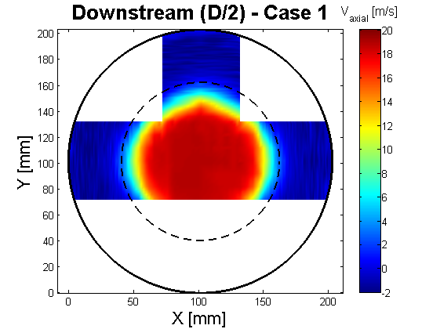

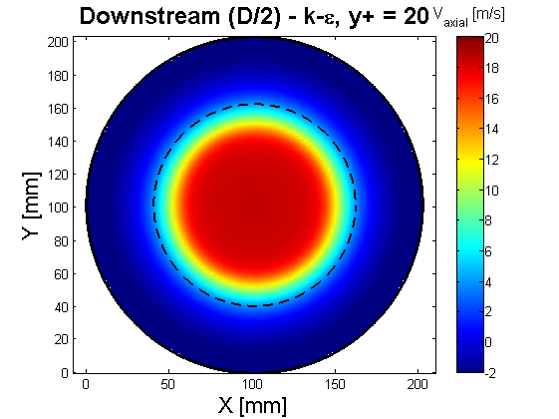

Figure 10: Plot of the downstream velocity field for Case 1.

Streamlines are plotted in Figure 11 to show the fluid velocity behaviour downstream of the orifice plate. No secondary reattachment lengths are found in the numerical simulation, as reported by Benhamadouche et al. [4] for k-ε turbulence model.

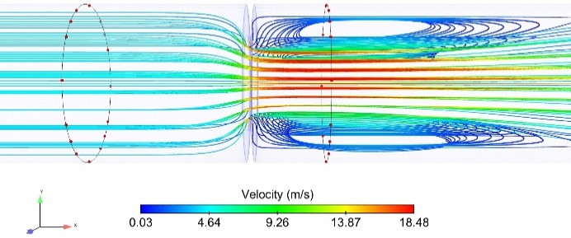

Figure 11: Streamlines around the orifice plate in Case 1 with k-ε turbulence model.

Figure 12 shows 1D upstream and 0.5D downstream velocity fields for Case 2.

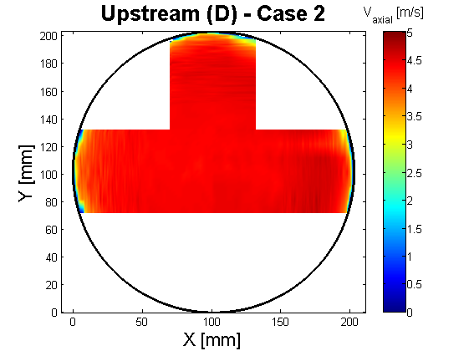

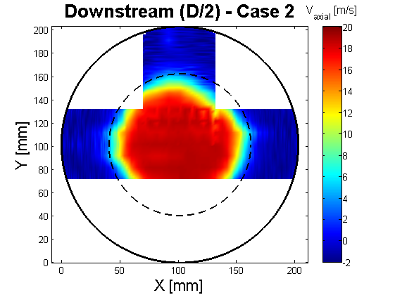

Figure 12: Plot of upstream and downstream velocity field for Case 2.

Comparisons can be done between Case 1 and Case 2 (cf. Figure 13). The axial velocity profile in Case 2 does not have time to be fully developed upstream, contrary to Case 1. The axial velocity flow seems to accelerate for Case 2 on the upper pipe, which corresponds to the upper 90° bend upstream of the orifice plate, where the velocity begins to speed up. Maximum relative error is close to 2.5% between experimental and numerical velocity profiles in the center of the pipe, upstream of the orifice plate. The experimental flow rate can be estimated assuming that upstream velocity is symmetric: the flow rate is so overestimated near 2%.

The effect of the upstream 1D inlet profile is negligible downstream of the orifice plate: the impact of this device is predominant due to the mixing. Maximum relative error is near 3.4% between experimental and numerical velocity profiles in the center of the pipe, downstream of the orifice plate.
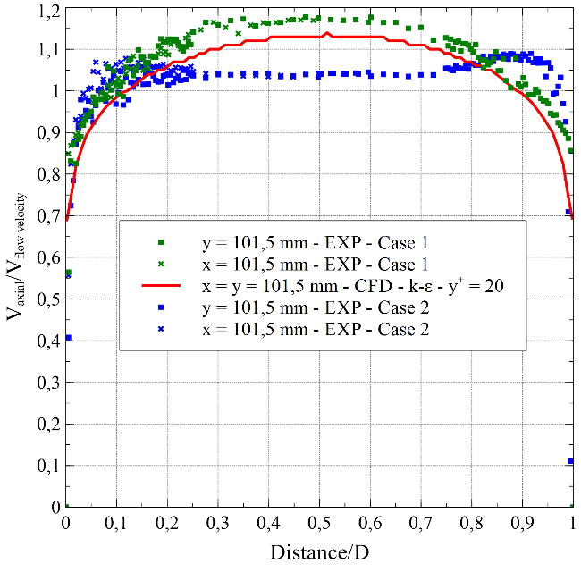
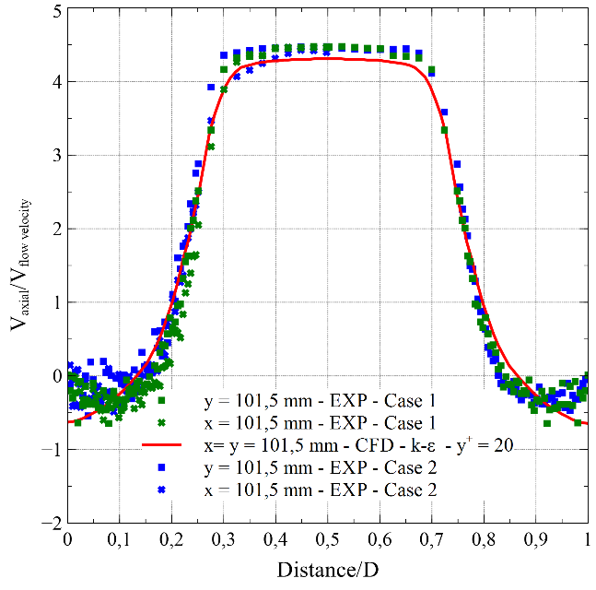

Figure 13: Comparison of the upstream and downstream velocity field for Case 1 and 2.

Axial velocity symmetry can so be applied to Case 1 and Case 2 downstream of the orifice plate.

5. Conclusion

This study presents a comparison between experimental data (differential pressure and velocity profiles) and CFD calculations for an orifice plate. CFD simulation of the orifice plate flow metering using a high-Re standard k-ε turbulence model shows that the pressure recovery downstream of the orifice plate is quite well predicted for a very long straight length of pipe upstream of the orifice plate. Indeed, comparison between ISO 5167-2 C_{D} and the discharge coefficient calculated by CFD shows a 2% bias.

The first CFD simulation predicts quite well the velocity fields even if no secondary reattachment lengths are found in CFD simulation. It has been highlighted that a change in inlet profile 1D upstream of the orifice plate doesn’t clearly disturb the symmetry of the fluid flow downstream due to the mixing created by the orifice plate.
Comparison between experimental and numerical velocity profiles is promising, with a maximum relative error close to 2.5% upstream and 3.4% downstream of the orifice plate in the center of the pipe.

To improve the previous conclusions, new CFD calculations have to be performed with other turbulence models. Low-Re turbulence models as k-ω SST and EB-RSM will consequently be tested to improve orifice plate discharge coefficient numerical predictions. These CFD simulations will be performed not only with an orifice plate installed in accordance with ISO5167-2 but also with non-conformity configurations.

References

- ISO 5167-1, “Measurement of fluid flow by means of pressure differential devices inserted in circular cross-section conduits running full – Part 1” (2003)
- ISO 5167-2, “Measurement of fluid flow by means of pressure differential devices inserted in circular cross-section conduits running full – Part 2” (2003)
- ISO/TR 12767, “Measurement of Fluid Flow by Means of Pressure Differential Devices – Guidelines to the Effect of Departure from the Specifications and Operating Conditions given in ISO 5167” (1998).
- Benhamadouche S., Malouf W.J. and Arenas M., “Effects of spatial discretisation and RANS turbulence modelling on the numerical simulation of a flow through a square-edged orifice in a round pipe”, E-proceedings of the 36th IAHR World Congress, The Hague, the Netherlands (2015).
- Manceau R. and Hanjalić K., “Elliptic blending model: a new near-wall Reynolds-stress turbulence closure”, Phys. Fluids, Vol. 14, pp. 744-754 (2002)
- Shah M. S., Joshi J. B., Kalsi A. S., Prasad C. S. R. and Shukla D. S., “Analysis of flow through an orifice meter: CFD simulation”, Chemical Engineering Science, 71, pp. 300-309 (2012).
- Erdal A. and Andersson H.I., “Numerical aspects of flow computation through orifices”, Flow. Meas. Instrum., Vol. 8, No. 1, pp. 27-37 (1997).
- Shaaban S., “Optimization of orifice meter’s energy consumption”, Chemical Engineering Research and Design, 92(6), pp. 1005-1015 (2014).
- Mohan Kumar H.M., Yogesh Kumar K.J. and Seshadri V., “CFD Analysis of Flow Through Dual Orifice Plate Assembly”, International Journal of Emerging Technology and Advanced Engineering, Volume 5, Issue 10 (2015).
- Benhamadouche S., Arenas M. and Malouf W. J., “Wall resolved large eddy simulation of a flow through a square-edged orifice in a round pipe at Re=25000”, NURETH, 16th international Topical Meeting on Nuclear Reactor Thermal Hydraulics, Chicago (2015).
- Shan F., Fujishiro A., Tsuneyoshi T. and Tsuji Y., “PIV measurements of flow field behind a circular square-edged orifice in a round pipe”, Experiments in Fluids, 54(6), pp. 1-18 (2013).

