Metrological support of gas flowrate measurement in the Russian Federation
ViktorFafurin¹, Ilya Isaev²,

¹FGUP VNIIR, fafurin.viktor@yandex.ru, Kazan, Russian Federation
¹FGUP VNIIR, ilya.isaev@mail.ru, Kazan, Russian Federation

E-mail (corresponding author): office@vniir.org

Abstract
The key objective of this report is to familiarize the audience with the contemporary state of the metrological base in the field of natural gas flowrate measurement in the Russian Federation and invite the conference members to cooperate in the specified field.

1. Introduction

Russian Federation is one of the leading exporters of natural gas. Metrological issues related to natural gas flowrate measurement are directly associated with the economical and industrial well-being of the country.

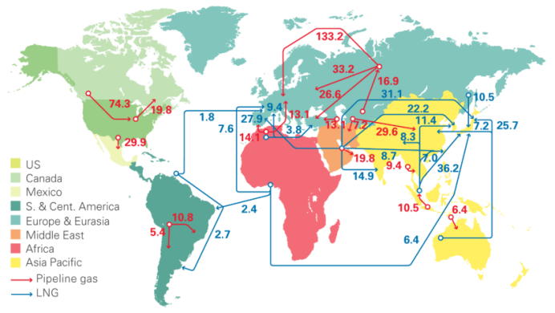

Figure 1:Natural gas trade movements 2015 - trade flows worldwide (billion cubic meters) (source: Includes FGE MENAgas service, GIIGNL, IHS, IHS Waterborne, PIRA Energy Group and Wood Mackenzie) [1]

However, the solution of these issues is not only a national task – it is a result of consolidated interaction of the international metrological community. This article contains the basic principles of metrological support of of gas flowrate measurements in the Russian Federation in order to increase the effectiveness of cooperation between the metrological community and the Russian Federation in the specified field.
The following four points are related to the metrological support of gas flowrate measurement in the Russian Federation:
- Federal laws of the Russian Federation directly or indirectly related to the issued of metrology
- traceability of measurement results: this section contains issues of the standards base of the Russian Federation in the field of gas flowrate measurement and the national standard specifying the state measurement chain for gas flowrate measuring instruments
- a series of standards (both national and interstate) specifying general issues arising during the performance of gas flowrate measurements
- recognition by the international metrological community: this section describes the cooperation of the leading research institute (in the field of gas flowrate measurement) of the Russian Federation - FGUP VNIIR - within the framework of РМО and the participation of FGUP VNIIR in global metrological projects

An individual section of this article is dedicated to each of these general points.

2. Laws on metrology

Today, legislation on the Russian Federation contains a broad range of legal and normative regulations, adherence to which is aimed at ensuring the uniformity and accuracy of measurements. The legal framework of Russian metrology is presently determined at the highest possible level.

2.1. Constitutional provisions in the field of metrology.
According to the Constitution of the Russian Federation (Article 71, r), standards, reference standards, metric system and time measurement are under the jurisdiction of the Russian Federation. Thus, these provisions of RF Constitution establish the centralized management of the general issues of legal metrology. These constitutional provisions were developed by the adoption of laws "On ensuring the uniformity of measurements" and "On technical regulation", Decrees of the Russian Government on individual issues of metrological activity, and regulatory documents of Rosstandart of the Russian Federation: technical guidelines, national, interstate and international standards, as well as the recommendations of state research metrological institutes of Rosstandart of the Russian Federation specifying the fundamental principles of metrological activity.

2.2. Law "On technical regulation"
The law was adopted in order to reduce administrative and economical pressure exerted on manufacturers; eliminate technical barriers in trade; increase the effectiveness of market protection against hazardous products, and facilitate the country's accession to the WTO and rapprochement of Russian codes in the field of technical regulations with international rules and regulations. This Federal Law establishes relations occurring during the development, adoption, application and fulfilment of product requirements. This law is aimed at the elimination of redundancy in the mandatory requirements of standards; removal of the unreasonable barrier for business development; provide an acceptable level of product safety.

2.3. Law "On ensuring the uniformity of measurements"
Law of the Russian Federation "On ensuring the uniformity of measurements" establishing the legal framework of ensuring the uniformity of measurements regulates the relations between state authorities of the Russian Federation and legal bodies and individuals regarding the manufacturing, issuing, operation, repair and import of measuring instruments. The law is aimed at the protection of rights and legal interests of citizens, established public order and economy of the Russian Federation, and negative circumstances of inaccurate measurement results. The law promotes progress on the basis of creation and application of state standards of physical units and harmonization of the Russian measurement system with the world practice. Federal Law "On ensuring the uniformity of measurements" establishes the State system of ensuring the uniformity of measurements (hereinafter – GSI) and determines mandatory metrological requirements for measurements performed in this field. For instance, GSI field comprises:
- performance of activities in the field of health care;
- performance of environmental protection activities;
- trading and the performance of packaging works;
- performance of activities in the field of national defence and safety;
and other types of activities with a total of 19 points. The law establishes the following mandatory requirements for measurements: measurements according to GSI must be performed using certified measurement procedures and measurement instruments of an approved type having passed the verification process. In order to fulfil the requirements of this Federal Law the following orders have been issued by the Ministry for Industry and Trade of the Russian Federation:
- No.4091 dd. December 15, 2015 "On establishment of the Order of certification of primary reference measurement procedures (methods), reference measurement procedures (methods) and their application";
- No.1081 dd. November 30, 2009 "Procedure for standard sample or measuring instrument type approval testing and the procedure for issuing type approval certificates for standard samples or
measuring instruments, setting or change of the validity term for the said certificates, verification intervals for the measuring instruments, and requirements for standard sample and measuring instruments type approval marks and the procedure of their application";
- No. 1815 dd. July 02, 2015 "On approval of the procedure for verification of measuring instruments, requirements for verification marks and contents of the verification certificate";
instantiated procedures performed during procedure approval, testing and verification of measuring instruments.

2.3 Technical regulations
One of the major goals of technical regulation in the territory of the Russian Federation is the adoption of technical regulations (hereinafter – TR). TR are adopter in order to protect lives and health of individuals and legal bodies, state and municipal property, protect the environment; prevent actions which may mislead consumers, provision of energy efficiency and efficient use of resources. The following TR from the field of transportation of liquid and gaseous hydrocarbons are presently undergoing the acceptance procedure within the Eurasian Economic Union (hereinafter – EEU):
- EEU technical regulation "On safety of combustible natural gas prepared for transportation and (or) use".
- EEU technical regulation "Requirements for liquefied hydrocarbon gases designed for use as fuel".
- EEU technical regulation "On requirements for main pipelines for transportation of liquid and gaseous hydrocarbons"

3 State verification schedule and standards of the Russian Federation for gas flowrate measuring instruments

In accordance with the law of the Russian Federation "On ensuring the uniformity of measurements" unit standards and measuring instruments used in the territory of the Russian Federation should be traceable to state primary standards of the corresponding units. In order to implement the provisions of the law, state verification schedules of the corresponding measurement units approved in accordance with an established procedure in the form of a regulatory document are currently being developed. The verification schedule for volumetric and mass flowrate measuring instruments is regulated in the territory of the Russian Federation by GOST R 8.618-2014 "State verification schedule for means measuring volume and mass flow of gas"
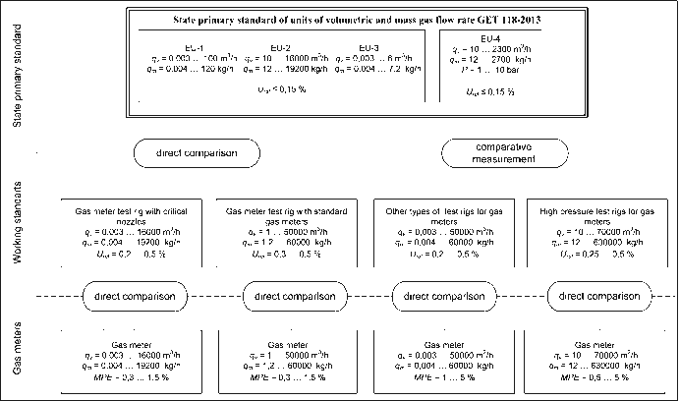
Figure 2: Verification schedule

At the top of the state verification schedule is the State primary standard of units of volumetric an mass flowrate of gas GET 118-2013. The standard is designed for storage and reproduction of units of volumetric and mass gas flowrate within the range of 3∙10⁻³ to 16000 m³/h, transfer of unit sizes to working standards and working measuring instruments in order to provide the uniformity of volumetric and mass gas flowrate measurements. The standard is represented by a complex of facilities reproducing a measurement unit with the highest accuracy in the Russian Federation. The standard comprises 3 facilities operating with air at atmospheric pressure and a single facility working on air at pressure up to 1 MPa.

Transfer of a volumetric flowrate unit from the State primary standard to working standards in accordance with the state verification schedule can be performed by means of a direct comparison or unit transfer with the use of a comparison standard. Critical nozzles having received a measurement unit from GET 118-2013 are particularly used as an integral part of first echelon working standards. Rotary and turbine gas meters with special configurations of various standard sizes demonstrating high repeatability and stability of metrological characteristics are used as comparison standards. Besides, these comparison standards can be used during the performance of international comparisons.

Ural regional metrological centre (URMTs) has been established in the Russian Federation for testing and verification of gas flowmeters in working conditions on the basis of Dolgoderevenskaya gas-metering station (working medium – natural gas, pressure up to 7.5 MPa). Its functional capabilities and metrological characteristics correspond to those of the best foreign metrological centres. Its limits of the relative error of gas flowrate (volume) measurement amount to 0.3%. Together with FGUP VNIIR the centre performs testing of national and foreign measuring instruments for the purpose of confirmation of metrological characteristics and preparation of recommendations on their possible use at the facilities of PJSC Gazprom.

Construction of the third section of URMTs is a highly promising project. It will allow to establish a fully functional metrological centre for testing of flow meters and gas meters of all standard sizes within the gas pressure range of 0.6 to 7.5 MPa. In the future this centre is going to accommodate primary gas flowrate standards working on natural gas and pressure, and develop testing facilities for the generation of various gas flows for research purposes.
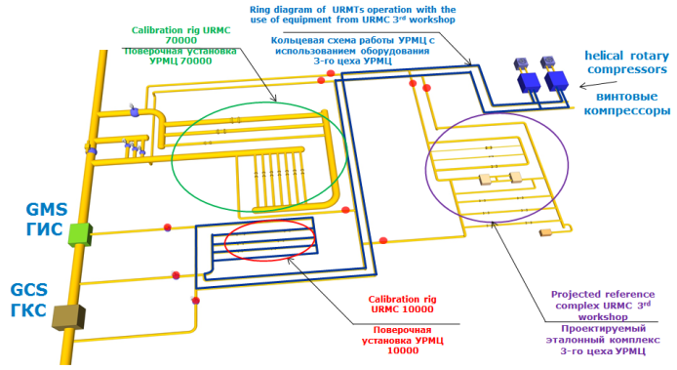
Figure 3: Ural metrological centre

The reference standard of the currently designed third shop is designed for the use of Gas Oil Piston Prover - GOPP. Verification gas of the reference standard is combustible natural gas. Uncertainty of the reference standard according to the design project amounts to 0.07% within the flowrate range of 5 to 120 m³/h at gas pressure up to 7.5 MPa. IRPP rotary piston prover is planned to be used at the next level of the hierarchy of measurement unit transfer. IRPP prover has a modular structure composed of ten IRM-Duo rotary gas meters with gas flowrate ranges under working conditions from 5 to 400 m³/h each. Its uncertainty amounts to 0.13-0.15% within the flowrate range from 5 to 4000 m³/h at gas pressure up to 7.5 MPa.

4. Standards used for natural gas flowrate measurements in the Russian Federation

4.1 General provisions
An essential requirement for the increase of measurement accuracy is the modernization of regulatory documentation. The majority of issues related to the organization of metrological support in the field of natural gas metering have been thoroughly developed and solved in accordance with the requirements of effective regulatory documents. Below is a brief summary of regulatory documentation (hereinafter – RD) establishing general metrological and technical requirements for gas flowrate measurements:
- GOST 8.417-2002 "State system for ensuring the uniformity of measurements. Units of quantities". The standard establishes units units of physical quantities used in the territory of the country: names, designations, definitions and rules of their application
- GOST 2939-63 "Gases. Conditions for determination of volume". The standards is related to gases and specifies conditions for determination of their volume in the process of mutual payments with consumers. In the Russian Federation gas temperature 20 °С, pressure 0.101325 MPa and relative humidity 0% are referred as standard conditions.
- GOST R 8.563-2009 "State system for ensuring the uniformity of measurements. Procedures of measurements". The standard covers measurement techniques and procedures including the procedures of quantitative chemical analysis, and establishes general provisions and requirements related to development, certification, standardization, and application of measurement procedures, as well as to corresponding metrological supervision
- GOST R 8.596-2002 "State system for ensuring the uniformity of measurements. Metrological assurance for measuring systems. Main principles". The standard establishes general provisions on the metrological support of measurement systems (hereinafter – MS) at the following stages of their life cycle: development (design), manufacturing and operation.
- GOST R 8.733 – 2011 "State system for ensuring the uniformity of measurements. Systems for measuring the quantity and parameters of free oil gas. General metrological and technical requirements". The standard is related to systems for the measurement of quantity and parameters of free oil gas and specifies general metrological and technical requirements.
- GOST R 8.741-2011 "State system for ensuring the uniformity of measurements. Volume of natural gas. General requirements for measurement procedure". The standard concerns procedures for the measurement of volume of natural gas reduced to standard conditions and establishes general requirements for natural gas volume measurement procedures. This standard is used during the development of procedures for the measurement of volume of gas transferred to consumers or transported by main pipelines.

4.2 Standard measurement procedures
Standard measurement procedures used in the territory of the Russian Federation are classified into groups on the basis of utilized primary flowrate transducers:
- GOST R 8.740-2011 State system for ensuring the uniformity of measurements. Flow rate and quantity of gas. Procedure of measurements by turbine, rotary and vortex meters.
- GOST R 8.611-2013 State system for ensuring the uniformity of measurements. Flow rate and quantity of gas. Procedure for measurements of by ultrasonic meters
- GOST 8.586.1,5-2005 (ISO 5167-1,5:2003) Measurement of liquids and gases flow rate and quantity by means of orifice instruments.
The specified standards establish generally accepted procedures for the measurement of volumetric flowrate and volume of natural, commercial oil and other single- and multicomponent gases reduced to standard conditions with the use of various measuring techniques.

4.3 Properties of natural gas
Concerning the issue of determination of properties and quality of measured gas, the majority of standards of the Russian Federation are harmonized with corresponding ISO standards:
- GOST 30319.2 «Natural gas. Methods of calculation of physical properties. Definition of compressibility coefficient». The standard specifies four methods for the definition of compressibility coefficient of natural gas: with unknown complete composition (two methods NX19 and GERG-91) and known composition of natural gas (AGA8-92 DC and VNIC SMV methods). The standard specifies preferred application fields of each method in accordance with measured parameters (pressure, temperature, density of natural gas at standard conditions and composition of natural gas), however does not prohibit the use of any of these methods in other fields.
- GOST R 8.662-2009, ISO 20765-1:2005 «State system for ensuring the uniformity of measurements. Natural gas. Gas phase thermodynamic properties. Methods of calculation for transmission and distribution applications on base of the AGA8 fundamental equation of state». Harmonized with ISO 20765-1:2005
- GOST R 8.769-2011, ISO 12213-3:2006 «State system for ensuring the uniformity of measurements. Natural gas. Compression factor of gas phase. Method of calculation based on gas physical properties». Harmonized with ISO 12213-3:2006
GOST R 8.662-2009, ISO 20765-1:2005 and GOST R 8.769-2011, ISO 12213-3:2006 are standards which specifies the method of calculation of compressibility factor of natural gas prepared for transmission and distribution over gas transmission pipelines, at condition that it is only in the gas phase. The standard concerns gases prepared for transmission over gas transmission pipelines in pressure «p» and temperature «t» ranges, in which transmission and distribution of gases in performed in practice.

4.4 Sampling and gas properties:
- GOST 31370-2008, ISO 10715:1997 «Natural gas. Sampling guidelines». The standard specifies requirements for sampling, preparation and handling of representative samples of main gas which has been subjected to processing. It also features requirements for sampling methodology, location of the sampling probe and structure of auxiliary equipment for sampling and sample handling. The standard concerns spot, direct and sequential sampling. Special attention is given in the standard to such components of natural gas as oxygen, hydrogen sulphide, air, nitrogen and carbon dioxide. The standard does not concern sampling of liquid or multiphase flows. Harmonized with ISO 10715:1997
- GOST 31369-2008, ISO 6976:1995 «Natural gas. Calculation of calorific values, density, relative density and Wobbe index from composition». The standard concerns physicochemical quality indicators and specifies algorithms for calculation of high heating value, low heating value, density, relative density and Wobbe index of natural gases, natural gas simulators and other combustible gaseous fuels on the basis of known composition at standard measurement conditions. The calculation of physicochemical quality indicators of natural gas requires the use of various physical values of pure components specified in the standard. The standard features methods of accuracy assessment of calculated values of main quality indicators of natural gas. The methods of calculation of quality indicator values on the basis of molar fraction or mass concentration are applicable for any composition of natural gas, natural gas simulator or any other combustible fuel which is generally in gaseous state. For the calculation of quality indicator values of a gas, whose composition is known in volume ratios, these methods are only applicable for gases generally composed of methane (molar ration of methane not less than 0.5).Harmonized with ISO 6976:1995

4.5 Compositional analysis of gas
- GOST 31371-2008, ISO 6974:2000 «Natural gas. Determination of composition with defined uncertainty by gas chromatography». Composed of 7 parts. GOST 31371.7 features a procedure of measurements of molar ratio of components of combustible dried natural gas by gas chromatography in ranges specified in the standard. The procedure is designed for application in analytical (testing) laboratories and at metering station monitoring the physicochemical quality indicators of combustible dried natural gas. The procedure can represent a basis for the performance of commercial accounting of combustible dried natural gas. Harmonized with ISO 6974:2000

4.6 Analysis of Sulphur compounds in gas
- GOST 22387.2-2014 «Combustible natural gases. Methods for determination of hydrogen sulphide and mercaptan Sulphur». The standard concerns combustible natural gases and specifies methods for determination of hydrogen sulphide and mercaptan sulphur: - photocolorimetric – with mass concentration of hydrogen sulphide in the range from 1.0*10⁻³ to 5.0*10⁻² g/m³ and mercaptan sulphur in the range from 1.0*10⁻³ to 2.5*10⁻¹ g/m³; - potentiometric – with mass concentration of hydrogen sulphide and mercaptan sulphur in the range from 1.0*10⁻³ to 0.5 g/m³; - iodimetric – with mass concentration of hydrogen sulphide in the range from 1.0*10⁻² to 150.0 g/m³ and mercaptan sulphur in the range from 1.0*10⁻² to 1.0 g/m³.
- GOST R 53367-2009 «Combustible natural gas. Determination of sulfur-containing components using chromatographic method». The standard concerns combustible natural gases transmitted over gas transmission pipelines, designed for industrial and utility application, and features a chromatographic method of determination of sulfur-containing components: hydrogen sulphide, mercaptans and carbonyl sulphide. The standard is used for determination of sulphur-containing compounds in methane, combustible natural gas and natural gas simulators.

4.7 Moisture content analysis
- GOST R 53762-2009 «Natural combustible gases. Determination of hydrocarbon dew-point temperature». The standard specifies requirements for the measurement of hydrocarbon dew-point temperature by visual and automatic condensing methods in natural combustible gases supplied from field gas treatment facilities, underground gas storage facilities and gas processing plants to main gas pipelines, transmitted over them and supplied to consumers.
- GOST R 53763-2009 «Natural combustible gases. Determination of water dew-point temperature». The standard specifies requirements for the measurements of water dew-point temperature by visual and automatic condensing and sorption (dielkometric, coulometric, piezoelectric, interferometric) methods in natural combustible gases supplied from field gas treatment facilities, underground gas storage facilities and gas processing plants to main gas pipelines, transmitted over them and supplied to consumers, and used as fuel for internal combustion engines.

5. Interaction with the international metrological community

National standard of the Russian Federation
GET 118-2013 participates in international comparisons: COOMET projects No.219/Sk-00 and No.412/UA/07 have been completed. As a result of comparisons, FGUP VNIIR Calibration and Measurement Capabilities (CMCs) have been registered in BIPM CMC Database in gas flowrate range from 0.12 to 800 m³/h, and the institute has received an approval to use the CIPM MRA logo.
Bilateral comparisons of national standards of China and the Russian Federation are presently performed within the framework of COOMET topic No.679/RU/16. By mutual agreement with NIM, critical nozzles with nominal flowrate from 4.5 to 50 m³/h have been selected as transfer standards. This work was joined by the National Institute of Germany PTB, and after the publication of comparison results this comparison can be reclassified as a supplementary comparison within COOMET. The experimental part of works was completed in summer of 2016.

In 2016 a new topic was registered in COOMET - topic No.680/RU/16 on the performance of comparisons in gas flowrate range from 20 to 6500 m³/h. We invite all members of the metrological community to consider the possibility of participation in this comparison.

6. Conclusion
The article reflects the general features of metrological support of gas flowrate measurements in the Russian Federation. The established vertical hierarchy of metrological support facilitates effective interaction with metrological institutes from other countries. FGUP VNIIR has received recognition of the international metrological community and a right to use the CIPM MRA logo. The availability of this logo on calibration certificates implies that:
- VNIIR has signed the CIPM Mutual Recognition Agreement (as one of Rosstandart institutes) and therefore assumed an obligation to follow the regulations, rules and principles of ensuring the uniformity of measurements established by the international metrological community;
- VNIIR fulfils these obligations by stating and confirming its measurement capabilities (СМС) published in an open international database managed and continuously updated by BIPM;
- VNIIR is an active participant of international key comparisons of standards allowing to determine and confirm the accuracy level of Russian state standards, from which units sizes are, in turn, transferred to working and other measuring instruments using approved measurement chains;
- certificates will be accepted and have legal force abroad;
- VNIIR has a right to perform calibrations of measuring instruments for foreign customers.

It does not seem possible to reveal all peculiarities of metrological support even for an individual group of measurements, therefore please contact the authors of the article using contact information provided in the Abstract if you require any additional information. All members of the metrological community are invited to cooperate both within regional metrological organizations and in the format of direct bilateral contacts regarding on issues of ensuring the uniformity of gas flowrate measurements.

References
[1] BP Global, Natural gas trade movements http://www.bp.com/en/global/corporate/energy-economics/statistical-review-of-world-energy/natural-gas/natural-gas-trade-movements.html

All Federal laws, subordinate act, technical regulations, interstate and national standards are available on-line at the following addresses: http://fundmetrology.ru/default.aspx, http://www.gost.ru/wps/portal/, www.eurasiancommission.org

