Calibration of A MEMS Anemometer
Liji Huang¹, Yenan Liu¹, Changming Jiang¹, Wenhong Deng¹, Li Lei² and Pujun Zhao²

¹Siargo Ltd., 3100 De La Cruz Boulevard, Suite 210, Santa Clara, California 95054 USA
²National Institute of Measurement and Testing Technology, Chengdu 610041, China
E-mail: Liji@Siargo.com

Abstract

Accurate calibration of an anemometer would often be required in a wind tunnel which can provide the reproducible metrology environment for the desired air velocity. However, such a calibration procedure is expensive and not suitable for mass production as the demands of the HVAC or building automation related IOT shall have to deploy a very large number of the anemometers. In this paper, we discuss the comparison of the calibration for MEMS anemometers in a commercial wind tunnel and a specially designed closed conduit with a diameter of 19 mm. It is found that the MEMS anemometer packaged into a plate at the probe that is parallel to the air flow direction with a well-defined boundary layer can be accurately calibrated to a full dynamic range over 100:1 in the designed closed conduit with only a constant deviation to the values obtained in a commercial wind tunnel. This allows mass production of the anemometers at a very low cost which enables the current application demands. This paper will discuss the design principle, the test data, and the theoretical understandings.

1. Introduction

Anemometers have a wide variety of applications in multiple industries for the instant acquisition of the air or gas flow speed metrology. The common types of the anemometers include rotary cups for meteorological (wind) measurements, turbine or vane type air speed meters in a manometer, pitot tube in ducts or enclosed conduits for air speed via the calculation from the measured differential pressures, and the hotwire anemometer often used in HVAC, laboratory or handheld measurement applications. Less common but high accurate Laser Doppler Anemometer (LDA) and ultrasonic anemometer are mostly used in the laboratory environments. Hotwire anemometer is the one considered to be commonly used yet with good accuracy. The first commercial hotwire anemometer can be traced back in 1959 when Thermo-Systems, Inc. (TSI) designed a cooled-film anemometer for transient measurements in high temperature fluid flows. [1] The anemometers based on this approach utilize the thermal dissipation or the King’s Law [2] where a fluid flow speed is proportional to the temperature change due to the heat of the hotwire carried away by the fluid flow and the heat transfer shall be measured by a temperature sensor at the downstream or the fluid flow speed can be calculated from the power consumption from a constant powered hotwire due to the temperature variations caused by fluid flow. In addition to a better accuracy, the hotwire anemometers also have faster responses. But they are fragile and prone to be damaged by foreign materials and are sensitive to temperature variations. Furthermore, as the anemometers shall be applied for open space air speed measurement, calibration of the anemometer is often done in a complicated wind tunnel system.

In recent years, increasing demands for anemometer clusters in building automation with air ventilation control and management asking for a high accurate yet cost effective anemometer that can measure and transmit the local air ventilation data to a central control system such that the system would be able to automatically or remotely adjust the local air ventilation and thereby the objective of reducing the system energy consumption can be realized. For the high raise buildings there will have a need of thousands of such anemometers with individual address and data process capability. The current hotwire anemometers and other technologies could not meet these requirements and therefore it requires a new approach of manufacture such an anemometer that shall be robust, reliable, and accurate while cost effective for manufacture. In this paper we present a new design of an anemometer using MEMS mass flow sensors with integrated MEMS temperature and humidity sensor. The paper shall also discuss a simple calibration approach in a closed conduit system and compared to those data acquired from a wind tunnel system.

2. Design of a MEMS anemometer

2.1 Meter assembly and meter probe
The design objective of this anemometer is aimed for the building automation, one of the popular internet-of-things (IOT) applications. It shall be used to measure the air flow in an air pathway or duct which would have different sizes and even different shapes. In addition, these pathways are often at a high ceiling or the air pathway ducts are pre-existed. Therefore it is virtually impossible to install an air flowmeter with a closed conduit into the pathway to acquire the desired data. Anemometer would then be a best choice of technology for such applications. Figure 1 shows the picture of an assembled anemometer with an insertion probe formality. The anemometer meter contains 5 major components as indicated in the figure. The meter head or the probe has a MEMS mass flow sensor and a MEMS temperature and humidity sensor integrated to provide the requirement environmental data; the probe and guided scale shall assist the user to insert the probe at the desired depth into the duct or an air pathway such that the proper metrology data can be obtained; the installation socket shall assist the user to fix the anemometer onto the air pathway; the interface provides the power and data connection; and the electronics for signal conditioning and data process are located inside the probe.

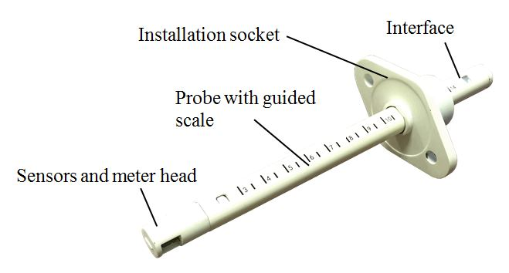

Figure 1: An assembled anemometer.

As the building automation applications usually require a cluster of such anemometers for the system to monitor and optimize the energy distribution inside a commercial building or at a residential house, cost would be a big factor for the feasibility. The anemometer is made of engineering plastics such as polycarbonate or fibre enhanced polycarbonate and the electronics are with a proprietary application specific integrated circuitry (ASIC).

2.2 Meter probe and electronics

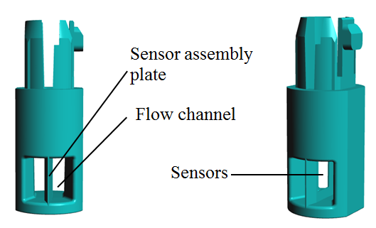

Figure 2: Design of the meter probe head.

The anemometers are often deployed to measure a gas flow speed in a large duct or even an open space. For the hotwire anemometer, it shall depend on the local air flow profile which may or may not be the same as the calibration conditions and therefore it often does not have a high measurement precision. For the current targeted applications, however, it shall be nullified if the data collected have large errors where the system would not be able to provide a correct feedback. Therefore the meter (sensor) head and probe design shall be critical to ensure an accurate metrology of the local air flow data upon the calibration.

Figure 2 shows the designed anemometer probe head. The head has a guided flow channel with the sensor assembly plate at the central position. The guided channel has a square shape with a dimension of 7×7 mm in cross section. A slightly wider opening at both the entrance and exit of the channel compared to the central dimension. The sensor assembly plate has a sharp edge at the entrance side of the guided channel such that a boundary layer condition could be generated in order that the flow will be forced and re-profiled into a desired stable flow condition at the entrance of the guided flow channel. The guided channel length is 12 mm. The MEMS flow sensor is placed at the centre of the sensor assembly plate and about 3mm from the front edge while the temperature and humidity sensor is place at the upper position of the sensor assembly plate. The design is to maintain a laminar flow profile at the sensing elements position of the MEMS mass flow sensor chip such that the measurement shall not loss the transferability at the calibration.

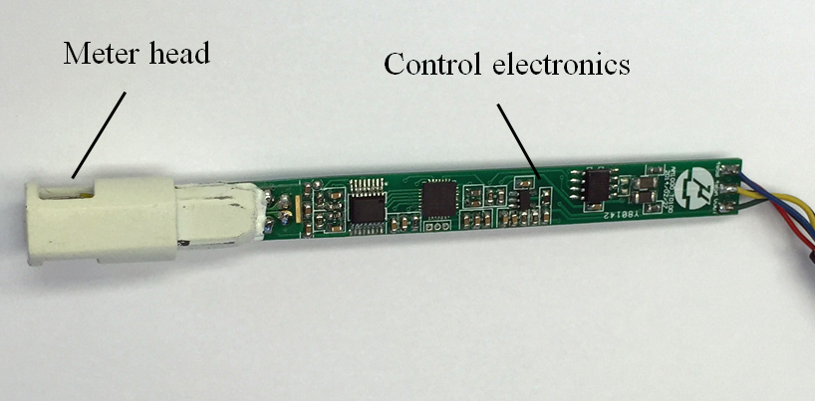

Figure 3: Control electronics and data interface.

Figure 3 show the control electronics and data interface. The electronics was designed using a low power approach such that the anemometer can also be powered by a battery in a standalone mode when the external power is not available or external power failure takes place. The control electronics with the ASIC contains a 24bit high precision analog-to-digital data converter, a micro-controller and a blue-tooth data interface. A RS485 Modbus interface is also included for remote multi-point data acquisition networking. For the building automation or residential HVAC applications, the air flow speed is well below 30m/sec and therefore the MEMS flow sensor is operated at the constant temperature calorimetric mode rather than anemometry or energy dissipative mode for easier compensation algorithm in environmental temperature variations.

3. Calibration

One of objectives of present work is to develop a cost effective calibration process such that the present designed anemometer can be manufactured at a high volume. For the traditional hotwire anemometers, there are many reports [3, 4] and discussions with various simple calibration setups and approaches but none of them can be universally applied to the full dynamic range. The generally accepted calibration for the anemometers is performed with a wind tunnel [5] where the open space condition can be established to the similarity of the actual application environments. Therefore, the present work utilizes the wind tunnel as the reference standard to gauge and compare the results from the calibration tooling developed.

3.1 Calibration in a wind tunnel
The designed anemometers were first calibrated at the wind tunnel system LW-9300 manufactured by Longwin Corporation [6] as shown in Figure 4. The system is an open-loop subsonic suction type wind tunnel structure with the uniformity over 98% and turbulence intensity less than 0.5%. The air flow speed ranges from 0.5 to 30m/sec and therefore it shall cover the designed anemometer flow ranges.

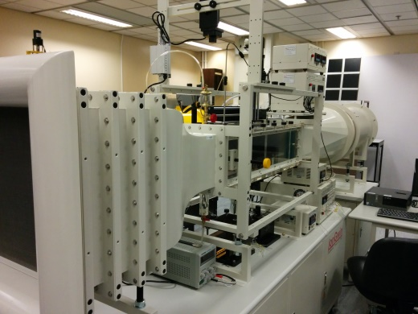

Figure 4: LW-9300 wind tunnel used for calibration.

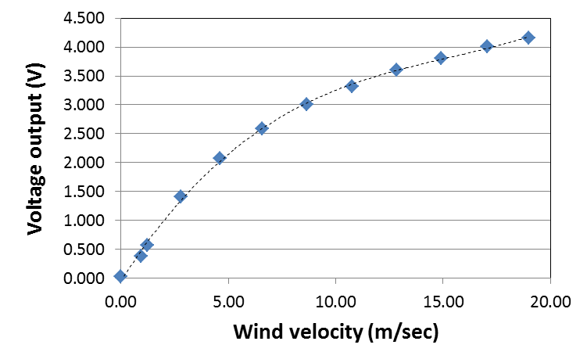

Figure 5: Output curve of the designed anemometer acquired in the wind tunnel.

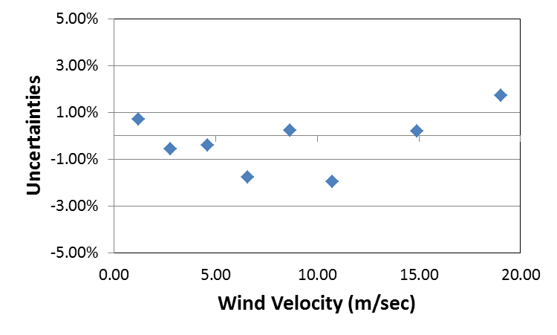
Figure 6: Uncertainties for the designed anemometer measured in the wind tunnel.
The reference air speed is provided by a Prandtl pitot tube and a TSI 8710 micro-manometer with ±3% of reading uncertainties for the air speed. Figure 5 shows the results for the designed anemometer for the air speed of 0 to 19m/sec. The output curve has a typical calorimetric sensor character.

During the calibration, the ambient temperature was kept at 20±2°C and the pressure is 99.8kPa with a humidity of 62%RH. The curve can be fitted with a polynomial. The data can then be preceded to linearization and the uncertainties of the anemometer can be obtained by repeatability measurement as shown in Figure 6. It can be observed that all the data fall within ±2% which could not be better as the reference TSI micro-manometer had a ±3% uncertainty.

3.2 Calibration in an enclosed conduit
The calibration in wind tunnel is considered to be accurate as for the stable flow profile in the tested dynamic range. It is however difficult to be performed for multiple units and therefore is costly and not efficiently for manufacture. Hence it is not a feasible and desired approach for high volume manufacture. One of the effective approaches shall be to perform the calibration in a closed conduit using a reference meter as the standard. To do this, it is critical that the flow profile shall be stable and it is desired that the flow profile to be laminar that is similar to that in a wind tunnel. In the current meter design, the MEMS mass flow sensor is placed and embedded into a plate at the centre of the guided flow channel and at the tip of the meter with the plate surface direction perpendicular to the air flow direction. According to the gas velocity boundary layer theory [7], the flow will re-profile into a laminar flow at the edge of a perfect plate inserted into the gas flow field with the critical transition (from laminar to turbulence) location, x_{c}, from the front edge of the plate being defined by the Reynold number, Re_{x}, the dynamic viscosity, µ, the density, ρ, and the free stream velocity, u∞ :

$${Re}_{x}≡\frac{ρ u_{∞}x_{c}}{μ}=5×{10}^{5} (1)$$
For air at the ambient conditions, the transition location shall be reversely dependent on the free stream velocity. From the above equation, when the free stream velocity is about 7.8 m/sec, the critical transition location shall be about 1 m. In the current design the sensor is located at about 3 mm from the onset (edge) of the boundary layer plate. At the 10 mm location, the free stream velocity shall be over 600 m/sec at the transition. Therefore the transition location shall be well beyond the size of the probe tip which suggested that the flow across the entire MEMS mass flow sensor would be laminar in the full dynamic range of the interests. In order to have a better reproducibility, it would be better to select the conduit that shall have the identical flow profile at the free stream velocity regime corresponding to the measurement dynamic range.

Figure 7 shows the critical transitional velocity against the conduit diameter at which the flow profile shall be changed from laminar to turbulence (Re=2300). With the smaller conduit diameters, the critical velocity shall be larger and the cost for the calibration shall be lower as well. However, as the reduction in conduit diameter there shall be an increase of the pressure loss due to the current size of the anemometer. Bases on the above factors, we selected a conduit with a diameter of 19mm (3/4”) that shall have a transitional flow speed about 1.77 m/sec. This corresponding to a transition location x_{c} = 4.4 m, which is far larger than the designed dimension for the assembled sensor’s boundary layer.

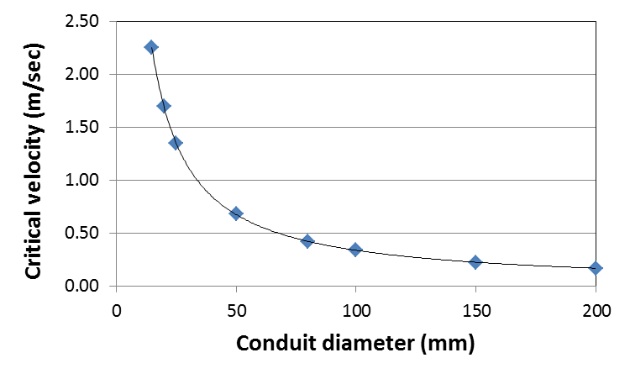

Figure 7: Critical velocity vs. conduit diameters.

Figure 8 shows the configuration of the calibrator with an enclosed conduit. The length of the calibrator is 200 mm with the insertion port at 2/3 of the total length from the flow inlet. The anemometer sensor guided channel is placed at the central of the calibrator channel. During the calibration, a mass flow controller made by Alicat Scientific with an uncertainty of ±(0.4+0.2FS)% and an repeatability of ±0.2%FS was used as the reference meter. The mass flow controller utilizes a differential pressure sensor for the metrology and is traceable to NIST (US National Institute of Standards and Technology). The straight pipe with the identical diameter of the calibrator and a length of 20 times of the diameter of the pipe (20D or 20×19=380mm) is used to connect the reference meter and the calibrator. Another end of the calibrator is also connected with the straight pipe with the 20D length and the identical diameter of the calibrator. The one end of the pipe not connected to the calibrator is open to the air. During the calibration, the environment conditions were kept the same as those during calibration with the wind tunnel.

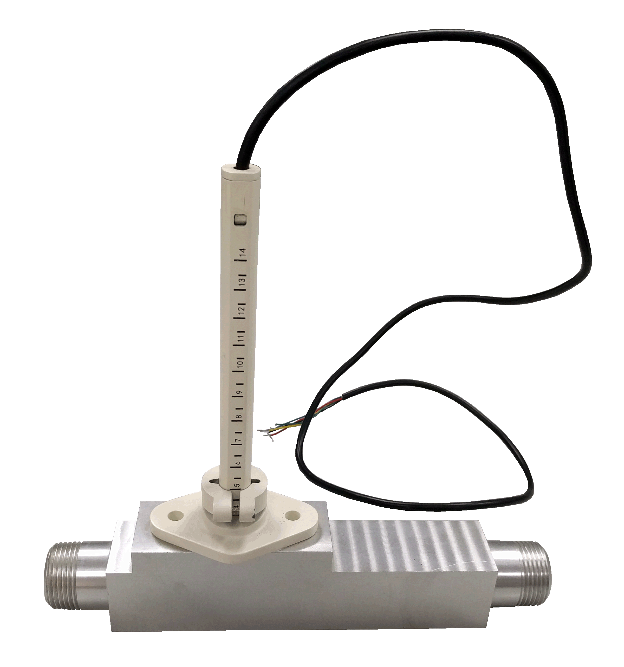
Figure 8: The designed calibrator showing the anemometer installed in the enclosed conduit with a diameter of 19mm.

An air compressor with particle filters was used to supply the air flow for all the calibration in the closed conduit.

4. Discussions

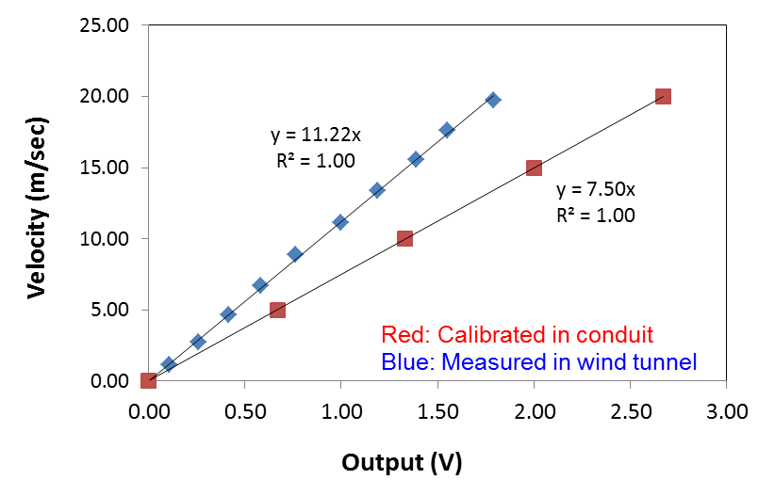

Figure 9: Comparison of the outputs of the anemometer calibrated in in the enclosed conduit and the wind tunnel.

Figure 9 shows the results for the same anemometer calibrated in the closed conduit and measured in wind tunnel for the air speed from 0~20 m/sec. This flow speed in the closed conduit covers the Reynold number up to 25,958 which is well into the turbulence regime. It can be observed that the output linearity is excellent which suggested that the calibration is feasible and can be correlated to those by a wind tunnel. In a previous study for the traditional hotwire technology, the calibration in a closed conduit could only be achieved in a low Reynold number range [3] up to 1590. The current data indicated that the MEMS sensors with anemometry can have its very advantages for the calibration in the closed conduit due to the assembled boundary layer condition that could extend the calibration into a much wider dynamic range of the air flow speed. The boundary layer is effective in conversion of the turbulent free stream flow in to a laminar flow. In addition, the current study only employed 20D straight pipe as required by most of the flow meters for maintaining a stable flow conditions, which is far less than the needed minimal entrance length for fully developed laminar pipe flow of (0.08Re+0.8)D. [8] In case of a Reynold number of 2000 in the upper limit in the laminar range, the length for fully developed laminar flow shall be 160.8D.

However, the measured speed data were not identical and there was constant deviation from the velocity measured in a wind tunnel and those in the closed conduit. The constant can be found by the fitting curve with the conversion factor of 1.5 (=11.22/7.50) in the present configurations, i.e. the velocity measured in the closed conduit was smaller than those measured in the wind tunnel. This could come from the fact that in the closed conduit the velocity distribution across the conduit is not constant in particular in the laminar flow regime. The central point where the MEMS anemometry sensor was placed had a high velocity compared to those locations towards the wall of the conduits. The reference meter could only provide the flowrate from which an averaged flow velocity was derived. This averaged flow velocity would be smaller than those in corresponding case of a wind tunnel where the flow velocity profile is uniform. It is of interest that this character can be maintained throughout the flow range and into the turbulent regime, which further suggested that the boundary layer configuration played a key role for the acquired data in the full dynamic range.

5. Concluding Remarks

The present study indicated that a anemometer with the MEMS mass flow sensor as designed can be calibrated in a closed conduit which could be correlated to the calibration in a wind tunnel with a constant factor. The calibration covers a large dynamic range and is very efficient for a high volume manufacture that shall be needed in some of the today’s applications.

Further studies will be carried out for calibration comparison at the closed conduits in different dimensions such that accurate data acquisition in different applications can be established.

References

- Olin J. “The evolution of thermal mass flow meters”, Inmag, 10, 8, 2002.
- ISO 14511: Measurement of fluid flow in closed conduits – thermal mass flowmeters, 2001.
- Ozahi E, Carpinlioglu M.O. and Gundogdu M.Y., “Simple methods for low speed calibration of hot-wire anemometers”, Flow Measurement and Instrumentation, 21, 166-170, 2010.
- Lee T, and Budwig R., “Two improved methods for low speed hot-wire calibration”, Measurement Science and Technology, 2, 643-646, 1991.
- Chun S., “Air Speed Measurement Standards Using Wind Tunnels”, Chapter 9, Wind Tunnels and Experimental Fluidic Dynamic Research (Croatia, InTech), 2011.
- For the detailed description of LW-9300, see http://www.longwin.com
- Incropera F.P. and DeWitt D.P., Fundamentals of Heat and Mass Transfer (Hoboken, John Wiley & Sons), 2002.
- White F M, Viscous Fluid Flow (New York, McGraw-Hill), 1984.

