A Novel Vortex Gas Flow Meter with MEMS Flow Sensor

**Liji Huang**

*Siargo Ltd., 3100 De La Cruz Boulevard, Suite 210, Santa Clara, California 95054 USA*

*E-mail: Liji@Siargo.com*

# Abstract

This paper presents the design and experimental results of a novel vortex gas flow meter that utilizes the MEMS thermal mass flow sensor as the sensing element which is placed inside an unsymmetrical structure of the bluff body. While the fast response MEMS thermal mass flow sensor measures the vortex shedding frequency from the unbalanced differential pressure generated from the turbulence flow via the structure inside the bluff body, it also measures the mass flow rate of the media flowing over passing the sensor. With the proper design of the sensing channel, it is found that the sensor can measure the vortex shedding frequency at its lowest limit of Reynold number of 2300 which is well below the detecting limit by the current existing vortex flow measurement technology, and thus significantly extends the dynamic range of the vortex flow meter to over 160:1. The benefit of the simultaneously acquired mass flow data considerably reduces the cost for conventional addition of temperature and pressure sensor for compensation. Further, by comparison between the measured volumetric and mass flowrate it also provides the capability to alert if the composition of the flow media changes. In another words, the mass flow data can also be used for the density metrology that allows the possibility to substantially improve the measurement accuracy for media like steam.

# 1. Introduction

A Vortex flow meter or vortex shedding street flow meter is one of the most commonly used flow measurement apparatus in industrial process monitoring, steam measurement and other applications as it can be deployed for both liquid and gas flow measurement and is simple to use with a relatively low cost. The operational principle for vortex flow meters although they can be in different configurations, is based on the phenomenon observed by Theodore von Karman in earlier twentieth century, which indicated that the frequencies of the vortex generated by a bluff body in the flow media shall be proportional to the media flow speed. The vortex flow meters have three major components packaged inside a flow conduit: a bluff body, a vortex frequency detecting sensor and signal process electronics. The bluff body [1] can be made into a variety of geometrical formality from which the vortex street would be generated. The geometrical shapes of the bluff body are also related to the vortex detecting approaches. The most commonly used geometrical shape is triangular or trapezoid one placed at the middle of the flow meter conduit which utilize a pressure sensor to measure the vortex frequencies. There are many types of sensors that can be used to measure the vortex frequency, including thermal sensor [2] piezoelectric element [3] pivoting strut [4], optical sensor [5] and other sensors such as ultrasonic sensors, mechanical vibrational sensors and strain gauge sensors. The electronics of the meter shall be capable of effectively capturing the changes of the vortex frequency and correlating the changes to the measurement of the fluid flowrate.

Vortex flow meters however have some intrinsic issues for some of the applications. In recent years, the external vibrational frequency interference to the meter measurement has been much improved such as with an inertial sensor to differentiate the parasitic frequency. [6] Theoretically, vortex shedding street can occur at a Reynold number of 2300 or even lower, but most of the practical vortex flow meters would not operate for Reynold number less than 10000. By adapting a micro-machined thermal mass flow sensor for the detecting of the vortex frequency, it was disclosed that due to the fast response time and high sensitivity, the detectable stable or linear vortex frequency can be at a lower Reynold number than those by other sensing measurement approach. [7] However, even with such a sensing scheme by placing the micro-machined thermal mass flow sensor at a through channel symmetrically inside the bluff body and perpendicular to the fluid flow direction, the available products on market do not show an improvement but to a Reynold number of about 8000. The alternative approach is to employ a composite sensing scheme. [8] As the vortex flow meters measure only the volumetric flowrate, to obtain the mass flowrate, additional temperature and pressure sensor shall be necessary to be installed in particular for gaseous flow media. These improvements on the one hand increase the complexity of the metrology data process leading to a reduction of accuracy, on the other hand, they shall increase the manufacture cost and add the uncertainties for reliability.

Steam measurement is one of the major applications for the vortex flow meter. However, due to the large pressure loss, it is difficult to calibrate the meter with air or gases but water or liquid. In addition, the steam may have different states such as saturated or unsaturated state which shall have different densities. Accurate measurement of steam flow is still pending for solutions even though control of energy consumption has its increasing importance.

Therefore it is the objective of this paper to present a vortex flow meter that shall be able to solve the above technical difficulties while utilizing the simplicity and existing advantageous features [9]. In particular, the new meter shall be able to have extended dynamic range in low flowrate regime, and have the mass flowrate measurement capability which shall further provide the metrology data for the fluid density variations.

# 2. Design of the Meter

*2.1 Bluff body*

For a vortex flow meter, the bluff body shall be one of the critical components for performance. Through the years, there were many studies for the best shapes of a bluff body and it is now generally in agreement that a trapezoid body shall provide the good dynamic range as well as reproducible strong vortex street generation. The front dimension or width (*d*, as shown in Figure 1) of the trapezoid should be about 0.236 to 0.321 times of the diameter of the fluid conduit, and the majority of the current vortex flow meter design adapts the value of 0.283 with a piezo resistive pressure sensor placed at a certain distance to the tail of a trapezoid shaped bluff body. Another parameter is the length of the bluff body, *L*, over *d* which is in the range of 1.2~1.25 to balance the measurement signal at low and high flowrates.



Figure 1: The bluff body and measurement channel design: (a) the existing design and (b) the present design.

In the present design, the measurement of the vortex frequency shall be realized by a MEMS thermal mass flow sensor inside the bluff body in a measurement channel. The design is shall also target to reduce pressure drop as well. As the optimized width *d* of the trapezoid is determined by the considerations of a stable vortex generation, a linearized dependence with the flowrate and pressure loss. To reduce the pressure loss, the easiest approach is to reduce the width *d* of the bluff body towards the low limit of the theoretical values. However, as the sensor shall be placed inside the bluff body, it needs to have an optimized measurement channel length as well which shall limit the minimization of the bluff body width. Moreover as the measurement of the vortex frequency shall be obtained via the differential pressures at the two side of the bluff body, the length of the bluff body would not be limited by the calculation of the measurement of the frequency at a distance to the tail of the bluff body. In the present design, experimental tests have been carried out for a variety of values for the bluff body width to the dimension of the flow conduit *D* as list in Table 1. The top angle of the trapezoid is also related to the selection of the width *d* and the length *L*. The tested values of these values are also listed in Table 1.

**Table 1.** Tested and design parameters of the bluff body

|  |  |  |  |
| --- | --- | --- | --- |
|  | **Minimum** | **Maximum** | **Designed** |
| ***d*/*D*** | 0.230 | 0.283 | 0.255 |
| ***L*/*d*** | 1.200 | 1.500 | 1.420 |
| ***α*** | 25° | 45° | 28° |
| ***β*** | 90° | 110° | 90° |

*2.2 Vortex measurement sensor*

Use of the MEMS thermal mass flow sensor for the measurement of the vortex frequency had been proposed but not a main stream technology as the earlier version of the thermal mass flow sensor was made of thin hot wires which were prone to be damaged by particles, although it had advantages in vibration resistance and fast response time, the reliability would become the major issue. In particular with the advancement of the electronics and the introduction of fast response pressure sensors with vibration filtering, the hot wire was seldom a choice of sensor for vortex flow meters. The disclosure of a vortex flowmeter with the thermal mass flow sensor was to place the thermal mass flow sensor at an elevated position inside the bluff body [7] to prevent the damage. However it was not practical as the complicated measurement channel introduced addition flow instability making the signal conditioning difficult. As it is shown in Figure 1, for the vortex flow measurement with the thermal mass flow sensing technology, the sensor is placed in a measurement channel parallel to the width of the bluff body such that the pressure differences generated by the vortices at the two sides of the bluff body can push the flow through the channel and the sensor shall count the frequencies of the flow passing through the channel. Therefore the thermal mass flow sensor is only used for frequency measurement and its mass flow function is not activated.

In a recent release by Azbil (www.azbil.com), the MEMS mass flow sensor was used in their MVF series of vortex flowmeters. The MVF meters employ the MEMS mass flow sensor to measure the vortex frequency in an arrangement inside the bluff body similar to that shown in Figure 1(a). It claimed that it can meter the low flowrate with the Reynold number of 8700 compared to those by most of the current vortex meters that start the readings at a Reynold number above15000. As the sensor’s mass flow capability is not functioning, additional temperature and pressure sensors has to be included in the meter electronics in order to measure the mass flowrate of the fluid. Therefore this improvement does not solve the major concerns for the applications of the vortex flow meter in addition to the high manufacture cost.

In the present design, it is also desired to further extend the dynamical measurement range towards the lower Reynold numbers. The design measurement channel inside the bluff body is shown in Figure 1(b) in which the channel is not parallel to the width of the bluff body but tilted with an angle. By tested various configurations, the final design is having an angle of 90° which was found to be the most optimized one for the signal to noise ratios. The measurement channel diameter in this study was about 2 mm. The channel can also made with a venturi shape where the MEMS mass flow sensor was placed at the throat of venturi structure that shall further accelerate the flow in particular at the low flow regime in order to enhance the sensitivity. In this design, the ports of the measurement channel at the two sides of the bluff body shall have the different pressure values because of the asymmetrical positions. Compared to the symmetrical design, it is found that the small flow can be delivered to the measurement channel due to the larger differential pressures, and further the delivered flow shall have a mass flow component and the mass flow data can be obtained via the deconvolution of the signal. In particular the mass flow information is embedded in the data of the amplitudes. Although it complicated the algorithm of the signal conditioning and data processing but it maintained the high accuracy of the mass flowrate without having the additional data acquisition errors from the temperature and pressure sensors. The simultaneously measured volumetric and mass flowrate shall also help to identify any changes in flow medium density as well as compositions which would be a critical advancement for the metrology of steam and gases with variable compositions such as natural gases.



**Figure 2**: Composite MEMS flow sensor.

To further solve the problem of changing metrology accuracy of a calorimetric mass flow sensor when the flow medium is not clean or the contamination or deposits is present on the surface of the sensors. In the present study, a MEMS flow sensor integrated with thermal time-of-flight sensor [10] and calorimetric sensor is used in the present vortex flowmeter measurement, as shown in Figure 2. For the thermal time-of-flight sensor, the measurement is solely dependent on the thermal pulse traveling time between the transmitter and receiver, which is the time measurement domain only and therefore it shall not be dependent on the changes in amplitude compared to that for the calorimetric sensors. At the calibration, both thermal time-of-flight and calorimetric data shall be registered and the comparison of those for the different flowrate provides additional information of the flow media as well as enhancement in reliability.

# 3. Results and Discussions

*3.1 Metrology performance*

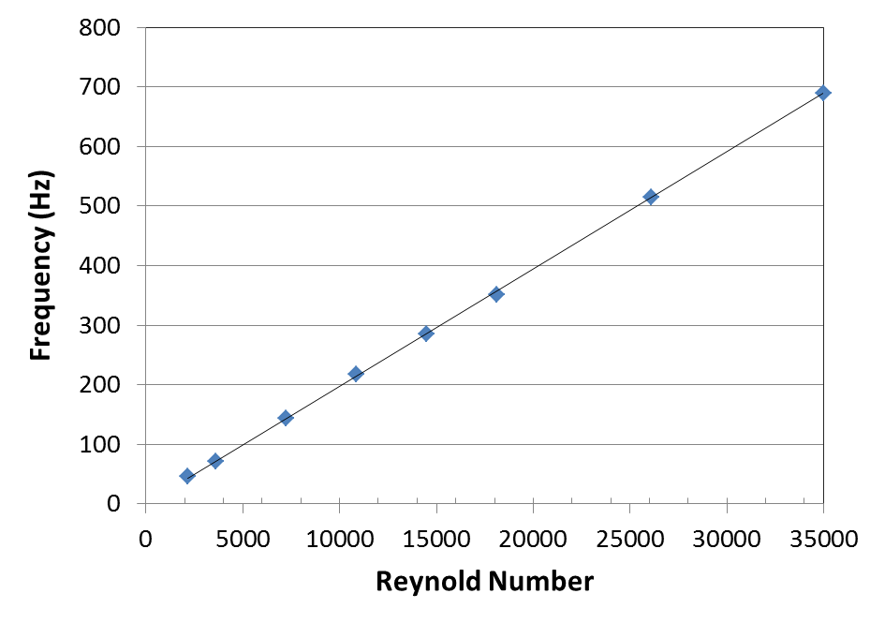

**Figure 3:** The measured flowrate vs frequencies at the low flow regime.

Figure 3 shows the experimental results of the vortex flow meter with a conduit diameter of 50mm and the bluff body having the parameters shown in Table 1 and the MEMS thermal mass flow sensor for the data acquisition. The meter tests were performed with a sonic nozzle system. The detailed description of the calibration system can be found in a previous publication [11]. It was found that the lowest frequency can be measured without losing the linearity was at the flowrate of Reynold number of 2300 which was corresponding to the state of onset of turbulence in the fluid conduit. Hence this would be the lowest possible value for the linearity of the vortex frequency response to the flowrate changes. The corresponding vortex frequency measured was 45.6Hz and a Strouhal number of 0.8304 for the flow conduit with the conduit diameter of 50mm. With this design the *K* factor was much larger as compared to those for most of the conventional vortex flowmeters. The data indicated that the design had further improved the sensitivity and dynamic measurement performance of the vortex flow sensing. As the vortex flow has a good high flow measurement capability, we have tested in various sizes of fluid conduits up to 80 mm in diameter that the measurement dynamic rangeability can reach to over 200:1. For example in a flow conduit of 50mm in diameter, the linearity of the measured flowrate was starting at about 5m3/h and up to 1200m3/h.

Another significant advantage of the present design is the capability of simultaneous acquisition of mass flowrate data for the fluid. The asymmetrical data acquisition channel inside the bluff body enables the asymmetrical pressure at the two ports of the data channel. The different differential pressure shall drive the different flowrate across the MEMS mass flow sensor from the different flow directions. By extrapolating the differences, it was found that the amplitudes measured can be correlated to the mass flowrate of the fluid in the main flow conduits. Figure 3 shows the correlations for which the data can be further linearized with the calibration procedure. In principle, for the flowrate with a Reynold number smaller than 2300 when the volume flowrate was not available, the mass flowrate could however be measured where the differential pressure generated the vortex street was trivial. With the current design, it was found that the data however were very noisy for the flowrate at the Reynold number below 2300 and the correlation between the mass flowrate and the acquired data was difficult to be established. Additional work shall be carried out to further investigate the possibility for the mass flowrate acquisition below the Reynold number of 2300, which shall further extend the dynamic range of the meter although the data shall not be consistently having both volumetric and mass flowrate but a composite register.

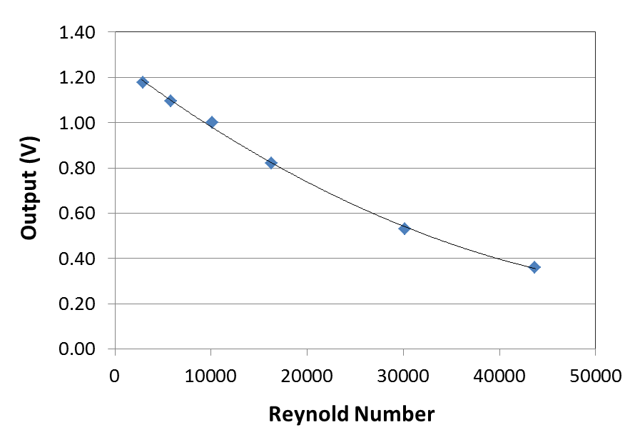

**Figure 4**: Amplitude output *vs.* Reynold number.

As the temperature of the fluid, *T*, can be measured from the temperature sensor integrated on the MEMS composite sensor chip, it was therefore possible to calculate the pressure of the fluid, *P*, from the mass flowrate, *V*0, and volume flowrate, *V*, that are simultaneously acquired:

$$P=\left(\frac{T}{T_{0}}\right)×\left(\frac{V_{0}}{V}\right) ×P_{0} (1)$$

where *P*0 is the pressure at the reference/standard conditions. Hence, the current design would enable the high accuracy of mass flowrate measurement without introduction of separated temperature and pressure sensors in the measurable dynamic range of the meter and provide all key parameters of the metrology data. These data can be further used to calculate the density of the flow medium by correlating the mass flowrate and the volumetric flowrate, or provide an alert of changing gas compositions.

*3.2 Pressure loss*

One of the disadvantages of the vortex flowmeter is its high pressure loss due to the size of the bluff body at the central point of the flow conduit which forces the generation of the vortex streets but blocking the free stream flow and increasing the pressure loss. As one of the key applications of the vortex flow meter is for energy metering, the high pressure loss consumes additional energy that is very much undesirable. In the current design, it is the object to reduce the dimension of the bluff body in particular the dimension of the front size of the bluff body such that the pressure loss can be reduced. The measured data of the pressure loss of the current design (Table 1) are shown in Figure 5. It can be seen that at the Reynold number of 145,000 or about 300m3/h, the pressure loss was about 50% reduction in comparison with the pressure loss reported from one of the vortex flowmeter using the MEMS flow sensor as the sensing element. [12] This is particularly nontrivial for the practical applications as the larger pressure loss will require higher pressure at the upstream in order to deliver the desired flow resulting in high energy consumption.

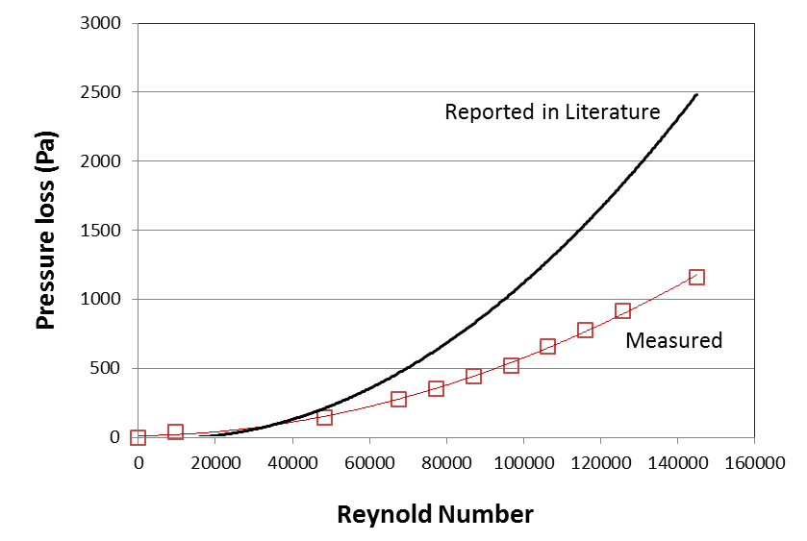

**Figure 5**: Pressure drop compared to the conventional vortex flowmeters.

# 4. Concluding Remarks

In Conclusion, this paper describes a new design of vortex flowmeter with a bluff body using a MEMS mass flow sensor as the sensing element for the vortex frequency detection. The design enables a significant extension of the dynamic range to the lowest Reynold number of 2300 with linearity in record. This extension shall be particularly useful for fluid metering such as steam metering with custody transfer or tariff applications for which the current technology is always troubled by the tariff loss at the low flow regime. In addition, the current design provides the density measurement capability which shall solve the current issues for steam measurement where the steam may change the state from a saturated to unsaturated one. Reduction of the pressure loss is another advantage with which the energy consumption for the delivery of the flow medium can be significantly reduced.

Additional work will include the further optimization of the design for flow medium such as steam; Additional optimization for mass flowrate detection at the flowrate below Reynold number of 2300. The electronics can also be further improved for accommodation of battery operation options for easier applications in hazardous zones.

# References

1. Rodely A. E., “Bluff body flow meter”, US Patent No. 3,572,117, March 23, 1971.
2. Matsubara N., “Explosive-proof high temperature compatible, multi-vortex flow meter”, US Patent No. 7,861,602, January 4, 2011.
3. Wada M., Honda M. and Andoh T., “Vortex flow meter”, US Patent No. 6,480,812, November 12, 2002.
4. Konyukhov A. and Bogdanov V., “Vortex flow meter with vortex oscillation sensor plate”, US Patent No. 8,596,141, December 3, 2013.
5. Maul J. and Ohle F., “Vortex flow sensor”, US Patent No. 6,351,999, March 5, 2002.
6. Gossner K., “Vortex flow meter having an inertial sensor for detecting parasitic oscillations”, US Patent No. 8,820,176, September 2, 2014.
7. Kiguchi S., “Karman vortex flow meter”, US Patent No. 5,708,214, January 13, 1998.
8. Takahashi, K., “Multi-vortex flowmeter employing mass flow rate or volume flow rate as switching point”, European Patent No, 2,028,456, February 25, 2009.
9. Huang L., “A vortex flow meter with micro-machined sensing elements, US Patent pending No. 15177208, June 8, 2016.
10. Yao Y., Chen C., Wu X. and Huang L., “MEMS thermal time-of-flight meter”, FLOMEKO 2010, October 13-15, Taipei.
11. Deng W., et al., “Calibration and verification of MEMS mass flow meters for custody transfer”, FLOMEKO 2010, October 13-15, Taipei.
12. Yamatake Corporation, *MVF Series Microflow Vortex Gas Flow Meter User’s Manual* (Yamatake Japan), 2005.