SIP-HLT07 contributions to method improvement in syringe pumps calibration

Elsa Batista¹, Isabel Godinho², Maria do Céu Ferreira³, Andreia Furtado⁴, Peter Lucas⁵

¹IPQ ebatista@ipq.pt, Caparica, Portugal
² IPQ igodinho@ipq.pt, Caparica, Portugal
³ IPQ mcferreira@ipq.pt, Caparica, Portugal
⁴ IPQ afurtado@ipq.pt, Caparica, Portugal
⁵VSL, plucas@vsl.nl, Delft, The Netherlands

E-mail (corresponding author): ebatista@ipq.pt

Abstract

For more than 25 years, multi-infusion has been known to cause severe dosing errors. A great percentage of these errors can be avoided if the users of infusion technology have a better understanding of these equipments. Therefore, it is very important to create awareness and understanding by users of infusion technology. The goal of this EMPIR SIP project SIP-HLT07 (15SIP03) – Infusion Uptake, is to maximize the uptake of the key outputs of the previous project JRP MeDD – Metrology for Drug Delivery.
One key output of JRP MeDD has been the realization of calibration services for infusion devices. These services followed the design, construction and validation of several calibration facilities. Furthermore, following the show cases of calibration of infusion systems, JRP MeDD has generated a vast experience on how to calibrate infusion devices with the best possible uncertainty. While this knowledge has been presented at various scientific conferences and published many times in magazines, it has not yet been formalized via amendments on the actual standards. The current available standards dealing with calibration of infusion devices (and accessories) using the gravimetric method, e.g. ISO 7886-2, IEC 60601-2-24, ISO 28620, IEC 62353, need meaningful alterations, especially on the requirements of the low flow rate calibrations, as required by the neonatal care.

1. Introduction

Infusion instruments are widely used, given that they are fundamental for primary health care, in/out hospital providing drug delivery, nutrition and hydration to patients. Hence, it is crucial that the volume and flow measured by these devices be the most accurate and precise possible. To ensure this, it is necessary to have the appropriate calibration methods.

From 2012 to 2015, such calibration methods have been the main focus of the project Metrology for Drug Delivery (MeDD) [1] from the European Metrology Research programme (EMRP). In this joint research programme (JRP), several Metrology Institutes (Swiss Federal Institute of Metrology - METAS, Danish Technological Institute - DTI, Centre Technique des Industries Aérauliques et Thermiques, France - CETIAT, Portuguese Institute for Quality - IPQ and Dutch Metrology Institute - VSL) developed the primary standards for liquid flow rate ranging from 100 nl/min to 10 ml/min [2]. The primary standards for liquid flow rate were validated by means of a EURAMET comparison, project 1291 [3]. Two secondary standards, a flowmeter and a syringe pump were calibrated for flow rates in an interval from 33.3 μl/min to 10 ml/min. The results obtained by the participant laboratories were in agreement with the determined reference value.

The metrological characterization of several drug delivery devices particularly, syringe pumps and peristaltic pumps was included in the MeDD project scope.
Assays for flow rate, start up delay, compliance, temperature, pressure and viscosity like in [4] were performed to determine the measurement accuracy of the drug delivery devices.

The outcomes of this project were discussed in international conferences and presented in scientific papers, reports and best practice guides that can be found in www.drugmetrology.com. Nonetheless, this data was never formalized in the way of amendments of the relevant standards, specifically ISO 7886-2 [5], IEC 60601-2-24 [6] and ISO 28620 [7]
To further communicate the knowledge obtained from MeDD JRP, a new project (Support for Impact Project (SIP) 15SIP03 – Infusion Uptake) started in May of 2016. This project is in frame with the European Metrology of Innovation and Research Programme (EMPIR). The 15SIP03 JRP has two main goals:

- To develop an E-learning module made available on the E-learning platform of the ESICM (European Society for Intensive Care Medicine), with the aim to create awareness and understanding of multi infusion risks and thereby reducing dosing errors, thus decreasing adverse patient incidents and increasing the quality of medical treatment.
- To incorporate the best metrology practices relating calibration of infusion devices in ISO standards ISO 7886-2 and IEC 60601-2-24.

2. Calibration method

The primary method for flow determination in the calibration of syringe pumps is the gravimetric method.
This method is based on the mass measurement of the calibration liquid as a function of time on a balance. The flow rate is in general determined by the quotient of the mass difference (initial and final) and time interval including some corrections following equation 1.
The calibration setup used during MeDD JRP consists of a flow generator, connected to a device under test (DUT) upstream of a collecting vessels standing on an analytical balance (Figure 1). This balance measures the mass, which is precisely timed to calculate the Δm/Δt quotient [1].
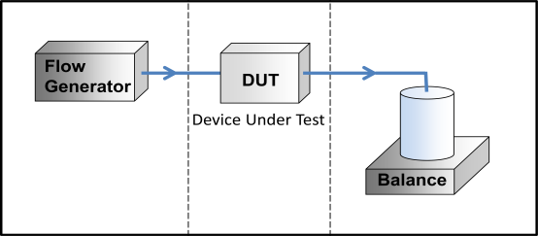

Figure 1: Schematic of the primary flow calibration setup used in MeDD project.

3. Calibration of syringe pumps

3.1 Calibration setup
The calibration of syringe pumps is performed at IPQ, by the gravimetric method in a flow interval from 600 ml/h (10 ml/min) to 3 μl/h (50 nl/min) with a 0.15 % to 6 % relative expanded uncertainty.

Two different balances were used AX26 and XP205 according to the flow rate to be measured. Both balances are installed in vibration-free tables, in the same ambient control room where the calibrations are performed, in a temperature range of (20 ± 3) ºC and a relative humidity above 50 %. These balances are in synch with a computer which collects and analyses the weighted liquid with precise time measurements (every 50 ms). This is performed by a LABVIEW bespoke program [8] developed on purpose for this measurement method.

As a calibration liquid, ultrapure [9] and degassed water was used. An evaporation trap was installed around the weighing vessel to prevent water evaporation (Figure 2).

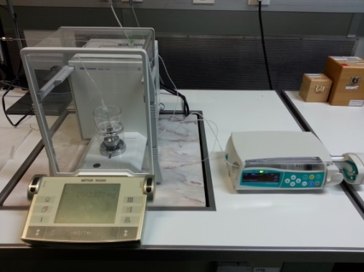
Figure 2: Balance AX26 an evaporation vessel in its plate (on the left) and a syringe pump (on the right) during a calibration.

Although evaporation is kept to a minimum value, the determined evaporation rate (δQ_{evap}) is considered as a correction term in the volume flow rate (Q) (equation 1). Other contributions to the model are the density of the liquid (ρ_{W}), final time (t_{f}), initial time (t_{i}), final mass (I_{f}), initial mass (I_{i}), air density (ρ_{A}), mass pieces density (ρ_{B}), expansion coefficient (γ) and water temperature (T). The δm_{buoy} term accounts for the buoyancy contribution of the dispensing needle immersed in the weighing vessel.

$Q=\frac{1}{t_{f}-t_{i}}\left[\left(\left(I_{f}-I_{i}\right)-\left({δm}_{buoy}\right)\right)×\frac{1}{ρ_{wW}-ρ_{A}}×\left(1-\frac{ρ_{A}}{ρ_{B}}\right)×\left[1-γ\left(T-20\right)\right]\right]+δ_{evap}$ (1)

3.2 Calibration procedure
The calibration procedure for syringe pumps is as follows:

1. Equilibrate the syringe, the water and all the apparatus at a temperature of approximately 20 ºC for 24 h before testing.

2. The temperature of the water as well the room temperature, relative humidity and atmospheric pressure are continuously measured and registered throughout the experiment.

3. The syringe is filled with ultrapure degassed water to beyond its nominal capacity. Before attaching the Teflon tube and mounting it on the pump, remove the air bubbles by inverting the syringe so that the nozzle lumen is uppermost and depress the plunger. A needle is connected at the end of the tube. The line is filled by running the syringe pump at a high rate until a steady flow of drops come at the end of the needle. Finally the needle is immersed in the water inside the weighing vessel.

4. The target flow is programed in the syringe pump. Data acquisition begins after 10 minutes of steady flow over 15 minutes. An example of the data collection and flow variability during a syringe pump calibration is presented in Figure 3. The mean variation is of the order of 0.1 %.

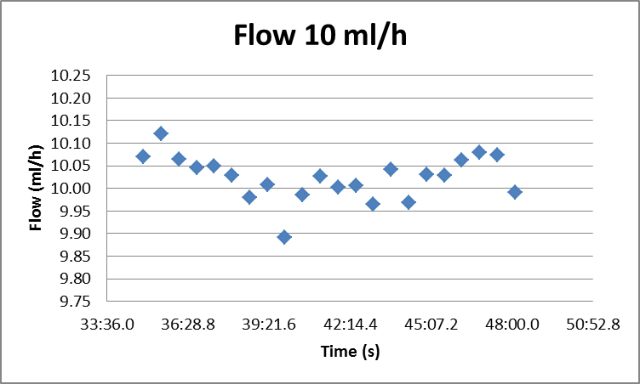

Figure 3: Flow measurement results for a syringe pump at 10 ml/h.

4. Evaluation of measurement uncertainty

The uncertainty of the gravimetric method used for flow (Q) determination is estimated following the Guide to the Expression of Uncertainty in Measurement (GUM) [10].

The main contribution for the standard uncertainty of gravimetric method for calibration of infusion pumps are: mass measurements (m), density of the mass standards (ρ_{B}), density of the water (ρ_{W}), density of the air (ρ_{A}), evaporation rate (δQevap), water temperature (T), time (t), expansion coefficient of the disposable syringe (γ), standard deviation of the measurements (δQrep) and buoyancy on the immersed dispensing needle (δQmbuoy) (Table 1).

Table 1: Uncertainty components
Uncertainty components | Standard uncertainty | Evaluation process | Evaluation type | Distribution
Final mass | u(I_{L}) | Calibration certificate | B | Normal
Initial mass | u(I_{E}) | Calibration certificate | B | Normal
Density of the water | u(ρ_{W}) | Calibration certificate | B | Normal
Density of the air | u(ρ_{A}) | Literature | B | Rectangular
Density of the mass pieces | u(ρ_{B}) | Calibration certificate | B | Rectangular
Temperature | u(T) | Calibration certificate | B | Normal
Expansion coefficient | u(γ) | Literature | B | Rectangular
Evaporation | u(δQ_{evap}) | Standard deviation | A | Normal
Final time | u(t_{f}) | Estimation  (1 μs) | B | Rectangular
Initial time | u(t_{i}) | Estimation  (1 μs) | B | Rectangular
Buoyancy | u(δQ_{mbuoy}) | Calibration certificate | B | Normal
Repeatability | u(δQ_{rep}) | Standard deviation | A | Normal

Detailed information regarding the uncertainty calculation and validation using Monte Carlo method is described in [11].
The major contribution for the flow measuring uncertainty is the flow instability which is evidenced by the repeatability of the measurements.

5. Present calibration standards for infusion devices

Currently, several standards dealing with calibration of infusion devices (and accessories) using the gravimetric method, e.g. ISO 7886-2 [5], IEC 60601-2-24 [6] and ISO 28620 [7] exist. However, for these ISO standards not all buoyancy corrections are taken into account. Consequently, calibrations at low flow rates may be erroneous which can lead to incorrect dosage in medical treatments, i.e. an unexpected over or under doses when used in the field. Moreover, the corrections when these instruments are used in field applications, e.g. usage of accessories and varying operating conditions, are omitted in these standards.

From the analysis of standards ISO 7886-2 [5] and IEC 60601-2-24 [6], it could be verified that:
a) There is no addressing on how to correct for evaporation;
b) There is no indication for tests to be performed for different flow rates and replicates;
c) There is no reference for test duration as well as recommendation of minimal time for flow stabilization;
d) The density formula as a function of temperature of the calibration liquid is not given, only the density value at 20 ºC;
e) There is no correction for buoyancy;
f) No information on how to measure the calibration liquid temperature is given;
g) There is no recommendation for the need to program the syringe pump accordingly to the type of disposable, mainly the plastic syringe used;
h) There is no reference to uncertainty budget.

ISO 28620 [7] assesses the determination of the flow measurement error. However, is it is not enough detailed. We propose that this ISO standard includes the following information: the buoyancy correction, the number of repetitions, and information on how to measure the water temperature and density formula as a function of temperature of the calibration liquid.

6. Conclusion

Among other aspects, MeDD project was important to conclude that ISO 7886-2 [5], IEC 60601-2-24 [6] and ISO 28620 [7] are insufficient to provide the required calibration needs for infusion instruments. We carefully detailed these inconsistencies for each of the ISO standards, where most consistently these fail to provide a clear method on buoyancy correction and detailed parameters of calibration procedure. We also note a lack of clear instructions for the corrections to which apply on field applications. Therefore, we strongly support the need of the new EMPIR 15SIP03 project started in May 2016, for the correct broadcast of all proposed and meaningful amendments of applicable ISO standards.

References

- Lucas, P., Klein, S., Metrology for drug delivery, Biomedical Engineering, 2015, 60(4)
- EURAMET project report 1291 - Comparison of primary standards for liquid micro flow rates, April 2015, www.euramet.org
- Bissig, H., Petter, H.T., Lucas, P., Batista, E., et all, Primary standards for measuring flow rates from 100 nl/min to 1 ml/min – gravimetric principle, Biomedical Engineering, 2015, 60(4)
- Batista, E., H Bissig, H., Petter, H.T., Lucas, P et all, Assessment of drug delivery devices, Biomedical Engineering, 2015, 60(4)
- ISO 7886-2, Sterile hypodermic syringes for single use, Part 2: Syringes for use with power-driven syringe pumps, 1996
- IEC, IEC 60601-2-24 Medical electrical equipment - Part 2-24: Particular requirements for the safety of infusion pumps and controllers, Switzerland, 2012
- ISO 28620, Medical devices -- Non-electrically driven portable infusion devices, 2010
- Batista E., Gala J., Ribeiro L., Almeida N., Filipe E., Martins R. Desenvolvimento de um padrão de medição de caudal de fluidos. Medições e Ensaios. 2014, Bd. 7.
- ISO 2696, Water for analytical laboratory use – specifications and test methods, 1987
- JCGM 101, BIPM, IEC, IFCC, ILAC, ISO, IUPAP and OIML, “Evaluation of measurement data – Supplement 1 to the Guide to the Expression of Uncertainty in Measurement – Propagation of distributions using a Monte Carlo method”, Joint Committee for Guides in Metrology, 2008
- Batista E., Almeida N., Godinho I., Filipe E., Uncertainty calculation in gravimetric microflow measurements, AMCTM X, 2015

Acknowledgement
The EMPIR project “15SIP03 – Infusion Uptake” is carried out with funding of European Union under the EMPIR. The EMPIR is jointly funded by the EMPIR participating countries within EURAMET and the European Union.

