Volume comparison on calibration of micropipettes - Gravimetric and photometric method

Elsa Batista¹, Isabel Godinho², George Rodrigues³, Doreen Rumery⁴

¹IPQ ebatista@ipq.pt, Caparica, Portugal
² IPQ igodinho@ipq.pt, Caparica, Portugal
³Artel, grodrigues@artel-usa.com, Portland, USA
⁴Artel, drumery@artel-usa.com, Portland, USA

E-mail (corresponding author): ebatista@ipq.pt

Abstract

Micropipette calibration can be performed by two different methods: the gravimetric method, described in ISO 8655-6:2002, and the photometric method, described in ISO 8655-7:2005.
In order to verify the degree of agreement between these methods and with different operators in each laboratory, an EURAMET bilateral comparison between IPQ – Portuguese Institute for Quality (pilot laboratory) and Artel, accredited laboratory according to ISO 17025 was performed (project 1353). Four different micropipettes from 1000 μL to 0,1 μL volumes were calibrated by six different operators, one from IPQ and five from Artel. Two runs were performed for each micropipette. IPQ acting as the pilot laboratory determined the reference value.

1. Introduction

There are two methods generally used for calibration of micropipettes. The gravimetric method described in ISO 8655-6:2002 and the photometric method described in ISO 8655-7:2005.

The gravimetric method is the most commonly used by National Metrology Institutes (NMIs) and by accredited laboratories to calibrate volume instruments. This method consists of weighing a delivered volume of the micropipette into a beaker placed on a balance.

The photometric method uses a high-resolution photometer and colorimetric solutions to determine the volume delivered by a micropipette. The basic principle behind photometric measurement is the conservation of mass [1]. Two additional assumptions are also made to allow the photometric method to be used easily for volume measurements: the conservation of the volume and the Lambert-Beer Law.

In order to verify the degree of agreement between the two methods and different operators in each laboratory, a bilateral comparison between IPQ (pilot laboratory) and Artel was proposed in February 2015 to EURAMET Technical Committee for Flow, project 1353[2].

There are several types of micropipettes, single channel or multichannel [1]. The type suggested for this comparison was the single-channel piston pipette, which is the most commonly used in laboratories and easy to handle. The micropipette needs to have attached a removable plastic tip in order to aspirate the liquid. The tips were supplied by Artel, and are the tips recommended by the pipette manufacturer.

Four variable micropipettes were used, namely the ones with nominal volumes 1000 μL, 100 μL, 10 μL and 2 μL.

In following Figure 1 one of the micropipettes used for this comparison is presented. It is made essentially of plastic polypropylene and with a coefficient of thermal expansion of 2.4 ×10⁻⁴ ºC ⁻¹ [3].

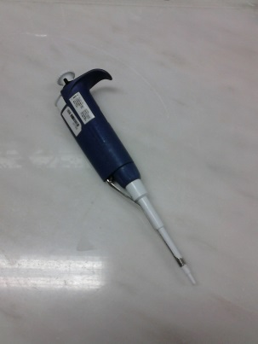

Figure 1: 2 μl variable micropipette

2. Calibration methods

2.1 Gravimetric method
The gravimetric method is considered the standard method and consists on weighing the delivered volume of the micropipette [1]. The calibration liquid used is generally pure water (distilled, bi-distilled, or deionized) with conductivity lower than 5 μS/cm and was chosen to suit the level of accuracy required relative to the amount of water used. A conversion is performed from mass to volume at a reference temperature of t₀ (normally 20 ºC). The recommended equation is described in ISO 4787 standard [4] and in (1).
(1)

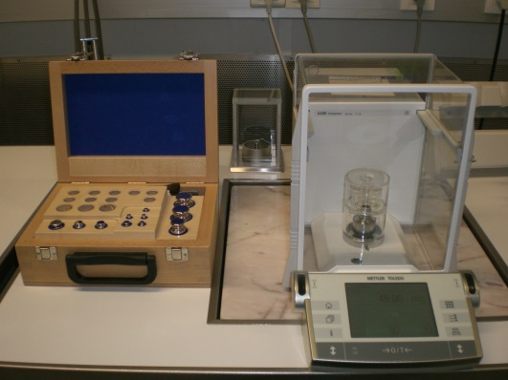

Figure 2: Mass comparator and weights

2.2 Photometric method

In the photometric method colorimetric solutions and high-resolution photometer are used to determine the volume delivered by a micropipette. The basic principles of the method are the conservation of mass, the conservation of volume and the Lambert-Beer Law [5].

In the dual-dye photometric setup (Figure 2), two colorimetric solutions are used. Each solution (one red and one blue) has an absorbance peak at a specific analytical wavelength. The basis of this technique is the following: an unknown volume of red dye is delivered into a vial containing a known volume and concentration of blue dye. After mixing, the change in absorbance of the resulting volume can be calculated as a ratio. The equation that describes this measurement principle is as following:

$V_{s}= V_{B}\left(\frac{\frac{A_{S}}{A_{B}}}{K-\frac{A_{S}}{A_{B}}}\right)$ (2)
Where,
A_{S}/A_{B} is the absorbance ratio measured in the Photometer
K is the calibration factor for the dyes
V_{B} is the volume of the blank solution
Vs is the volume delivery to be determined.

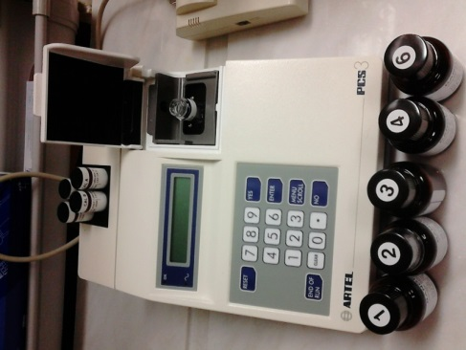

Figure 3: Artel photometer – PCS3

3. General conditions for calibration

The transfer package consists of a set of 4 variable micropipettes; all artefacts have been calibrated in different volumes; the gravimetric results of IPQ were expressed at a reference temperature of 20 °C and 10 measurements were performed for each micropipette in each selected point.

The micropipettes were handled with care, i.e., only by operators qualified in volume metrology.

Each participating laboratory used its own instruments and procedures.

To reach temperature uniformity, the tips and the liquids used in these tests were placed in the measurement laboratory at least 24 hours before any measurement was performed, at a temperature close to 20 ºC.

The Humidity was higher than 50 %. The ambient temperature was between 17 ºC and 23 ºC.

Each laboratory described the equipment used in the calibration, as shown in table 1.

Table 1: Equipment characteristics
Balance | Type | Range | Resolution
IPQ | Electronic | (0 - 22) g | 0.001 mg
Artel | Electronic | (0 – 5.1) g | 0.001 mg
Artel | Electronic | (0 - 220) g | 0.01 mg
Water thermometer | Type | Range (ºC) | Resolution
IPQ | Digital | (-30 to 150) | 0.01 ºC
Artel | Digital | (-50 to 150) | 0.001 ºC
Air Thermometer | Type | Range | Resolution
IPQ | Digital | (0 to 50) ºC | 0.1 ºC
Artel | Digital | (-40 to 60) ºC | 0.01 ºC
Barometer | Type | Range (hPa) | Resolution
IPQ | Digital | (800 - 1150) | 0.01 hPa
Artel | Digital | (500 - 1100) | 0.01 hPa
Hygrometer | Type | Range | Resolution
IPQ | Digital | (0 - 100) % | 0.1 %
Artel | Digital | (0 - 100) % | 0.01 %
Photometer | Type | Reagents
IPQ | PCS3 | Lot Code 43253
Artel | PCS3 | Lot Code 6802

4. Evaluation of measurement results

4.1 Reference value
The comparison reference value and the respective uncertainty are based on the results presented by IPQ.

4.2 Consistency determination
To verify the consistency of the results the well-known normalized error - E_{n} is used and defined as:

${E_{n}}_{lab-i}=\frac{ε_{lab-i}-ε_{RV}}{\sqrt{U^{2}\left(ε_{lab-i}\right)+U^{2}\left(ε_{RV}\right)}}$ (3)

where $ε_{lab-i}$ is the error of lab-i for a certain point, $ε_{RV}$ is the comparison reference value (RV) for the error and $U\left(ε_{lab-i}\right)$ and $U\left(ε_{RV}\right)$ are the respective expanded uncertainties (k = 2).

With the value of $E_{n}$, one can conclude that the results of the laboratory for a certain point are consistent if $E_{n} ≤1$.

The results of the laboratory for a certain point are inconsistent if $E_{n} >1$.

5. Results

The gravimetric method and the photometric method were used by each laboratory. Artel presented results for 5 different operators. IPQ used only one operator.

Two different runs were made by each operator in each point in order to obtain the reproducibility of each operator. For the point 0.1 μL, only one run was performed.

5.1 E_{n} values for gravimetric method
The E_{n} values for Artel are presented in the following figures:

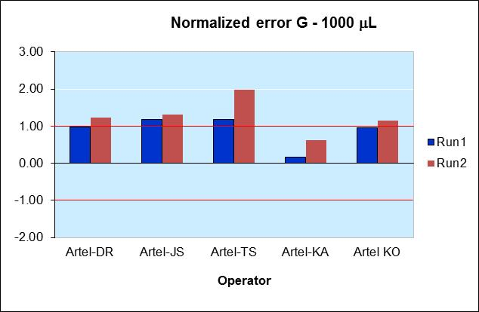Figure 4: E_{n} Results for the volume 1000 μL and considering Gravimetric method

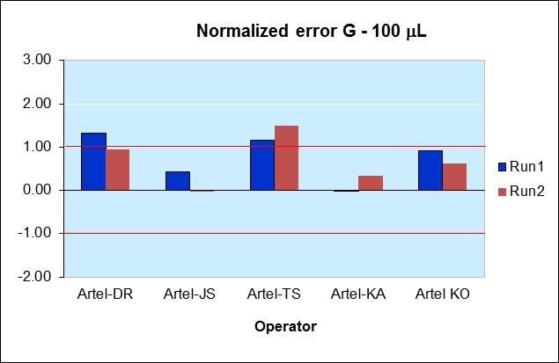

Figure 5: E_{n} Results for the volume 100 μL and considering Gravimetric method

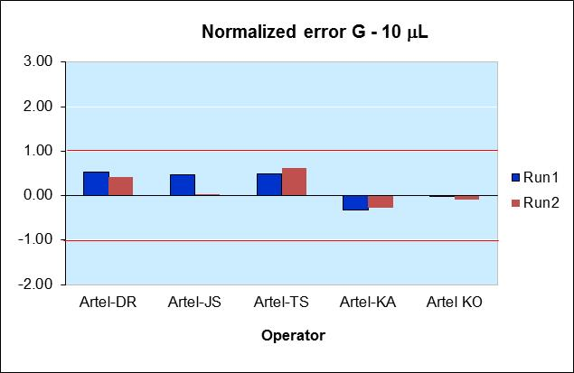
Figure 6: E_{n} Results for the volume 10 μL and considering Gravimetric method

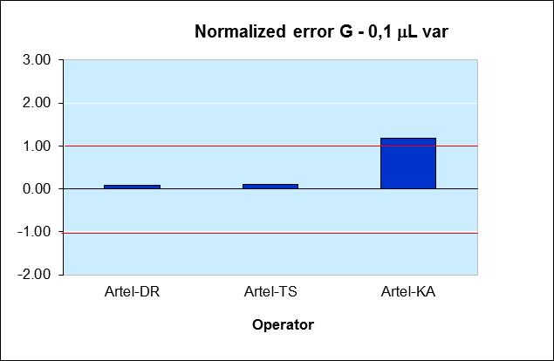

Figure 7: E_{n} Results for the volume 0.1 μL and considering Gravimetric method

The majority of the results are consistent. The worst case scenario is for the 1000 μl micropipette due to operator influence in pipetting.

Measurements were also performed at 1 μL and 0,2 μL and these results can be found in [2].

5.2 E_{n} values for photometric method
The E_{n} values for Artel are presented in the following figures:
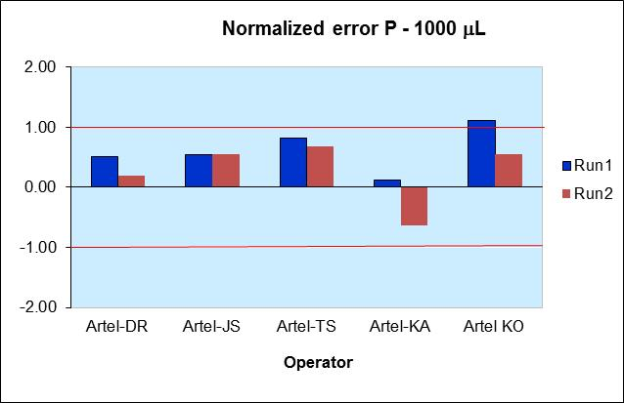

Figure 8: E_{n} Results for the volume 1000 μL and considering Volumetric method

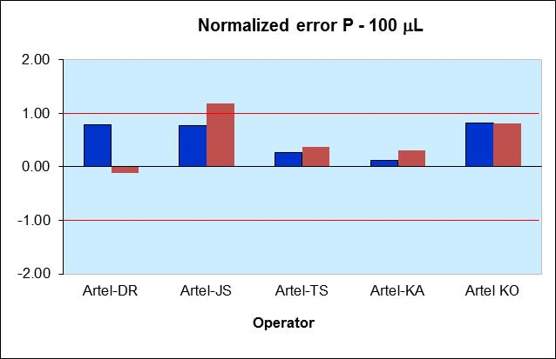

Figure 9: E_{n} Results for the volume 100 μL and considering Volumetric method

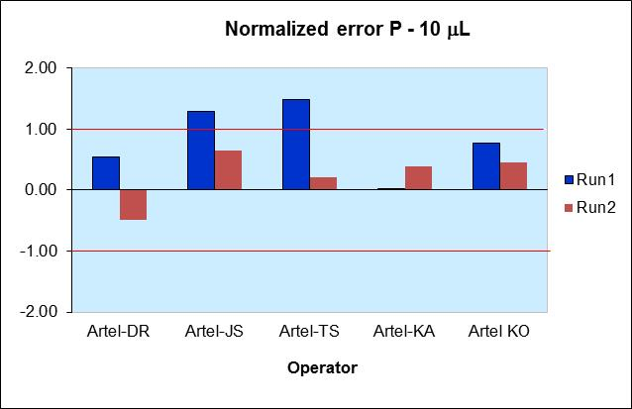

Figure 10: E_{n} Results for the volume 10 μL and considering Volumetric method

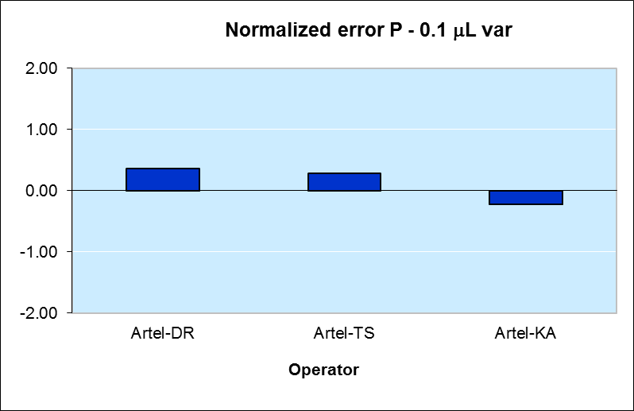

Figure 11: E_{n} Results for the volume 0.1 μL and considering Volumetric method

The majority of the results are consistent.

Measurements were also performed at 1 μL and 0,2 μL and these results can be found in [2].

5.3 Agreement of results
All the results from Artel were analysed and compiled in figure 12, which describes the percentage of consistent results for each method at each volume measured of the total runs and operators.

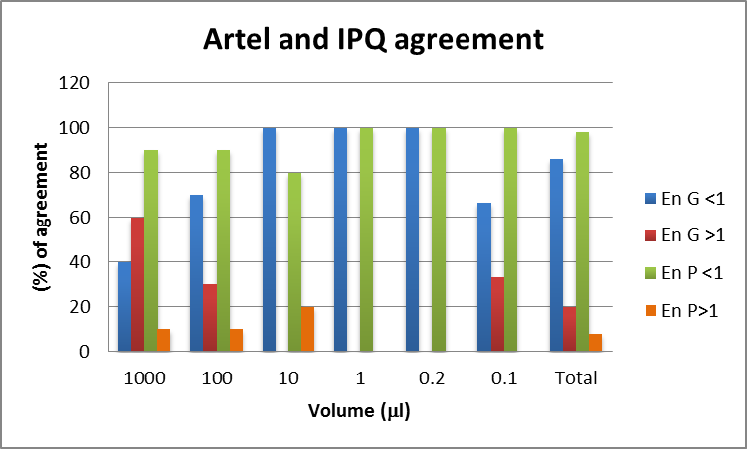
Figure 12: Agreement between laboratories

It can be verified from the figure that the photometric method yields 98 % consistency in the results while for the gravimetric method the value is 86 % which means that the majority of the results are consistent, except for the 1000 μL micropipette, where the worst agreement can be found, which is 40 %.

Also, it was observed that each operator has volume determination systematically higher or lower than the reference value. For example, operator KA has in general the smallest normalized error, and the delivered volume is the most consistent with IPQ. This might be due to the method of delivery and other bias methodology for liquid delivery which are similar for both operators, mainly the strength necessary for descending the piston of the micropipette.
The variability of results for large volumes found among the operators reflects the need to include an operator-to-operator standard deviation in the calibration uncertainty and calibration measurement capability.

6. Uncertainty calculations

Both laboratories determined the expanded uncertainty for each method according to the GUM – guide to the expression of measurement uncertainty [6].

6.1 Gravimetric method
The sources of uncertainty used by IPQ regarding the gravimetric method are [7 and 8]:
- Water temperature
- Water density
- Air density
- Mass pieces density
- Cubic thermal expansion coefficient of the material of the instrument under calibration
- Water evaporation
- Water mass
- Measurement repeatability of volume delivery
Depending on the determined volume there are two main sources of uncertainty: the repeatability for 1000 μL to 100 μL, and the mass for values lower than 100 μL.

The sources of uncertainty used by Artel regarding the gravimetric method are:
- Calibrated mass weights
- Balance repeatability and reproducibility
- Balance resolution
- Water evaporation
- Z factor
- UUT imprecision
- Measurement repeatability and reproducibility.

6.2 Photometric method
Regarding the photometric method used by IPQ, only two sources of uncertainty were considered. One obtained from the manufacturer specification of the PCS3 (reagents, resolution, instrument) and another from the repeatability of the measurements.
Depending on the volume to be calibrated, different samples solutions can be used and this fact will be reflected on the standard uncertainty of the instrument.

For the photometric method, the largest source of uncertainty depends also on the range used. For small volumes, repeatability is the largest contribution but for large volumes, bigger than 100 μL, the instrument is the most significant source of uncertainty. This is the opposite of what happens with the gravimetric method.

Artel considers the following uncertainty sources:
Instrument Uncertainty
- wavelength uncertainty at 520 nm and 730 nm
- air zero uncertainty at 520 nm and 730 nm
- glass uncertainty
- imprecision of measurement at 520 nm and 730 nm
- system linearity
- temperature
- mixing
- instrument resolution
Reagent Uncertainty
- blue & red dye absorbance
- stability
- blank volume
- glass
UUT Imprecision

Depending on the volume to be calibrated, different samples solutions can be used and this will be reflected on the standard uncertainty of the instrument.
Thus, for each range of volume values, are indicated the respective standard uncertainties;
Range 1 - 200 μL to 5000 μL with 0.19 % standard uncertainty
Range 2 - 50 μL to 199 μL with 0.26 % standard uncertainty
Range 3 - 10 μL to 49 μL with 0.21 % standard uncertainty
Range 4 - 2 μL to 9 μL with 0.21 % standard uncertainty
Range 5 - 0,5 μL to 1,9μL with 0.21 % standard uncertainty
Range 6 - 0,1 μL to 0,49μL with 0.23 % standard uncertainty

7. Conclusion

This bilateral comparison between IPQ and Artel comprised the calibration of four different micropipettes in different volume points and IPQ acting as the pilot laboratory determined the reference value.
The volume results obtained by Artel are 86 % consistent with the reference value for the gravimetric method and 98 % consistent for the photometric method.
The values obtained for higher volumes had the most percentage of inconsistent results; this may be due to a larger operator effect or the balance characteristics.
The value obtained for the expanded uncertainty for the 1000 μL, 100μL and 10 μL volumes is quite similar in both laboratories however for the smaller volumes the uncertainty of the reference value in both methods is smaller than Artel claims.

The uncertainty component that has a major contribution to the final uncertainty budget depends on the volume determined. In the photometric method for small volumes, the repeatability is the largest uncertainty component but for large volumes, bigger than 100 μL, the instrument is the most significant source of uncertainty. This is the opposite of the results obtained by the gravimetric method. In conclusion, the presented work seems to evidence that the best method to be used for smaller volumes than 100 μL is the photometric method.

The variability found between the operators for large volumes reflects the need to include the operator-to-operator standard deviation in the calibration uncertainty and in the calibration measurement capability.

References

- ISO 8655-1/2/6, Piston-operated volumetric apparatus, 2002
- EURAMET project report 1353 - Volume comparison on Calibration of micropipettes – Gravimetric and photometric methods, January 2016, www.euramet.org
- ASTM E542: Standard Practice for Calibration of laboratory Volumetric Apparatus, 2000.
- ISO 4787; Laboratory glassware – Volumetric glassware – Methods for use and testing of capacity, 2010
- George Rodrigues, Bias and transferability in standards methods of pipette calibration, Artel, June 2003
- JCGM 100, GUM 1995 with minor corrections. BIPM et al, Evaluation of measurement data – Guide to the expression of uncertainty in measurement, Joint Committee for Guides in Metrology, 2008.
- EURAMET guide, cg 19, - Guidelines on the determination of uncertainty in gravimetric volume calibration, version 3.0, 2012
- E. Batista et al, A Study of Factors that Influence Micropipette Calibrations, NCSLI Measure Vol. 10 No. 1, 2015

