Development of a calibration process for water meters close to real world conditions

D. Schumann¹, G. Wendt², J. Tränckner³

¹PTB – The National Metrology Institute of Germany, Daniel.Schumann@ptb.de, Braunschweig, Germany
²PTB – The National Metrology Institute of Germany, Gudrun.Wendt@ptb.de, Braunschweig, Germany
³The University of Rostock, Jens.Traenckner@uni-rostock.de, Rostock, Germany
E-mail (corresponding author): Daniel.Schumann@ptb.de

Abstract

A growing awareness of environment as well as consumption leads to rising and novel requirements on flow metering technology, e. g. higher flowrate ranges, smaller measurement uncertainties and calibration procedures more orientated to the actual requirements of further use. This means a changeover from ideal stationary calibration conditions to realistic measurements and a demand for meters which operate precisely under the real working conditions.
As an example, realistic conditions, especially the profiles of real water demand, deviate fundamentally from the existing test procedures of water meters at well defined, constant and reproducible reference flows as prescribed, for instance, in the existing documents in legal metrology like OIML R49 [1] or ISO 4064 [2]. In real world, a daily profile of water consumption is characterized by short water tappings, overlays of different tapping events, varying flank increases, leakage and stagnation. The main purpose of the investigations described is to develop both - highly realistic calibration procedures for water meters based on real water consumption profiles as well as the physical opportunities to generate them. Based on the analysis of water consumption measurements at more than 300 German households and of several international consumption profiles, realistic flowrates and flowrate sequences can be identified. To simulate such highly variable flowrates, a device-related test setup using cavitating nozzles has been developed. With the test rig, it is possible to generate reproducible dynamic flowrates also under laboratory conditions. The corresponding behaviour of different water meters at the simulated consumption profiles are recorded electronically and are traceable to a gravimetric standard. First results show remarkable differences in the behaviour of the water meters in dependence on the different realistic profiles used.

Introduction

Daily practice of potable water consumption differs from person to person and from region to region. It depends on the widely differing consumer habits as well as on the particular external preconditions. In each case, the consumption is characterized by highly changing flowrates in time and quantity and is measured by a variety of different types of water meters, e. g. piston-, single-jet, multi-jet, ultrasonic or electromagnetic meters. In many countries, water meters are subject to legal metrological control. The current international documents mostly used in this field are the International Recommendation of OIML R49 “Water meters for cold potable water and hot water” [1] as well as the ISO Standard 4064 “Water meters” [2].
Amongst others, these recommendations define the technical and metrological requirements for the meters, the test procedures during type evaluation and verification as well as the concrete test conditions. Particularly here, an essential contradiction occurs between the long-lasting stable flowrate required for the tests and the highly dynamic flowrate changes during the water tapping under “real world conditions”.
The purpose of the following research is to identify these real world conditions and to develop procedures fulfilling the current practical demands.

Therefore, the consumption profiles of over 300 households in Germany and several international consumption profiles were used to identify the actual conditions of use of the water meters.
To reproduce such highly variable flowrates a device-related test setup using cavitating nozzles has been developed. The corresponding behaviour of different water meters at the simulated consumption profiles is recorded electronically and traceable to a gravimetric standard.

Identifying real world conditions

Public data
The necessity of developing and implementing more realistic test conditions for water meters is based on a high variety of the real conditions of the water meters’ practical use. Figure 1 [3] provides a worldwide overview of the actual total water withdrawal per country and year, whereupon the relation between water needs of several sectors (industry, agriculture and public consumption) differs considerably. The mean daily potable water consumption (without industry and agriculture) per capita ranges from 25 litres in India over 122 litres in Germany, 295 litres in the United States up to 500 litres in Dubai [4].
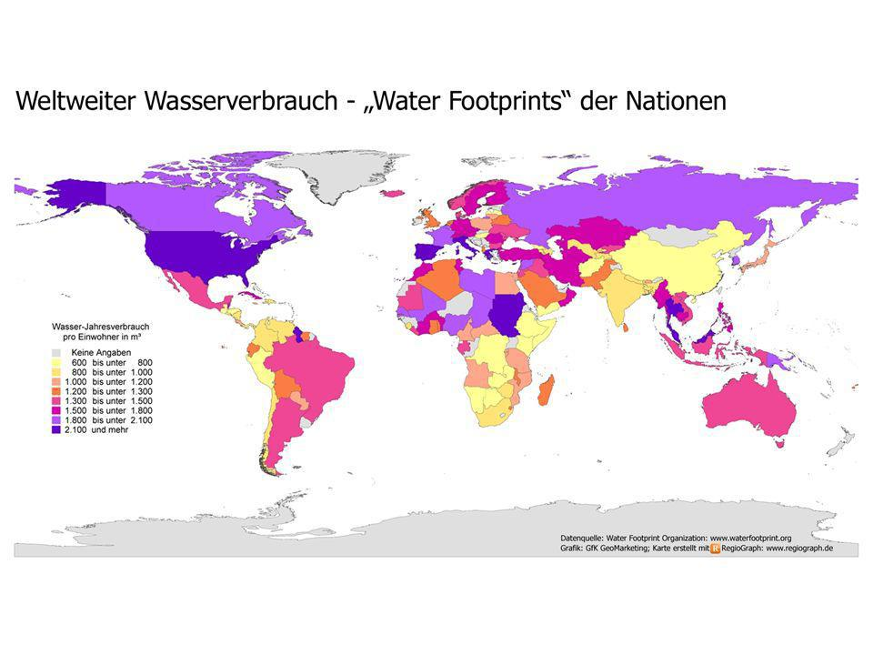
No data
600 – 800
800 – 1000
1000 – 1200
1200 – 1300
1300 – 1500
1500 – 1800
1800 – 2100
> 2100
Figure 1: Total water withdrawal worldwide per year and per capita in m³ (including all sectors such as industry, agriculture and public water consumption) [3]

A further analysis of these data shows, that for instance in Germany the mean water consumption per household splits up into seven main parts (Table 1). These types of use show an average consumption for German households, but they can be transferred to other countries – with varying portions of the total consumption.
The consumption profile of a household is characterised by a multitude of single tappings as well as tappings of different quantities and duration. Based on data recorded during a research project [5], can be concluded that the smaller the population of a house or a flat the higher the variance of consumption due to individual withdrawals.

Table 1: Composition of water consumption in Germany 2013 [7]
Type of use | Part of total consumption [%]
Bath, shower, personal hygiene | 36
Toilet | 27
Laundry | 12
Cleaning, car care, garden | 6
Dishes | 6
Food and drink | 4
Small trade | 9

The daily consumption curve of a multi-family house, which is shown in Figure 2, is just an example for a water withdrawal on household level. Keeping in mind that these consumption curves are measured with regular water meters, which are tested and approved through [1] and [2], the current real condition differs fundamentally from test conditions required in the existing regulations.
The analysis of the consumption curves in [5] does not only inform about the “simple” water withdrawal of the inhabitants, but also shows essential aspects of the peoples’ behaviour. Figure 3 represents the probability density function (PDF) of the consumption of a multi-family house over 8 weeks. A daily analysis of these data shows that the trend of this function recurs each weekday during the whole time of recording the water consumption. Furthermore, it follows approximately the same pattern. It should be mentioned that the time periods of no flow which represent the highest part during the observation period are not included in Figure 3 and Figure 4.
The reported curves are characterised by multiple single peaks in the lower flow part and two major peaks between 500 l/h and 1200 l/h. Keep in mind that in these households water meters of the size Q₃=4 m³/h (former Q_{n} 2.5) are used. The respective test flowrates of Q₁ at 25 l/h, Q₂ at 40 l/h and a nominal flowrate Q₃ at 4000 l/h (red lines in Figure 3 and Figure 4) lie completely outside of the actual flowrate range.

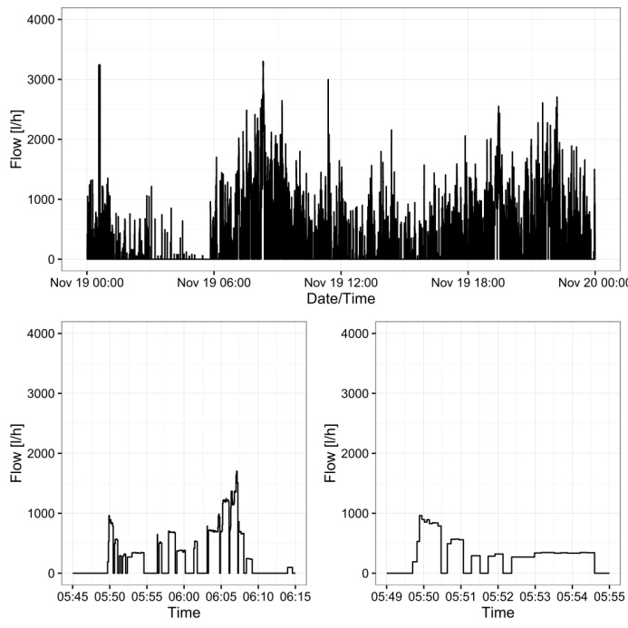
Figure 2: Real consumption profile of a multi-family house over 24 h (above), 30 min (on the left) and 6 min (on the right) [5]

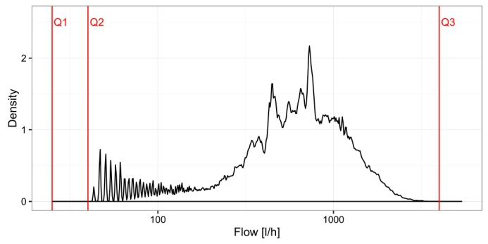
Figure 3: Probability density function (PDF) for a multi-family house during 8 weeks

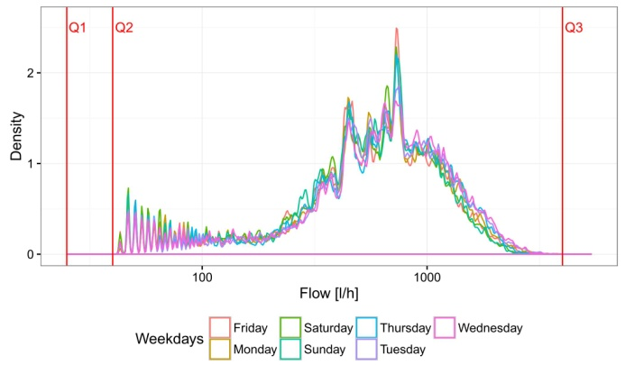
Figure 4: PDF for a multi-family house classified by weekdays

Therefore, an analysis of public data - as it was done to great extent in the study [5] - demonstrates that the requirements of the current test practice of water meters. contradict clearly to the real consumption conditions of potable water in two points:
- rapid changing flowrates regarding time and quantity versus constant flowrates and long-lasting measurement times during the tests
- immense differences between the consumption and the test flowrates

Overrun test results
The first focus concerning the development of more realistic test procedures was directed to the identification of the impact of mainly temporary withdrawals and small volumes on different types of water meters. For this, multi-jet and single-jet as well as piston and electromagnetic meters of different sizes and accuracy classes were subject to the measuring program shown in Table 2.
Table 2: Measuring program for the overrun tests
Flow [l/h] | Measuring time [sec]
300 | 2; 5; 10; 20; 30
600
900
1500
2500
5000

The water meters have been tested in a gravimetric test rig at the Physikalisch Technische Bundesanstalt (PTB) in Braunschweig. The overall expanded uncertainty (k=2) is smaller than 0.05 %. It has been determined in accordance with the “Guide to the Expression of Uncertainty in Measurement” [6].The displays of the water meters under test had been electronically recorded and analysed. As an example, the results of a Q_{n} 2.5 multi-jet water meter are displayed in Figure 5.

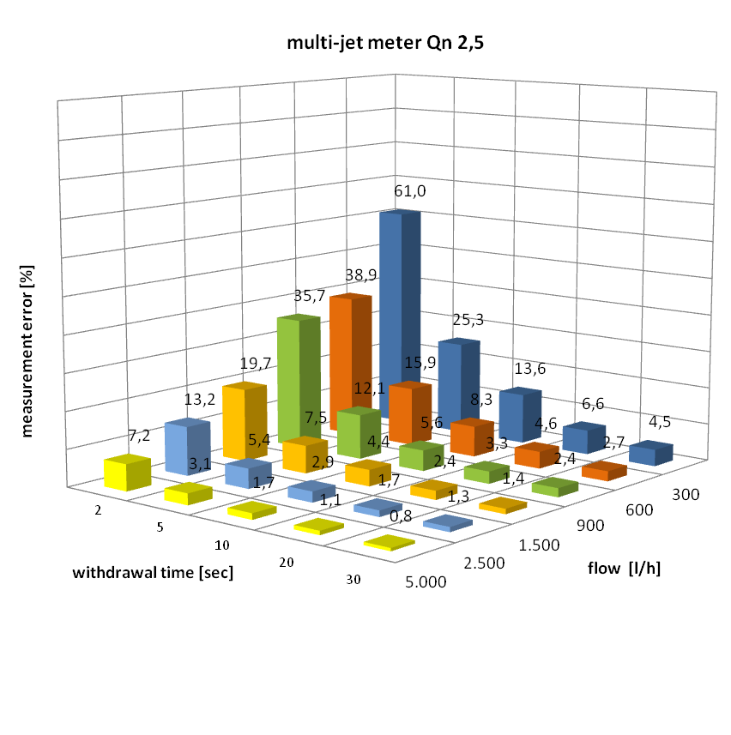
Figure 5: Example of the overrun measuring results for a multi-jet water meter Q_{n} 2.5

The highest measurement error of 61 % occurred during a two-second lasting flow of 300 l/h. The graph also illustrates, the longer the withdrawal time the lower are the measurement errors. When using single-jet meters for the measurement program, error deviations up to 170 % occurred at these conditions. For all investigations the error deviations were always positive.
At that place, it should be clearly emphasised that such high measurement errors are achieved at very extreme withdrawal situations. From the consumers’ point of view, further analyses have shown that the overall errors for an ordinary consumption profile during a whole day lie still within the maximum permissible errors in service. Nevertheless, the test results showed an urgent demand of a critical analysis of the current test procedures stated in the prevailing documents.

Practical implementation of dynamic testing conditions

Development of a new type of a test rig operating with cavitating nozzels
Up to now, all test procedures and test facilities in the field of quantity and flowrate measurement of flowing fluids are solely focused on the realisation of highly stable and reproducible flows without any disturbances or other influences. This approach does not only concern the primary standards of the national metrology institutes but it is common and usual practice. The discrepancies between test and real world conditions of the water meters can qualitatively transferred to a lot of other applications in fluid measurement; for instance in the automotive industries (measurement of instantaneous fuel consumption), in chemical, pharmaceutical and food industries (process controlling and quality insurance) or in oil production (amongst others also for danger prevention), with the same adverse effects. Therefore, the development of test facilities enabling the realisation of highly dynamic, reproducible and traceable flows is of growing interest.

Relaying on the excellent experience with critical nozzle in gas measurement, the PTB’s department “Liquid flow” started comprehensive research activities with so-called cavitating nozzles. The first step was the development of a special test rig using a set of six toroidal Venturi nozzles manufactured in accordance with the corresponding ISO standard 9300 for gas measurement [8]. Figure 6 and Figure 7 show the prototype of the test rig and the initially used nozzles, respectively.

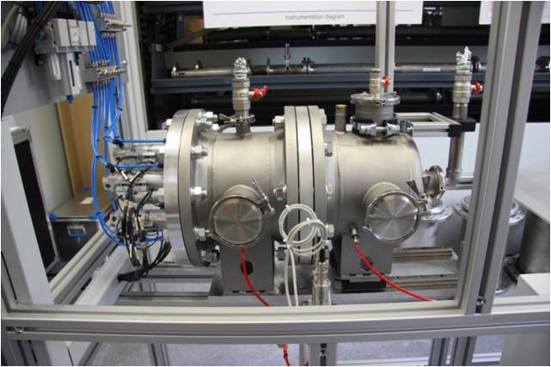
Figure 6: Test rig with six optionally shiftable cavitating nozzles

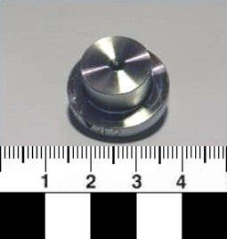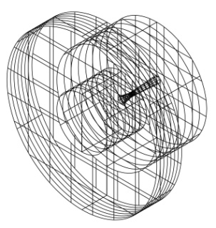
Flow
Figure 7: Initially used cavitating nozzles of toroidal shape

3.2 Realisation of reproducibly changing flowrates
The test rig developed is equipped with six nozzles realizing flowrates between 100 l/h and 5400 l/h. The corresponding diameters lie between 1 mm and 8 mm. Using different nozzle combinations, flowrates between 100 l/h and 10 m³/h can be realised in discrete steps of 100 l/h of any order. Instantaneous flowrate changes are possible, because of a very fast opening respectively closing of the nozzle holes by pneumatically driven pistons.
Figure 8 shows two “theoretical” flowrate profiles (sequence A: stepwise sloping and sequence B: alternating), Figure 9 (sequence C) reproduces the real consumption profile of Figure 2.

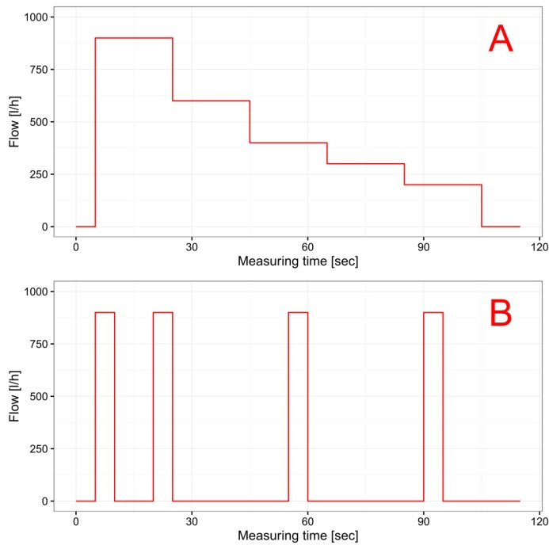
Figure 8: Theoretical flow sequences A and B representing stepwise sloping and alternating consumption profiles

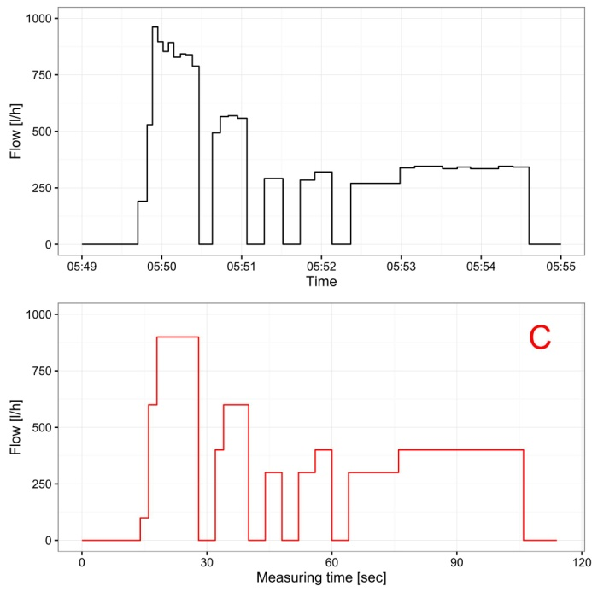
Figure 9: Real flow sequence C representing reproducing a really measured consumption profile according to Figure 2

3.3 Test results
Up to now, numerous profiles had been investigated. Besides the study of the cavitating nozzles themselves, also the behaviour of different types of water meters being exposed to several consumption profiles has been analysed. Especially, the different reactions of particular meter types had been of greatest interest. Figure 10 presents, as an example, the reaction of an electromagnetic flowmeter with high frequency output which follows the changing flowrates nearly without any delay.

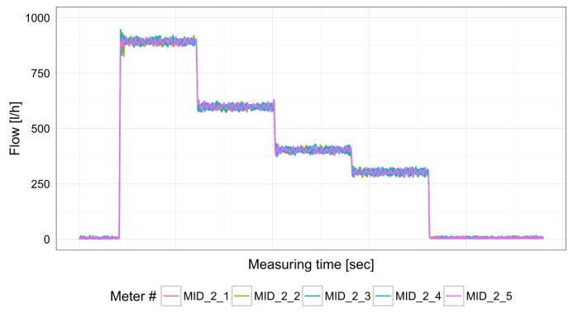
Figure 10: Test results of an electromagnetic flowmeter with high frequency output at sequence A

Figure 11 shows the results of an ultrasonic flowmeter developed to be used as a utility volume meter and to apply for consumption measurement in households (i.e. it is not configured for instantaneous flowrate measurements). Nevertheless, it also follows the flowrate changes relatively fast and gives stable flowrate indications at the plateaus.

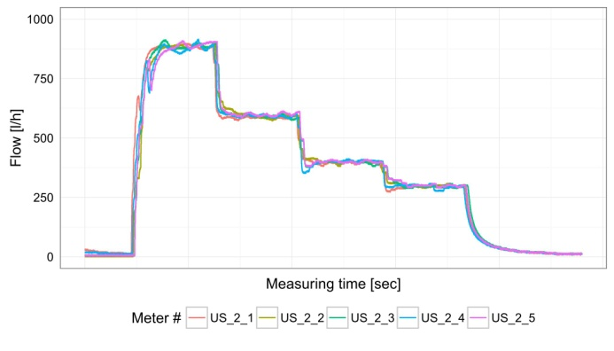
Figure 11: Test results of ultrasonic water meter at sequence B

Based on long-lasting studies of the flowrate stability realised by the cavitating nozzles, reproducibilities of these flowrates of 0.1 % and better could be verified.

3.3 Further steps
In cooperation with the University of Duisburg-Essen, comprehensive investigations of the theoretical background of cavitating flows through nozzles have been started. The reason is that only Venturi nozzles of toroidal shape had been used so far. The PTB was particularly interested in special investigations concerning the possibilities of an optimisation of the nozzles’ inner contour for their application under cavitating flow conditions. As a result of these activities, it was proposed to change the toroidal nozzle type to a Herschel Venturi-tube.
In addition to the simulation at the University of Duisburg-Essen, an acrylic-glass nozzle was prepared and with the help of a high speed camera, the flow conditions inside the nozzle had been recorded. The details of these investigations are presented in [9] and [10].

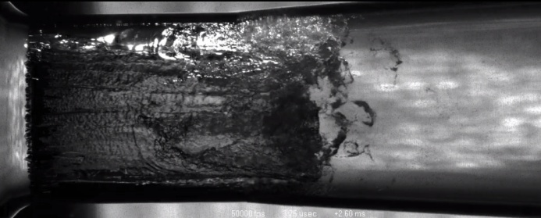
Flow
Figure 12: High speed recording of an acrylic glass nozzle (see also [9])

All the investigations carried out at PTB and the University of Duisburg-Essen validate the applicability of cavitating nozzles to realise highly reproducible flowrates also under rapidly changing flow conditions.

Conclusion

The paper presents the essential divisiveness between the practical conditions of use of water meters and the requirements in the current international regulations for water meter testing. While real conditions are characterised by highly dynamic and rapid changing flow conditions, the regulations enact stable and reproducible flow conditions on fixed flowrates far away from the real consumption mainly occurring in practical use.
The identification of the real world conditions of water consumption is one of the reasons requiring the development of novel test facilities and test procedures for utility water meters. Therefore, it is necessary to analyse the existing consumption profiles, to define and investigate representative profiles for typical applications and to show the influences of different profiles to different types of water meters.
On the other hand, it is necessary to develop and to establish a new generation of test rigs. First investigations with cavitating toroidal and Herschel Venturi-nozzles validate the applicability of these methods for creating highly reproducible dynamic flow conditions.
The combination of real world data of water consumption, baseline and experimental investigations and simulations are a promising mixture to establish a novel test process for water meter under conditions, which are closer to their realistic use and better to ensure reliable measurements.

References

- OIML R 49, Water meters for cold potable water and hot water, 2013
- ISO 4064, Water meters for cold potable water and hot water, 2014
- Water Footprint Organisation, Total water withdrawal worldwide per year and per capita in m³, http://www.waterfootprint.org
- Water consumption in: https://de.wikipedia.org/wiki/wasserverbrauch
- A. Korth, T. Martin (2016): “Aktualisierung von Verbrauchsganglinien für Haushalte, öffentliche Gebäude und Kleingewerbe sowie Entwicklung eines Modells zur Simulation des Wasserbedarfs”, DVGW-Forschungsvorhaben W-10-01-11
- Internationale Organisation für Normung (1995): Guide to the expression of uncertainty in measurement. 1. ed., corr. and reprinted. Genève.
- BDEW Wasserstatistik, https://www.bdew.de/internet.nsf/id/bdew-jahresstatistik-de
- ISO 9300, Measurement of gas flow by means of critical flow Venturi nozzles, 2005
- S. Brinkhorst, E. von Lavante, D. Güler, G. Wendt, „Experimental Investigation of Cavitating Herschel Venturi-Tube Configuration“, in FLOMEKO 2016, Sydney, 2016, submitted
- S. Brinkhorst, E. von Lavante, G. Wendt, (2015): “Numerical investigation of cavitating Herschel Venturi-Tubes applied to liquid ﬂow metering”. In: Flow Measurement and Instrumentation 43, S. 23–33. DOI: 10.1016/j.ﬂowmeasinst.2015.03.004

