Calibration guideline for the infusion pump analyzer applied in secondary laboratories in Thailand

T. Chinarak¹, K. Leetang¹ and P. Wongthep¹

¹National Institute of Metrology, Thailand (NIMT),
3/4-5Moo 3, Klong 5, Klong Luang, Pathumthani, 12120 Thailand
E-mail: theerarak@nimt.or.th

Abstract

The flow laboratory of the National Institute of Metrology, Thailand (NIMT), in cooperation with the department of medical sciences, and the department of health service support, ministry of public health developed the periodic testing and maintenance procedures of the infusion pumps according to the international standards, IEC 60601-2-24 particular requirements for the safety of infusion pumps and controllers, and requirements from the authorities in Thailand. The testing procedures are now widely used in hospitals across country. Since the infusion analyzer is used as a tester in one of the methods applied in the infusion pump testing procedures. Then, the calibration guideline for the infusion analyzer has been developed to support the secondary laboratories for calibrating the devices. The guidelines provide characteristic of the three main elements used for calibration which are the supply and flow control, the weighing system and the data acquisition system. The infusion analyzer has to be calibrated at least three points; 50, 100 and 300 ml/h that are required by the authorized person and normal conditions for patients in the hospitals. The uncertainties of calibrations are range from 0.31% to 0.57%.

1. Introduction

The infusion pump is one of the medical devices that have been used widely in the hospitals. Generally, they have the accuracy ranged from ±5% to ±10% depending on the IV set that they have been used with. In order to confirm that the pumps are still working properly, the testing procedures are introduced. The Thai version of the testing procedures (ISBN: 978-616-11-2153-2) [1] are developed under the cooperation of the national institute of metrology (Thailand) (NIMT), the department of medical sciences (DMSC), and the department of health service support (DHSS), ministry of public health. The testing and maintenance procedures of the infusion pumps have been studied according to the international standards, IEC 60601-2-24 particular requirements for the safety of infusion pumps and controllers, and requirements from the authorities in Thailand. The testing procedures of the infusion pumps have been distributed and applied to the hospitals since 2014.

In the testing procedures, the infusion pump analyzer is used for testing the infusion pump. That means that the infusion pump analyzer is the important device. Then, the next step of the project is the development of the infusion pump analyzer calibration procedures which would fulfill the traceability. The calibration is aimed to be as a guideline which has the least requirements for the facility set by the secondary laboratories in Thailand. The calibration points are set at 50,100 and 300 ml/h but other points are optional. The uncertainty of this setup is ranged from 0.31% to 0.57% that considerably sufficient for calibrating the infusion pump analyzer which has the accuracy of ±1%. One reference that emphasizes the uncertainty of this system is suitable is the MeDD report [2]. The report shows the uncertainty of the primary standard system of liquid flow facility at VSL is 0.11% (k=2).

Noted that in this guideline, the pressure calibration method is followed the Guideline DKD - R 6-1: Calibration of Pressure Gauges, however, the details of this topic is not discussed in this paper.

2. Equipments

The equipments used in the calibration system can be separated into three groups according to IEC 60601-2-24 [3] which are water supply, weighing system and data acquisition system. Each equipment is selected based on the availability, user friendly and service from manufacturer.

2.1Water supply
The water supply system is aimed for generating flow rates in the range of (10 – 1000) ml/h. The infusion pump is chosen to be the source of water supply. The infusion pump from Terumo, model TE171 using with the IV set for pump was selected to control the flow rate for this system. The IV set is set to the pump and the inlet of the unit under calibration, UUC. At the outlet of the UUC, the 1/4” stainless steel tube is connected and the water is flowing through the tube to the weighing balance. The reverse osmosis, RO, water is used for this system.

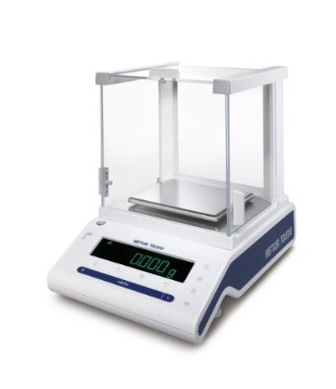
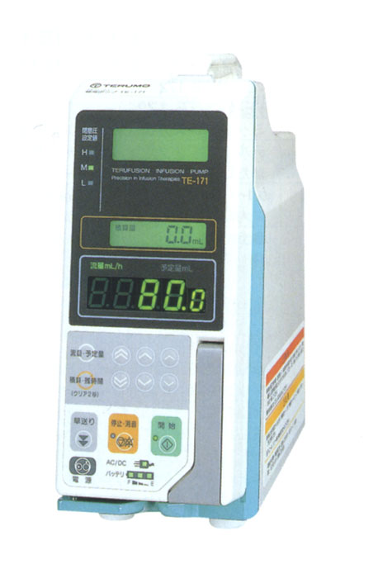
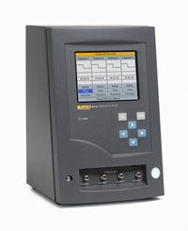
UUC
1.Infusion pump
2. Weighing System
3. Data acquisition system

Figure 1: The system setup

2.2 Weighing system
The study of effects of weighing balances due to the infusion devices [4] shows the factors that affect the uncertainty evaluations. Some of those factors are recognized by the users who often use the balances. However, for the small flow rate calibration, more factors have to be considered such as evaporation rate and environmental vibration. The Figure 2 shows the shield that prevents the variation due to the laboratory vibration and air flow.
Cover Evaporation protection
Shield
Variation of the environment
Fluid level
18G needle
Balance

Figure 2: Shield of weighing balance

Figure 3: Evaporation rate with four types of vessels

Evaporation is another factor that has to be considered. The evaporation rate is directly related to the mass loss during the calibration period. Then, the evaporations are tested with four different conditions; largemouth of polyethylene containers with and without cover, and small mouth of polyethylene containers with and without cover. Figure 3 reveals that the small mouth with cover giving the best result among four conditions. Moreover, the evaporation rate has to be counted into the uncertainty due to mass measurement.

2.3Data acquisition system
The data from the weighing balance are collected by using the LABVIEW programme. The LABVIEW is connected to the weighing balance (max. load 1020g) via RS232 which is the real-time data processing. Both measured mass and time are recorded every 30 seconds and in the form of text which can be analyzed by excel or other suitable programme. The raw data can be calculated to find the discrete flow rate, the accumulate flow rate and trumpet curve. The successively sequence of data is collected for about one hour this is counted as a one loop of calibration.

Moreover, other equipments used in this calibration are temperature PT100 for measuring the water temperature and the electronic thermo-hygrometer for measuring the room conditions; room temperature and humidity. The room conditions are controlled at (20 ± 2) ºC and (55 ± 15) %RH.

3. Calibration Procedures

The flow rates are calibrated at 50, 100 and 300 ml/h. Those flow rates are normally selected to infuse the drugs or solutions to patients. At each flow rates, mass and time are successively collected every 30 seconds from the weighing system. The calibration period is one hour and repeated for three loops. The data from the UUC are recorded depending on its software. However, the UUC data have to show the measured flow rates. Other parameters such as the water temperature, ambient temperature and ambient humidity are also recorded.

The measured mass and time are used for calculating the flow rates. The mass of each increment are converted to volume by using Equation (1) which comes from ISO/TR 20461 [5].

(1)
Where m_{w} the collected mass of water
Z the combined factor for buoyancy correction and conversion from mass to volume
Y the thermal expansion correction factor of the delivering device

Since the measured mass is collected at every 30 seconds, then, the discrete flow rates are executed every 30 seconds. Consequently, the discrete flow rates in one hour must be 120 data and the standard flow rates can be calculated from the average value of those data.

The flow rates of the UUC can only get from manufacturer’s software. The deviation of the set flow rates is allowed at ±10%. In Figure 4 to 6, the discrete flow rates of the UUC and standard system are plotted.

Figure 4: Discrete flow rates of UUC and standard system at 50 ml/h

Figure 5: Discrete flow rates of UUC and standard system at 100 ml/h

Figure 6: Discrete flow rates of UUC and standard system at 300 ml/h

The Figure 4 to 6 shows the instability of the discrete flow rates from the standard system (weighing method) and the UUC (infusion pump analyzer). The higher flow rates, the higher instability. Hence, the instability of the measured flow rates from UUC and the standard system are included to the uncertainty evaluation.

4. Uncertainty evaluation
The uncertainty evaluation for the small flow calibration can be written as shown below.

(2)

The uncertainties of the mass to volume conversion (u_{mw}, u_{Z}, u_{Y}) can be derived by the methods as shown in the ISO/TR20461 [1].

4.1 Time, u_{t}
The uncertainty due to time from the laptop, u_{t}, is 0.010 second. This value comes from the error occurred between the accurate frequency generator and the counting programmed in the laptop.

4.2 Instability of the flowrate, u_{fluctuation_WB} and u_{instability_UUC},
The instability of the discrete flowrate of the standard calibration system, u_{fluctuation_WB}, can be considered from the standard deviation of N data divided by the total collected numbers of data.
(3)
The instability of the discrete flowrate of the UUC, u_{instability_UUC}, can be considered from the standard deviation of N data divided by the total collected numbers of data.
(4)

4.3 Repeatability, u_{repeat_UUC}
The repeatability of the calibration, u_{repeat_UUC}, can be considered from the maximum deviation of the error caused by the calibration result.
(5)

4.4 Resolution, u_{res_UUC}
The resolution of the calibration, u_{res_UUC}, can be considered from the finest display of the unit under calibration that user can read.
(6)

5. Results

The results of calibration of each set point is shown in Table 1. All channels of the infusion pump analyzer are calibrated at flow rates; 50, 100 and 300 ml/h. The uncertainty of calibration are ranged from (0.31 – 0.57)% of reading. The error span of all channels (with uncertainty) are within ±1% which meets the specification of the analyzer.

Moreover, the calibration system was verified by using the standard flow meter (Bronkhorst, M13) which has accuracy ±0.25%. The standard flow meter was set instead of the UUC and tested at the same flow rates. The results of the calibration of the meter are compared with the result from its certificates and the international comparison [2]. From those results of the standard flow meter, the comparison result reveals that the E_{n} ratio is less than 1 for all set flow rates which means that the new calibration setup at NIMT has agreed performance as shown on Figure 7.

Table 1 : Calibration results of infusion pump analyzer
Flow rate | Channel | Error |  | Uncertainty
ml/h | No. | ml/h | % | (k =2)%
50 | 1 | -0.08 | -0.16 | 0.44
 | 2 | -0.03 | -0.06 | 0.49
 | 3 | -0.05 | -0.10 | 0.47
 | 4 | -0.20 | -0.39 | 0.57
100 | 1 | 0.16 | 0.17 | 0.31
 | 2 | 0.28 | 0.29 | 0.33
 | 3 | 0.37 | 0.39 | 0.47
 | 4 | 0.14 | 0.15 | 0.42
300 | 1 | 0.47 | 0.17 | 0.31
 | 2 | 1.52 | 0.54 | 0.31
 | 3 | 1.47 | 0.51 | 0.33
 | 4 | 1.85 | 0.65 | 0.31

Figure 7: Uncertainty of measurement, error span and accuracy of the standard flow meter (Bronkhorst, M13)

Using the trumpet curve to consider the stability time for testing the infusion pump of each flow rate is another important topic. The trumpet curve can be calculated by followed the IEC60601-2-24 [3]. The result of trumpet curves is shown in Table 2 and Figure 8. At flow rate 50 ml/h, the infusion pump has to infuse the solution through the infusion pump analyzer for 31 minutes prior to start the testing. This number is applied to channel 1 to 4 of the infusion pump analyzer.

Table 2 : The trumpet curve
Flow rate (ml/h) | Stability (window/min)
 | CH1 | CH2 | CH3 | CH4
50 | 31 | 31 | 31 | 31
100 | 11 | 11 | 11 | 11
300 | 5 | 5 | 5 | 2

This information is considerably useful for the operator in order to get the correct testing result when they are using the infusion pump analyzer to test the infusion pumps. Similarly, the stability time for 100 and 300 ml/h are 11 and 5 minutes that the infusion pumps have to infuse the solution through the analyzer prior to start the test.

Figure 8: Trumpet curve of flow rates; 50, 100 and 300 ml/h

6. Conclusion

The calibration guideline for the infusion pump analyzer has the least requirements for the standard system for calibrating the infusion pump analyzer which has the accuracy of ±1% of reading. The calibration system – weighing based method – has uncertainty of the system (0.31 – 0.57) % that is considerably adequate for calibrating the infusion pump analyzer. The guideline will be printed out and distributed to the secondary laboratories in Thailand by the DHSS and DMSC.

For future works, the proficiency test is required to confirm the equivalence of the ability of each laboratory.

References

[1] Standard procedures for testing of infusion pumps. ISBN 978-616-11-2153-2.
[2] C. David et.al. “Project MeDD – Task 1.1 Comparison report” December, 2013
[3] IEC 60601-2-24: Medical electrical equipment – Part 2-24: Particular requirements for the safety of infusion pumps and controllers, 1998 – 02.
[4] D.M. Clarkson, “Accuracy estimations of testing of infusion devices using weighing balances”, Medical Engineering & Physics, 24, 229 – 235, 2002.
[5] ISO/TR 20461: Determination of uncertainty for volume measurements made using the gravimetric method, 2000 – 11- 01.

