A Simple Method to Measure Wastewater in Pumping Stations

M.T. Pereira¹, N.M. Taira²,
M. Miki³,

¹Escola Politécnica da Universidade de São Paulo, Av Prof. Mello Moraes, 2231- 05508-970, São Paulo, Brazil
²Instituto de Pesquisas Tecnológicas, São Paulo, Brazil
³SABESP, São Paulo, Brazil
corresponding author: marcospereira@usp.br

The paper shows the development of an elbow flow meter for use in wastewater pumping facilities. The paper describes the results of laboratorial tests, the use of a specially developed pressure transducer for the measurement of the difference in the centrifugal force in the pressure taps of the elbow and, finally, the field tests in a wastewater pumping facility. Results show that for Reynolds numbers greater than 10⁵ the K coefficients are constant within ± 1% and follow the theoretical curves within ± 0,5%. The uncertainty in the measurement of the flow rate was determined to be better than 2%.

Measurement of wastewater in pumping stations is a difficult task: complicated fluid, harsh operational conditions, the proximity between pump and meter introduces distortions in the velocity profile, turbulence and pulsations. Few meters are suitable for this, and the forgotten elbow meter is an excellent option, if properly arranged.
According to Lipták ⁽¹²⁾ the theoretical value of $K$ for an elbow meter can be given by:
$K= \sqrt{\frac{r_{b}}{2D}}.(1+\frac{6,5}{\sqrt{{Re}_{D}}})±4\%$

The next figure shows the results obtained for the several arrangement adopted:

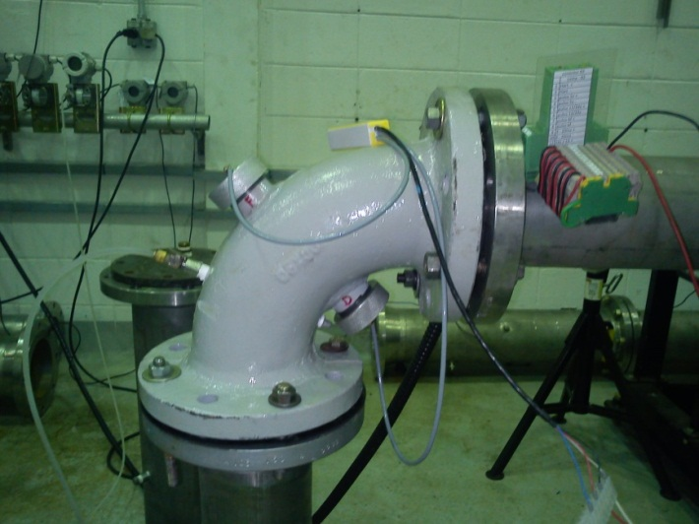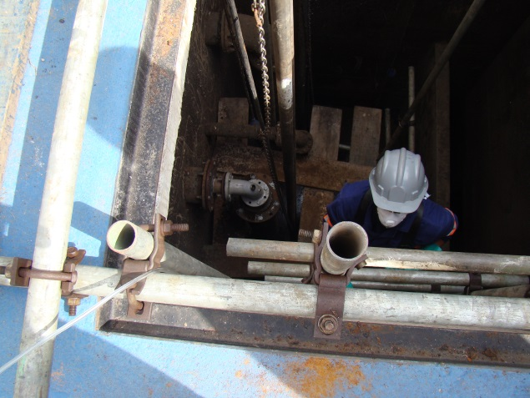
This figure shows the elbow under test in the laboratory and installed in the field.

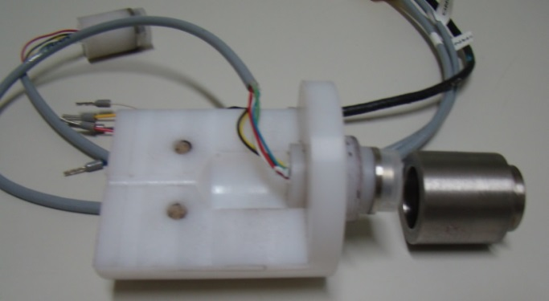
This figure shows the special pressure transducer developed for this meter.

The full article will shows the detailed results for this arrangement of elbow meter. It proves to be an alternative quite interesting for the measurement of wastewater, mainly for its robustness and the good solution for the measurement of the pressure difference between the inner and outer centrifugal forces of the meter.

