An Intercomparison of Water Flow and
Gas Flow Laboratories using ISO 5167 Dp Devices

Roy van Hartingsveldt¹, Jos van der Grinten¹, Stefan Knöfel² and Eberhard Gralla²

¹ NMi EuroLoop, Petroleumweg 36, 3196 KD Rotterdam-Vondelingenplaat, The Netherlands
² Siemens AG, EN PTEC PP, Erlangen, Germany
E-mail corresponding author: jos.vandergrinten@nmi-euroloop.nl

Between August 2013 and March 2014 an intercomparison was organized using a ISA 1932 nozzle, a long radius nozzle and a Venturi tube. The devices were made by Seiko in stainless steel according to the ISO 5167 standard [1] and are equipped with double pressure tappings. Two sections were made: a Venturi section and a section with interchangeable ISA and long radius nozzle.
The coordination was performed by Siemens.
In the intercomparison 3 water flow laboratories and 3 gas flow laboratories participated. Figure 1 below shows the results for the long radius nozzle. The Cd value is plotted as a function of the Re number. The left hand graph shows the results for the water calibrations, the right hand figure shows the results for the gas calibration. The other results will shown in the paper.

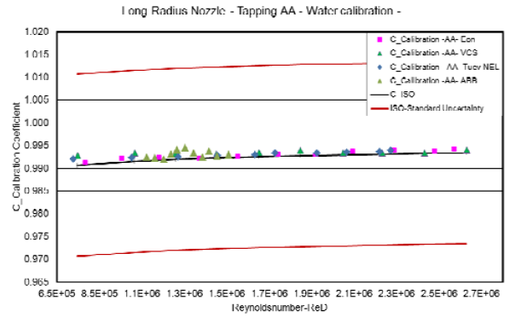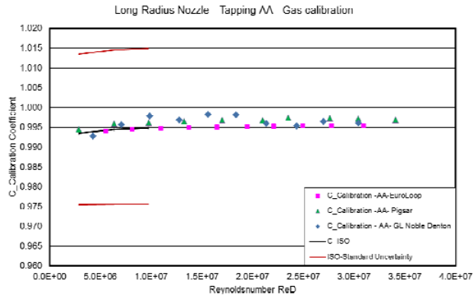
Figure 1: Calibration results for a long radius nozzle calibrated with water (left) and natural gas (right).

All calibration results agree within the measurement uncertainty with the literature value. As no literature values are available for the higher Reynolds numbers the result are considered to be presented to ISO for revision of the ISO 5167 standard.
One of the remarkable outcomes was the very good agreement for the long radius nozzle. The device produces the most stable results and appears to be suited best for future intercomparisons.

References
- ISO 5167-3,4 (2003): Measurement of fluid flow by means of pressure differential devices inserted in circular cross-section conduits running full — Part 3: Nozzles and Venturi nozzles — Part 4: Venturi tubes, ISO 2003, Geneva

